S1 Global Cavity Status - FNAL J. Kerby 11 Nov 2009

Cavites (plan)
ACC011 to be vertically tested (today); AES002 to be vertically tested next week. Backup AES004 to be horizontally tested next week. Assuming success two will be ready for shipment by mid-December.

Parts
JT File and Bill of Materials available through Don Mitchell; Instrumentation List / Flanges list delivered through Tug Arkan; Stepping Motor and Piezo information transmitted from Yuriy Pischalnikov
http://tdserver1.fnal.gov/dmitchel/FNAL_S-1_items.zip
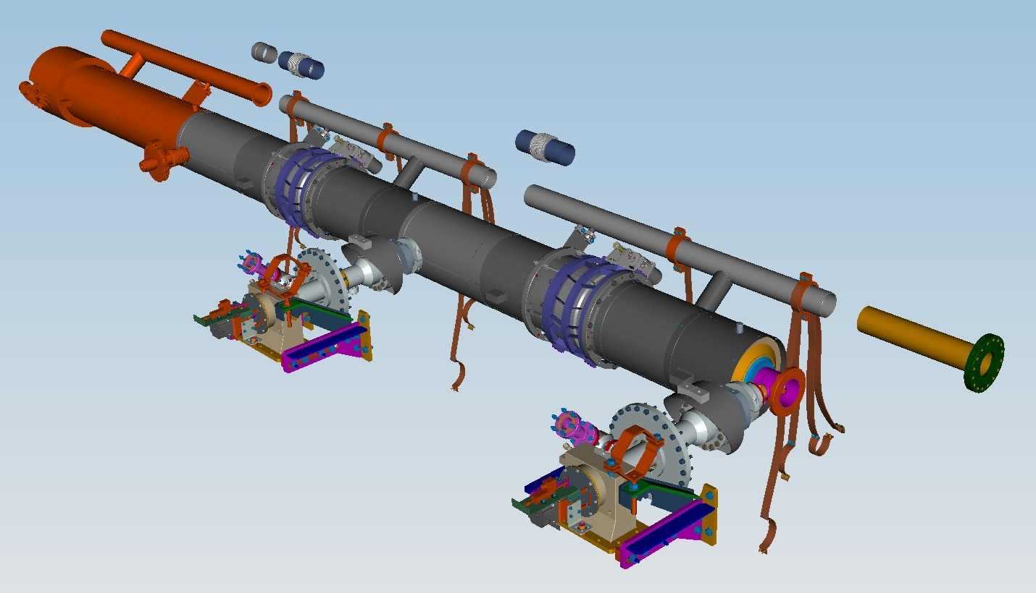

Tooling
Drawings supplied for requested contact tooling for modifications to KEK rail through Tug; shipping frames currently @DESY

Procedures
FNAL Procedures are available through Tug
http://tdserver1.fnal.gov/arkan/

Local Support
Propose Tug Arkan visit KEK during January clean room work; Serena Barbanotti to visit during February for Tuner / Magnetic Shield Assembly. Beyond this TBD.

