**2010 LINEAR COLLIDER SCHOOL**

**SUPERCONDUCTIN RF**

**HOMEWORK**

**Problem 1**

A film of thickness  made of a London superconductor (of penetration depth) is placed in a parallel magnetic field H0.

Calculate the magnetic field and supercurrent in the film.

Use the coordinate system where the film extends from  to, and the magnetic field is in the  direction.

Plot both for 

**Problem 2**

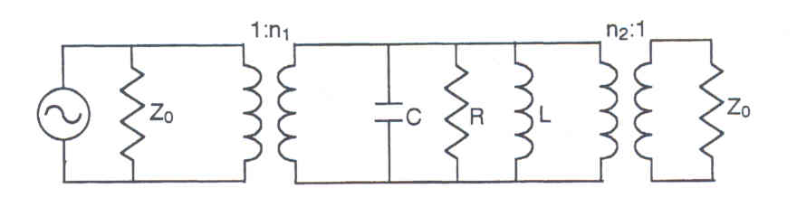

Assume a 2-port cavity with coupling coefficients β1 (input) and β2 (output)

Calculate the dissipated, transmitted, and reflected power for a given incident power.

Note: With a little bit of thinking you should be able to write down the answers directly with almost no calculations.

What happens if we interchange input and output?

What happens when β1=β2?

**Problem 3**

A superconducting cavity has 2 sources of power dissipation

-- Resistive losses with constant surface resistance

-- Field emission losses

What is the functional dependence of the quality factor (or its reciprocal) of the cavity on the accelerating gradient?

**Problem 4**

The power required to operate a cavity in the presence of beam loading is given by



where 

Derive that expression and show that the required rf power is minimal when



If additionally we need to control microphonics, then show that the optimal coupling and rf power are given by



**Problem 5**

Assume that we have a cavity providing a voltage to a very high current . If the detuning and coupling are optimized, show that the required rf power is  where  is the phase between the beam and the cavity voltage.

We now want the cavity to provide a voltage  using the same amount of rf power, and we want to determine what is the maximum current we will be able to accelerate.

Define 

Show that, if we can reoptimize the coupling, then the relationship between  is .

For example, this means that if we want to increase the gradient to 1.5 times its original value then we must decrease the current to 2/3 and still provide the same beam power.

On the other hand, if the power coupler is fixed and we cannot reoptimize the coupling, then show that the relationship between  is .

In this case we would have to decrease the current to 1/2 and only 2/3 of the power will be transferred to the beam and 1/3 will be reflected.

**Problem 6**

-- Calculate the radius and length of a 1.3 GHz TM010 pill box cavity

-- What are the geometrical factor and R/Q for a single cell

-- Calculate the BCS surface resistance at 2K.

Use the following formula to calculate RBCS:

 where *T*c = 9.2 K

-- If a real cavity has an R/Q which is 60% of that of the pill box cavity, but has the same geometrical factor, what is the total power dissipation for a 1 TeV accelerator if the cavities are operating at 30 MV/m. Assume a residual surface resistance of 5 nΩ

-- If the cost of a helium refrigerator per watt of capacity is

, what would be the refrigerator cost for 2K cw operation?

-- If the cavities operate at 30 MV/m, and the cost of cryomodules is $50k per meter of active length, what would be the cryomodule cost for a 1 TeV accelerator?