GDE Interim Report
2.3 Progress towards reproducible manufacture of high-gradient cavities
R.L. Geng, C. Ginsburg, J. Kerby
RG Rev. November 4, 2010
2.3.1 Introduction
The gradient choice for the ILC superconducting radio-frequency (SRF) cavities is important for the beam energy reach and the machine cost. At the time of RDR publication, a choice of 35 MV/m was made for cavity vertical qualification test. This choice was supported by the demonstration of ≥35 MV/m in several 9-cell TTF-shape cavities by a DESY-KEK collaboration.
Achieving 35 MV/m in 9-cell cavities reproducibly is important as the total number of cavities required for the ILC is far more than any SRF based machines built or planned. A global R&D program (S0 program) was established in 2006 to address this challenge. The S0 program, coordinated by the GDE cavity group, has broad global participation from ANL, Cornell, DESY, FNAL, JLab, and KEK. Significant progress in understanding the gradient limit and gradient scatter has been made by instrumented cavity testing at cryogenic temperatures and high-resolution optical inspection of the cavity RF surface. At the time of RDR, Europe was the only region having demonstrated 35 MV/m cavity fabrication and processing. Today, 35 MV/m cavity fabrication and processing have been demonstrated also in Asia and America region. A solid SRF technology base for the ILC on a global scale is now in place.
The global investments in ILC gradient R&D are rewarded not only by improved gradient yield and reproducibility but also an extended gradient envelope. By mid 2010, a major SRF gradient R&D milestone of 50% yield at 35 MV/m has been achieved. The average gradient in the state-of-the-art 9-cell cavities is raised to ~ 40 MV/m, a 5 MV/m increase as compared to the then state-of-the-art of 35 MV/m in 2005.
2.3.2 Globally coordinated gradient R&D program – S0 program
The ILC gradient R&D is a global effort with participation of ANL, Cornell, DESY, FNAL, JLab, and KEK. Information is exchanged regularly at the monthly GDE cavity group meeting. Cavities are exchanged across the labs and regions. There are growing interests and capabilities of cavity gradient R&D in other labs such as IHEP, PKU, and TRIUMF. Encouraging cavity results are emerging. From history, these R&D initiatives usually drive industrial interest and capability for SRF cavity manufacture and processing. A global SRF enterprise is rising because of the driving force by the ILC gradient R&D.
2.3.3 Understanding the source of gradient limit and scatter and “feedback loop”
Source of field emission is now understood. Besides the traditional particulate field emitters, niobium oxide granules is found to be a major field emitter introduced by the electropolishing process itself. Source of quench limit at < 25 MV/m is understood to be caused by highly localized geometrical defect near the electron beam welded joint at the cavity equator. These information is feedback to cavity processing and fabrication procedures and resulted in improved gradient results.
2.3.4 Progress in reproducible processing of high-gradient cavities
Cavity inner surface “auto rinsing” by continued electrolyte circulation after the EP voltage is shut off and improved post-EP cavity cleaning reduces field emission.
2.3.5 Gradient yield definition and global cavity result database
In the RDR goals of a 50% process yield by 2010 and a 90% production yield were defined at 35MV/m with a Q0 of greater than 8e9. As the Technical Design Phase of the ILC progressed, the need for a clear definition of what the gradient yield is was recognized, and the need for a globally consistent and available database for recording test results was recognized. In 2009 the ILC Global Cavity Database Team was created as a part of the S0 effort. The team included members from Fermilab, DESY, Jlab, Cornell, and KEK, and took on the task of not only creating the database, but also defining the rules for how the data should be included, and how the data would be presented. The results of this effort are a clear, objective, and publicly accessible database where the progress of cavity R&D can be tracked. In fact since mid 2009 the database group has done just that, presenting status at each major ILC workshop, meeting or review.
The most recent results for first pass and second pass results, presented in a time phased manner at the IWLC2010 meeting in Geneva, Switzerland, are shown below. By way of definition, plots only includes results from a vendor / laboratory combination who have previously demonstrated through test the ability fabricate and process a cavity that achieves > 35MV/m in a vertical test. A first pass result is one where the fabrication and processing have been completed according to the standard recipe leading up to the first test; a second pass result sums all first pass results greater than 35MV/m and second pass results where the a poorer performing cavity had some remediation applied based on diagnostics from the first test. Apparent from the graphs is the improvement with time of the yield curves, particularly for second pass results. This improvement is attributable to improved diagnostic and remediation tools that have been developed in the past years. A smaller gain is seen in the first pass results. This is consistent with our limited ability to recognize fabrication flaws early in fabrication by means other than vertical testing; improvement of our understanding of the critical fabrication parameters and the development of predictive quality assurance checks are an R&D direction in the upcoming TDP phase.

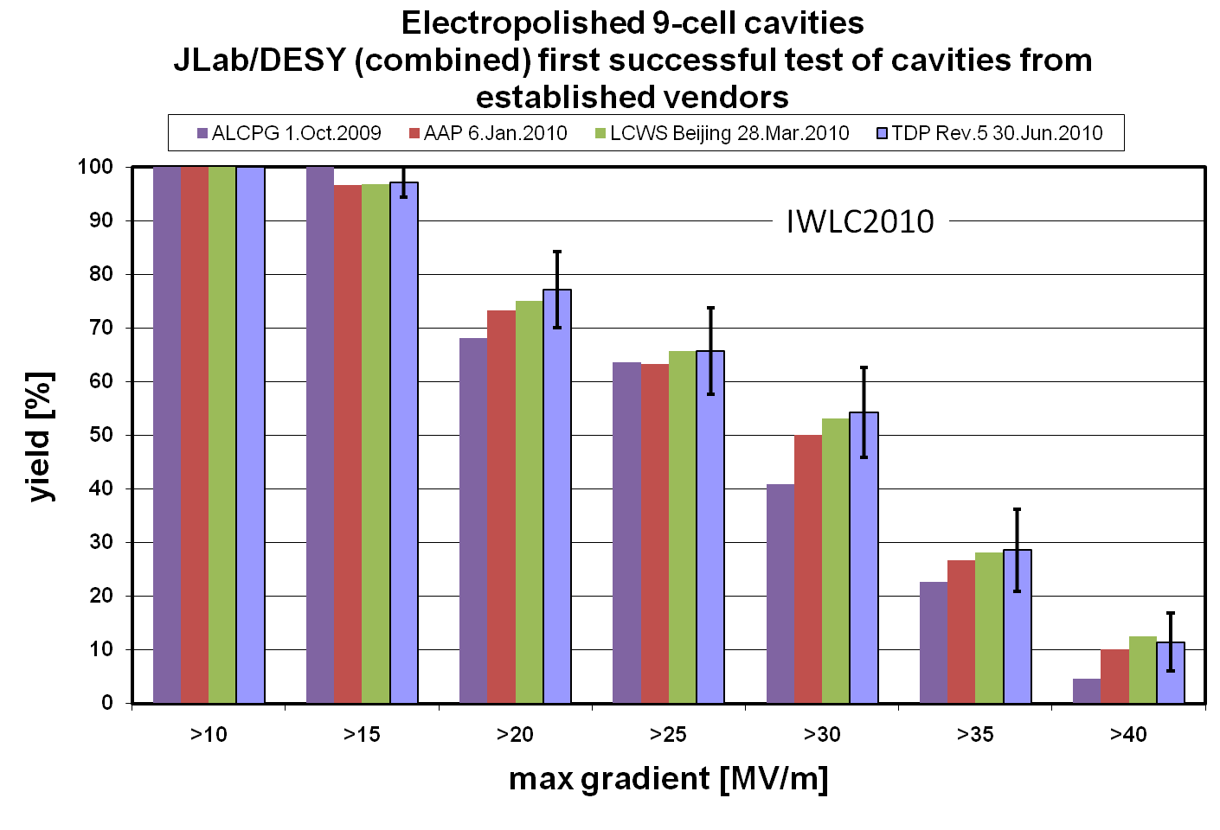
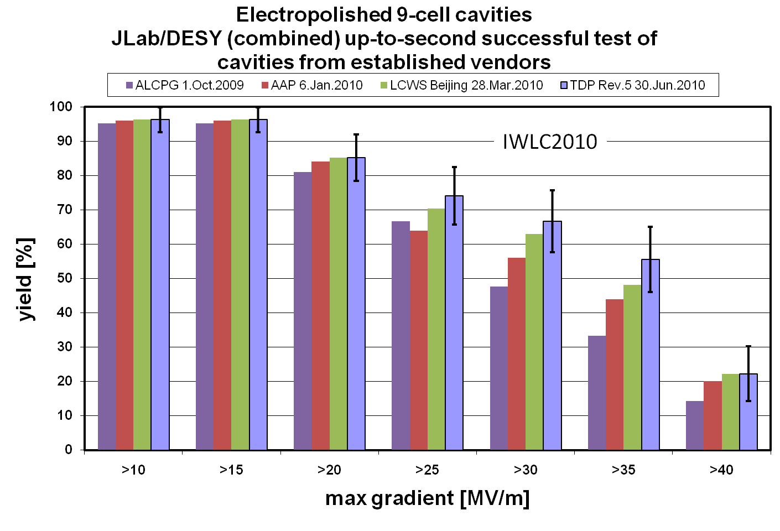
2.3.6 Reaching the TDP-1 gradient milestone of 50% yield at 35 MV/m
Optimized electropolishing and streamlined clean room assembly result in reproducible cavity gradient results. Feedback of knowledge from labs to industry responsible for improved fabrication in new industrial manufacturers.
2.3.7 Aiming at TDP-2 gradient goal and an example of 90% yield at 35 MV/m
After successful achievement of the 2010 goal of 50% production yield, the TDP-2 2012 goal remains a cavity gradient second pass yield of 90%. Though ambitious, our efforts will focus in two areas: at lower gradient, the modification of the production process to remove mechanical pits and other imperfections that now appear to be a leading cause of lower gradient quench limitations; and at higher gradients; improvement of the processing and assembly techniques that result in field emission. Though both of these efforts will start in our cavity R&D efforts with remediation of defects or emission seen in the first pass results, the goal will be to understand the problems well enough that our efforts can become predictive, rather than reactive.
For the mechanical defects, use of inspection systems such as the Kyoto camera, silicone pit modeling, or x-ray tomography to locate and categorize defects early in the production, and tracing of these defects to performance limiting locations as seen by T-mapping or second sound will require added inspection effort over the next years to create a database of defects and a more detailed understanding of the parameters that directly limit performance. For processing errors, more detailed understanding of the process itself, and the reasonable QA checks to make sure the processes are executed successfully each time, is required. This may include further tweaking of the standard process formula.
Finally, it should be noted that neither of the above R&D directions has been proven to be conclusively ‘the’ answer to the current yield limits. Current performance may be limited by another effect not yet understood, or the limitation could vary from vendor to vendor or laboratory to laboratory. Continued incremental improvements will rely on continued extensive inspections, until the exact root causes are proven.
2.3.8 Long-term cavity gradient R&D beyond TDR
Long-term R&D addresses the gradient need for the ILC 1 TeV upgrade. Aiming for gradient range of 40-60 MV/m provided by niobium cavities with improved cavity geometry and optimized material properties. Also fundamental R&D toward gradient up to 100 MV/m provided by new materials.

