2.1 Primary challenges for the SCRF Technology
2.1.1 SCRF Cavity Development
Superconducting RF (SCRF) Technology R&D is the primary global ILC technical activity during the Technical Design Phase (TDP). Underpinning the overall strategy of the R&D plan for the SCRF is the desire to produce the best possible cost-optimised solution for the Main Linac, consistent with the technology state-of-the-art. The 2007 Reference Design parameter choices for the accelerating gradient represented forward-looking goals those which could be demonstrated during a period of TDP. Excellent progress has been made in TD Phase 1 (TDP-1) towards these goals, and they remain fundamentally unchanged in TD Phase 2 (TDP−2), which also sees a shift in emphasis towards development of industrial mass-production models, for which several parameters still require either specification or review, as part of an overall exercise is cost optimisation.

The milestones for the TD Phase SCRF goals outlined are summarized in Table xx.
Table xx. Milestones for the SCRF R&D Programme
Stage | Subjects | Milestones to be achieved | Year
S0 | 9-cell cavity | 35 MV/m, max., at Q₀ ≥ 8×10⁹, with a production yield of 50% in TD PHASE 1, and 90% in TD PHASE 2 ^{1), 2)} | 2010/  2012
S1 | Cavity-string | 31.5 MV/m, on average, at Q₀ ≥ 10¹⁰, in one cryomodule, including a global effort | 2010
S2 | Cryomodule-string | 31.5 MV/m, on average, with full-beam loading and acceleration | 2012
- The process yield of 50 % in TDP-1, in the R&D Plan (release 2), has been revised to be the production yield of 50 % in the TDP-1.
- A quantitative evaluation of radiation emission is to be included in the milestone list in near future.

With the TDP R&D Plan (release 5), several key changes to the Reference Design baseline (2007 RDR) are under consideration. These are intended to allow:
- cost containment or cost reduction
- development of a project plan for industrialization of SCRF components and
- adoption to varieties of site topography.
Each of the above is an important strategic element for the GDE.
The most important baseline changes proposed are:

- Accepting a spread of cavity gradients within +/- 20 %, and a subsequent spread in cryomodule operational cavity gradients, resulting the required average accelerating gradient with the gradient spread.

The 2007 Reference Design baseline assumed that 80% of the manufactured cavities achieved a gradient ≥35 MV/m during the low-power vertical test, and that all cavities installed in the linacs operate at the same nominal gradient.
Supporting a distribution (spread) of accelerating gradients in the main linac is seen as cost effective as the choice of average accelerating gradient is the primary cost driver for the machine.
The benefit (cost effectiveness) of accepting cavity performance lower than 35 MV/m must be balanced against the need for high-performing cavities to maintain the average, and the increase cost and complexity of the increased RF power overhead, distribution system and LLRF controls, as well as the potential impact on operational gradient margin.
The specification of the cost-effective acceptable gradient spread is a TD Phase 2 deliverable.

- Specifying an operational gradient margin that would de-rate the effective gradient of an installed cryomodule in order to provide stable, controllable linac operation.

The 2007 Reference Designed assumed ~10% margin from vertical test (≥35 MV/m) to operational accelerating gradient (31.5 MV/m). This was intended to include some margin for cavity performance degradation during cryomodule installation, and controls overhead for stable heavy beam-loading operation. Both require review in TD Phase 2.
- Refining the definition of the production yield to allow a quantitative assessment of the cost-optimised accelerator gradient, ultimately supporting the adopted mass-production models and associated cost estimate.

- Redefining the baseline RF unit to reflect alternative HLRF schemes that may be better suited for a given site topography.

The 2007 Reference Design baseline RF unit (three cryomodules with 26 cavities and one focusing magnet-instrumentation package) remains a useful concept because it is half a linac FODO cell and because it is a manageable size for a beam test facility. In this section the term ‘RDR RF unit’ is refers to this subsystem.

- Allowing and promoting plug compatibility for key SCRF components within a cryomodule, potentially including the cryomodule itself.

This is a design, development and production concept that results in diverse technical approaches for these key components. A further development will be a consistent scheme for estimating the cost of a linac made from inter-changeable, plug-compatible components.

The primary R&D goals for SCRF include:
- Cavity: The primary R&D goal remains the demonstration of a field gradient of ≥35 MV/m at Q₀ = 8×10⁹ with the production yield of ≥90% in low-power vertical test (designated as S0 program).
- Cavity-integration: Plug-compatible cavity-package design and integration including tuner, input-coupler, He-vessel and magnetic shield, and the cavity string test with an average field gradient of 34 MV/m in one cryomodule (Designated as S1 and S1-global program). In parallel to the on-going effort on field gradient improvement, studies will also be made during TDP-2 of the requirements for industrialisation and mass production technologies for a future construction project, as well as a basis for the TDR updated VALUE estimate.
- Cryomodule: Plug-compatible and thermally-optimised cryomodule design and integration for cost-effective fabrication and operation. The effect of microphonics during cryomodule operation is also an important subject to be investigated.
- SCRF-system with beam acceleration: System integration and test of a string of cryomodules with a suitable RF distribution system. Demonstration of an average accelerating gradient of 31.5 MV/m on average at Q₀ = 10¹⁰ in the cryomodule operation with full beam-loading and beam acceleration (designated as S2 program).
- Cryogenics: System-engineering to realise cost-effective construction and operation. Study the coordination required to satisfy high-pressure vessel code/regulation in global cooperation.
- High-Level RF: Development of cost-effective modulator and power distribution systems capable of supporting a spread of cavity field gradients within a linac RF unit (average gradient operation). Specifically, the Klystron Cluster Scheme (KCS) and Distributed RF System (DRFS) solutions are investigated as part of the cost reduction studies, in support of a single Main Linac tunnel design.
- Main Linac Integration: Optimisation of layout and parameters of the Main Linac cryomodule string, including cavity, diagnostic, and quadrupole and alignment tolerances. Beam dynamics aspects including wake-field and HOM calculations.

Cavity gradient TDP2 R&D goal:
The interim TDP1 R&D milestone of cavity production yield, >50% at 35 MV/m (including cavities which have undergone a 2nd surface treatment and test process), has been achieved, as discussed in the cavity gradient R&D section, below. We consider strategies for gradient improvement, categorizing and prioritizing tasks leading toward the Technical Design Report (2012) and further effort beyond 2012. These are listed as:

- Short term R&D topics:
  - manufacturing process including quality control, preparation with surface treatment including a time/cost effective process such as “vertical EP”, and further studies towards the understanding and (further) reduction of field emission.
- Long term R&D topics:
  - seamless hydro-forming, large-grain with Chemical Polishing (CP), alternative cavity shapes, etc.

During the discussions, it was suggested that the current results indicate that an R&D target of 80% at 37 MV/m could be more practical; this was provoked in-part by the observation that recent cavity results indicate either gradients exceeding 35 MV/m, or much lower gradients (<25 MV/m), indicative of mechanical fabrication problems. Although the result is encouraging, it was felt that the statistics for these observations were still less sufficient to justify adopting this as the primary R&D goal. In addition, it is quite likely that the two goals listed in the table below for vertical test, (50% at ≥38 MV/m, 90% at 35 MV/m), will prove to be reasonably consistent once more statistics are gained during TDP2. For this reason, it was decided to keep the original TDP2 R&D goal of 90% at 35 MV/m (including second-pass processing). Keeping this goal underscores our emphasis on implementing quality control to sustain the high yield.

ML accelerator cavity operational gradient: Project specification
Based on the above, the ML accelerator cavity gradient specification is considered with the goal to produce a project specification which balances: 1) the required minimum cavity and cavity-string observed gradient limits and 2) the ML accelerator minimum operational gradient performance requirements. The discussion concluded as follows:

We are proposing to revise our major cavity performance guidelines to have two categories, as follows:

  - R&D goal for nine-cell cavity gradient in vertical test: ≥35 MV/m with 90% yield (with Q₀≥8E9) including 2nd pass processing and test (as needed). This infers an average gradient reasonably higher than 35 MV/m, and may be considered equivalent to ≥38 MV/m on average.
  - Project specification for nine-cell cavity gradient in vertical test: ≥35 MV/m on average with total gradient spread, of no more than ±20%.

We are also proposing to keep our best effort to realize a ML accelerator operational gradient of 31.5 MV/m, on average, with a gradient spread of no more than ±20%. An additional HLRF power margin of 10-15% will be required to support the proposed gradient spread, it may be balanced by the cost-effectiveness of accepting a gradient spread.

The summary our proposal is given in Table x.

Table x. Cavity performance specification and R&D goal.
Cost-relevant design parameter(s) for TDR | ML cavity gradient Project Specification | 9-cell Cavity R&D Goal
9-cell Cavity Gradient in Vertical Test, including 2nd pass, with Q₀≥ 8E9 | 35 MV/m, average w/ Spread: 28–42 MV/m  (≤ ±20 %) | 35 MV/m at 90 % yield  (equivalent to ≥ 38 MV/m, average)
9-cell Cavity Gradient in Cryomodule Test | 34 MV/m, average | 34 MV/m, average.  CM Gradient Test ≤ 3 %  below Vertical Test
ML  Operational Gradient  with Q₀ ≥ 1E10 | 31.5 MV/m average, w/ Spread: 25–38 MV/m  (≤ ±20%) | 31.5 MV/m, average.  Operational gradient limit ≤ 1.5 MV/m  below Cryomodule Test.  Controls margin ≤ 3 %
Required RF power overhead for control (see RF Power Table link, below) | ~10-15% (TBD)

In Table x, both the Specification and the R & D Goal are described in terms of an average cavity gradient to be achieved with an allowance for peak-to-peak gradient spread. Cavity performance is listed for two test stages, Vertical Test and Cryomodule Test, corresponding to tests done with single cavities and tests done after a cavity has been connected to a cavity string and inserted into a cryostat, respectively. The Main Linac (ML) Operational Gradient refers to the gradient at which the cavity can operate indefinitely following installation in the main linac. The table lists an R & D Goal of not more than 3% deterioration of cavity gradient from Vertical Test to Cryomodule Test, assuming the 35 MV/m with the 90 % yield to 34 MV/m on average, respectively. It also lists an R & D goal operational limit of not more than 1.5 MV/m below the limit seen in the Cryomodule Test and an operational Controls Margin gradient of not more than 3%.

    - High Power RF development with Single Accelerator Tunnel
The proposal to adopt a single tunnel solution for the Main Linac technical systems remains essentially that outlined in the SB2009 report. The original proposal was based on the utilization of two novel schemes for the HLRF:

- Klystron Cluster System (KCS). KCS has been identified as a preferred solution for ‘flat land’ sites where surface access (buildings) is not restricted
- Distributed RF System (DRFS). DRFS has been identified as being the preferred solution for mountainous region where surface access (buildings) is severely limited.

It is acknowledged that both these schemes require R&D (briefly described below). Having both R&D programmes in parallel can be considered as risk-mitigation against one or other of them failing. At the beginning of the cost-reduction studies (2008), the two primary obstacles to adoption of a single tunnel were identified as:

- safety egress
- operations and availability.

Both these issues were subsequently addressed, and the successful results reported in the SB2009 proposal (submitted December 2009).

The remaining identified issues were the technical feasibility and cost of the HLRF solutions upon which the single-tunnel proposal was based. Two components to successful adoption were identified:

- Definition of acceptance criteria for TD Phase R&D for successful demonstration of one or more of the novel HLRF schemes.
- Inclusion in the designs of a risk-mitigation strategy, whereby a fall-back to the RDR HLRF Technology solution could be adopted, should the R&D on DRSF or KCS not be considered successful. In this context, RDR HLRF Technology is defined to mean the technology based on a 10 MW multi-beam klystron (MBK) and a local rectangular waveguide power distribution system directly feeding a few cryomodules.

Technical Issues with DRFS
The basic concept of the configuration (a feasibility demonstration) will be tested this year at S1-global. A DRFS klystron has been designed and two are on order. Preparation for the S1-global test has advanced the DRFS design in 2010, generating substantial progress since January. Technical issues that remain include an evaluation of cost effectiveness (a cost estimate is due in 2011), klystron MTBF (scaled from KEKB linac S-band klystron performance), and radiation sensitivity for tunnel hardware (to be updated based on both XFEL experience and further experimental studies). Significant progress on RF power overhead analysis has been made, which has impact on the number of klystrons and the AC power requirements. Additional power margin is required to accommodate the proposed gradient spread, which is summarized in a separate recommendation. (See DRFS overview, slide 9; 800 KW is 14% more power than foreseen in RDR.)

Technical Issues with KCS
Full field tests of prototypes of all critical KCS components will be performed within the TD Phase. The stored energy in the test waveguide, which could be deposited during a breakdown test, is expected to reach about 1/6th of that available in a full ILC system discharge. A ten-meter section of waveguide and Co-axial Tap Off (CTO) prototypes have been successfully built and cold-tested in 2010. In addition, there was significant progress in understanding operational aspects. (For new estimates of the required overhead, see KCS Overview, slide 46. Neglecting RF power devoted to availability, 14% more power is needed). As above, some of this is to accommodate the proposed gradient spread, which is reviewed in a separate recommendation. Technical issues that remain include better understanding of the extrapolation of proposed tests to full system, quantification of system tolerances and assumptions (combiner etc.), and the development of an improved, detailed failure mode analysis.

RDR HLRF Technology Solution (back-up)
Two scenarios have been briefly studied for support of an RDR HLRF Technology solution in a single-tunnel:

- 10MW MBK + Modulator in the single tunnel
- XFEL-like solution with modulators (10% voltage) accessible in cryo refrigeration buildings/caverns, with long HV pulse-cables feeding 10MW MBKs (via a pulse transformer) in the single tunnel.

Both are considered technically feasible. (The latter is currently being constructed and will be operated at the European XFEL in 2014.)

It is proposed that these RDR-like single-tunnel solutions be carried forward in parallel with the proposed baseline configurations (KCS, DRFS), in enough detail to support a cost estimate (incremental). This estimate, together with the scope of the re-design work necessary to adopt one of the scenarios, will be factored into the TDR Risk Assessment. The main R&D and AD&I effort will continue to pursue the preferred baseline solutions, KCS and DRFS. In order to reduce the number of scenarios to be supported, we propose to phase out one of the RDR HLRF Technology scenarios within the next six months.

2.2 Development of World-Wide infrastructure (5 pages, Mark Champion, Hitoshi Hayano, and Detlef Reschke)

NML Facility at Fermilab
Mike Church, Sergei Nagaitsev
Fermilab
Fermilab is currently constructing the “SRF Test Accelerator at the New Muon Lab” (NML). NML consists of a photo-emitted RF electron gun, followed by a bunch compressor, low energy test beamlines, SCRF accelerating structures, and high energy test beamlines. The initial primary purpose of NML will be to test superconducting RF accelerating cryomodules for the ILC and for Fermilab’s “Project X” – a proposal for a high intensity proton source. The unique capability of NML will be to test these modules under conditions of high intensity electron beams with ILC-like beam parameters. In addition NML incorporates a photoinjector which offers significant tunability and especially the possibility to generate a bright electron beam with brightness comparable to state-of-the-art accelerators. This opens the exciting possibility of also using NML for fundamental beams research and tests of new concepts in beam manipulations and acceleration, instrumentation, and the applications of beams.

Building infrastructure – cryogenics, electrical power, RF power, water cooling, electronics racks, shielding, etc. are currently being installed. A single SC cavity is currently installed and tested, and a single SCRF cryomodule (type “TTF III+”) is in the building and cooldown is expected to commence in November, 2010. The electron gun will be installed and commissioned starting in January, 2011. Beamline construction will start in late CY2011 and we expect to start delivering beam in late CY2012.

The injector beamline is shown in Figure 1. It consists of a 1.3 GHz RF photo-emitted electron gun, followed by 2 SCRF accelerating cavities, a bunch compressor and beam diagnostics. The primary injector beamline will operate at ~40 MeV and is ~22 m in length. It will be capable of producing ILC-like beam structure: bunch charge = 3.2 nC, 3 MHz bunch repetition rate, bunch train length = 1 ms, 5 Hz bunch train repetition rate, and peak current in excess of >10 kA. Single bunch charge can be well over 20 nC. In addition, there is floor space for 2 reconfigurable 40 MeV test beamlines for a variety of experiments.

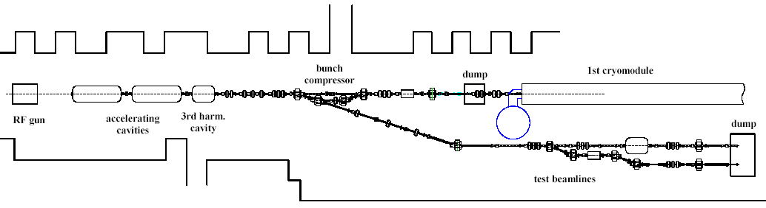
Figure 1: Injector beamline layout.

The acceleration section will initially consist of 3 ILC-type SCRF cryomodules (a single ILC “RF unit” powered by a single 10 MW klystron), capable of accelerating beam to ~750 MeV. A building expansion, almost completed, will allow for a total of up to 6 cryomodules and up to ~1500 MeV beam energy. A plan for the high energy downstream beamlines is shown in Figure 2. There will be floor space and infrastructure available for up to 3 high energy test beamlines (18 – 34 m in length) and a storage ring up to ~10 m in diameter. High energy beam dumps are being designed to absorb the 75 KW of beam power.

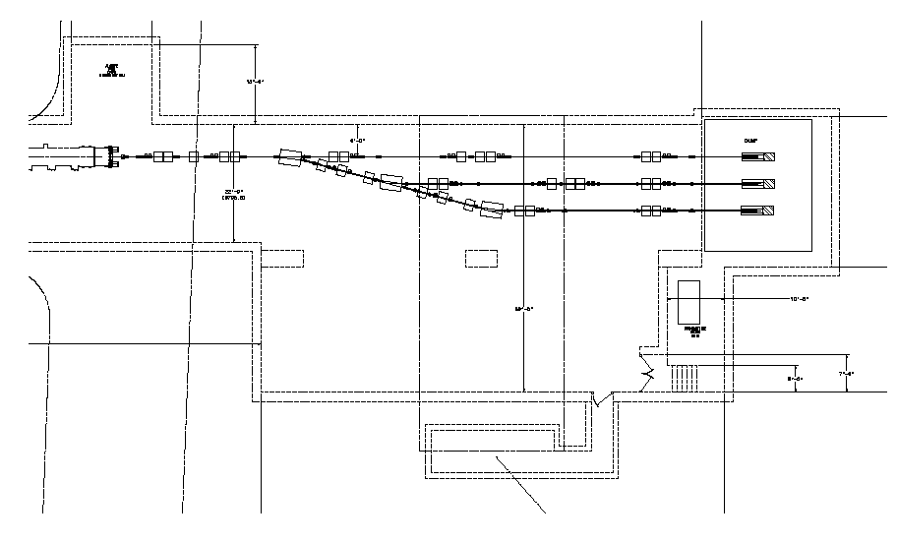
50’
10m
100 KW dump
spectrometer
cryomodule
matching section
Figure 2: High energy beamline layout.

In summary, in addition to providing realistic tests of a new generation of RF cryomodules, the new NML facility offers excellent opportunities to advance ILC system integration tests, as well as the accelerator science and technology on several fronts. Eventually, NML will become a truly open users’ facility with unique capabilities to advance accelerator research by groups from various institutions, to enhance accelerator education and to promote accelerator technology development for industrial applications.

---

Superconducting RF Test Facility (STF) at KEK
ILC cryomodule development, test and integration into the accelerator are performed in STF at KEK. Equipped 100m length of accelerator tunnel is the place of cryomodule test and system integration. The three high power RF power stations and cryogenics plant for the cryomodule are in the surface building of 60m x 30m dimension.

Cryomodule Test in STF Phase-1
The STF phase-1 test cryomodule consist from the two units of 6m horizontal cryostats which are the half length of ILC design, and each of them can accommodate 4 cavities. The type A 6 m cryomodule is designed to accommodate TESLA-style cavities, and the type B 6 m cryomodule is for low-loss (LL) cavity. The cool-down test was carried for the one TESLA-style cavity in the cryomodule A, one LL cavity in the cryomodule B in early 2008. Another cool down test using 4 TESLA-style cavities in cryomodule A was followed in 2008, also. One of the cavities out of four reached to 31.5 MV/m, ILC operation gradient. Other three were stayed around 20 MV/m. The study of LD (Lorentz Detuning) measurement and compensation, and the stabilization of field amplitude and phase of cavities were demonstrated by digital feedback controll using piezo actuator LD compensation. The demonstrated stability of amplitude was 0.04 %rms and phase 0.02 degree.rms. These stability performances are well below the specification of ILC. Several trials for LLRF ( Low-level RF control ) and power distribution were performed, such as simulated beam loading signal mixture, special filtering technique and IF ( Intermediate frequency ) -mixture ADC detection, QL ( loaded Q-value ) control by waveguide short and phase shifter, etc.

S1-Global Cryomodule test
The idea of the S1-Global is to realize ILC operational gradient 31.5 MV/m in the one cryomodule (8 cavities) by international research collaboration using world top-level performance cavities. The eight cavities were contributed from FNAL, DESY and KEK, and installed in two ‘half length cryomodules’ each 6 m long. A new one was designed and constructed by INFN, and a modification was made for the existing 6-m STF cryomodule A by KEK. They are connected in the STF tunnel as shown in figure 1. The assembly was started in January 2010, and cool down test was started in June 2010. The series of experiment are now on-going. We found the averaged maximum gradient in the cryomodule operation was 28MV/m, where the maximum averaged gradient in cavity vertical test was 30MV/m, as shown in figure 2. LD characteristics for 4 kind of tuner system are also measured in each cavity, and new LD compensation scheme was tried. Their performance result is now under analysis. The thermal performance study, tuner performance study, cavity high gradient operation by vector-sum control, LD compensation by RDR scheme, and DRFS ( Distributed RF System ) test are planned toward February 2011.

Figure 1: S1-G cryomodule and cavity package of each laboratory. (a): FNAL cavity with Blade tuner, (b): DESY cavity with Saclay-type tuner, (c): KEK-a cavity with slide jack tuner and (d) KEK-b cavity..

Figure 2: Cavity performance in the S1-G cryomodule. Blue bars show the gradient measured by vertical test, and red bars show the achieved gradient in the cryomodule. Their average gradient were 30MV/m and 28MV/m each.

Development plans of STF phase-2
The planned STF phase-2 accelerator is illustrated in figure 3. The new power scheme of DRFS which is proposed for single tunnel design in mountainous site, will be demonstrated, instead RDR power scheme. They consist of two ILC cryomodules driven by 9 DRFS klystrons, a photocathode RF gun driven by a 5MW klystron, and two 9-cell cavities capture module driven by a DRFS klystron. On a way of phase-2 construction, the compact X-ray source development is included in the commissioning of the beam source part of phase-2 accelerator.
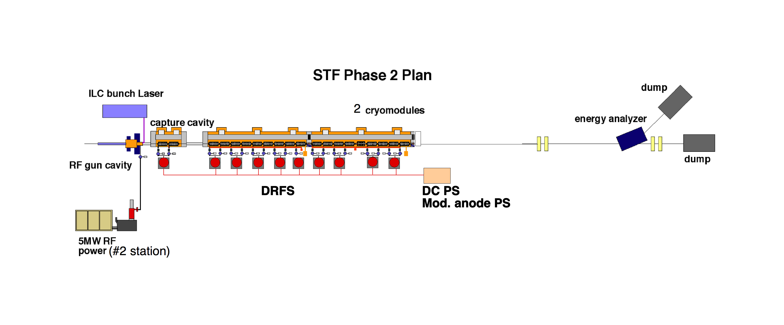
Figure 3: STF phase-2 accelerator diagram using DRFS power scheme.

The procurement of two cavities for the capture cavities and 9 cavities for the first cryomodule was started in 2009. The fabrication of the cavities which must follow the high pressure gas regulation independent with the cryomodule and refrigerators was already permitted, and the fabrication was started. It will take 2 years for the production complete.
The beam source development to build the photocathode RF gun system has major step forward in 2010. The RF gun cavity and the input coupler were fabricated and delivered to STF by the development of DESY-FNAL-KEK team through US-Japan collaboration program, on November 2009. After minor modification to the cavity water jacket and beam pipe flange, the pumps, solenoid, waveguide, RF window and the Cs2Te photocathode system are assembled into the gun cavity. RF process of the cavity was done up to 2MW input without serious problem. The drive laser for the photocathode was also developed and delivered from IAP and JINR of Russia. The laser system is the collaborative development between KEK-IAP-JINR from 2007. The laser generates 10ps pulsed UV light (266nm) with 3MHz repetition during 1ms RF pulse with 5Hz klystron repetition. The extracted electron charge in one bunch will be 3.2nC, which is ILC specification.
After finished the X-ray generation experiment, the first ILC cryomodule will be installed in STF tunnel by the end of 2012. The second run of the phase-2 accelerator is scheduled from January 2013 to July 2013. In the meantime, the rest of cryomodules will be in preparation. Also the rest 9 cavities will be fabricated and processed in parallel way, in order to catch up the second cryomodule installation.

-----

Development of Infrastructure at STF SCRF
For the cavity treatment at STF, the new electro-chemical polishing (EP) facility was constructed and became operational in 2008. The system includes EP system, BCP ( Buffered Chemical Polish ) utilities for the small parts and flange surface, ultra-sonic rinsing, high pressure rinsing system (HPR) and clean room for cavity assembly. The optimization study of the EP system and rinsing system is continuously performed after the commissioning. 10 channels of temperature monitors were attached on the various points of the cavity surface in every EP treatment during EP and water rinsing in order to keep the temperature below 35 degree. The current density of EP also tried to optimize by setting 30 to 35 mA/cm2 for reasonably low current density to suppress sulfur generation. The solution ingredient during ultra-sonic rinsing in order to remove sulfur particles out from the cavity surface were surveyed. The detergent FM-20 of 2% is now used, as a result of survey. Washed out water from HPR is routinely monitored by particle counter and TOC (Total Organic Component) for the contamination monitoring.
The vertical test stand (VT) for the cavity field test is also commissioned in 2008. The first 4m depth of cryostat was installed in the STF building floor together with radiation shielding and helium pumping system. The VT test is routinely operated once in a week by using 2000 litter helium Dewar for the cooling. The temperature mapping system and X-ray mapping system are used for the every vertical test cavities. The 352 carbon resister temperature sensors and 142 PIN diodes X-ray sensors are installed around each cell and end group HOMs. The temperature rise and X-ray intensity are summarized as map plots in a real time manner, in order to identify heat spot easily, and easy to think the connection with followed surface inspection, as shown in figure 1.

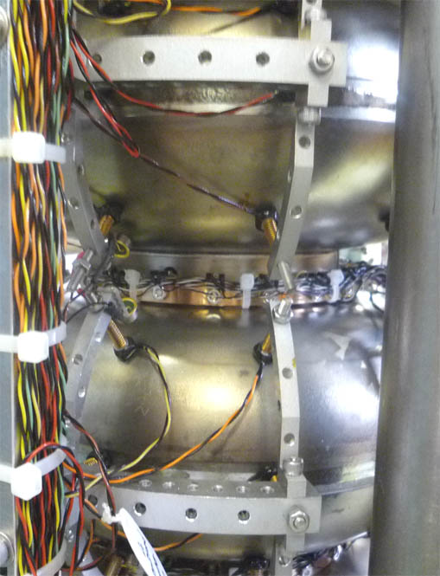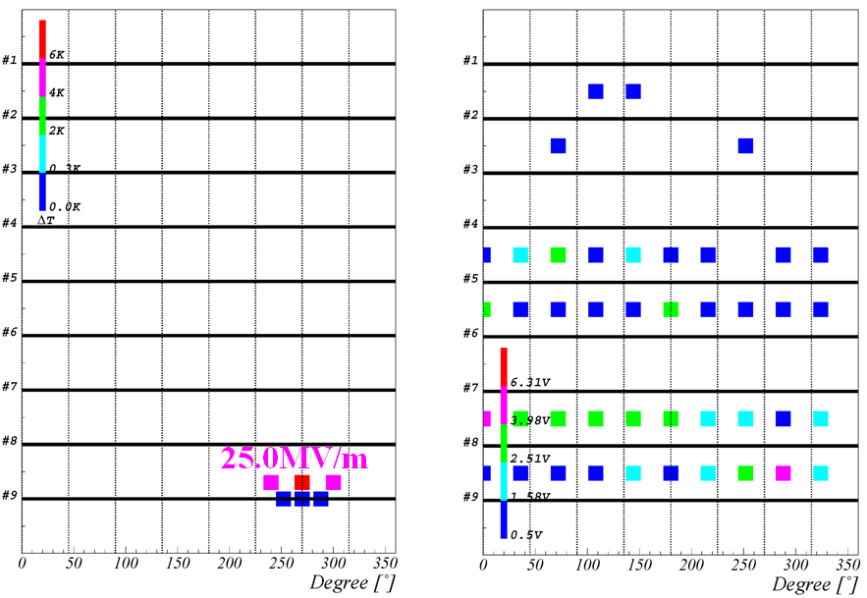
Figure 1: Temperature mapping inspection in the cavity vertical test. Picture of sensor installation (left) and temperature rise mapping and X-ray intensity map result (right) are shown.

The development and upgrading of cavity surface inspection camera was done by the collaboration with Kyoto University. Newly developed high performance C-MOS camera and LED illumination combination brought more high resolution, 10 times brighter and much more long life illumination. Also, in order to inspect various style of cavity like EP-jig installed or helium jacket installed, the camera cylinder rotation was developed instead of cavity rotation. Automated image capturing and defect finding software was developed and under optimization.

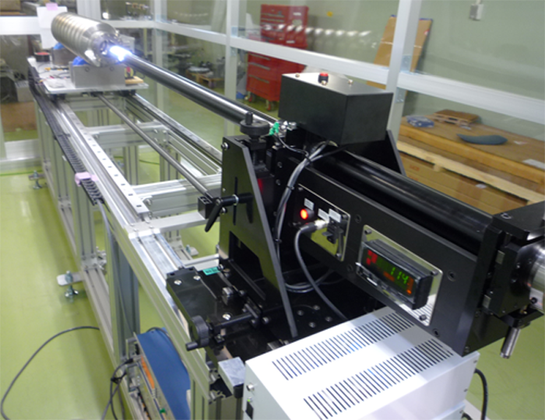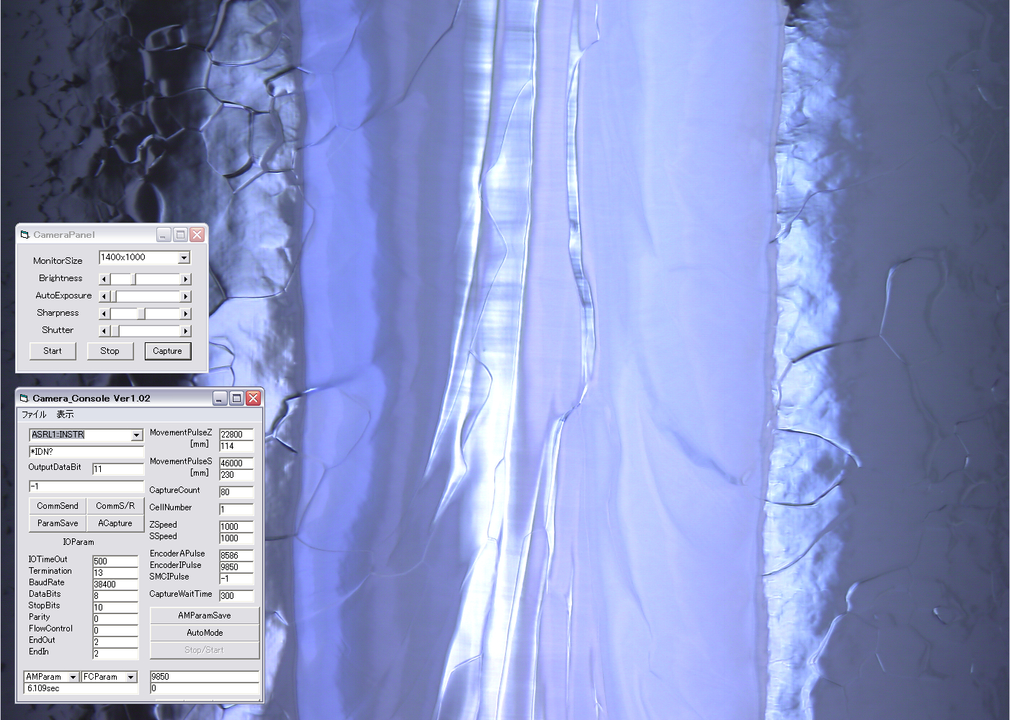
Figure 2: Improved inspection camera (left) and automated image capture software (right) are shown.

The surface repair tool for cavities, in case that the cavity has clear defects inside and its performance is limited by these defects, is required. Enough small grinding mechanics fitted to 78mm diameter of the cavity with very small CCD observation camera shown in figure 3, together with progress of molding or replica technique to get precise information of defect inside, make the repair possible recently at STF. One of good example is the case of “MHI-08” 9-cell cavity. The pit type defect (0.7 mm x 0.5 mm of size and about 115 µm depth) was found by the inspection camera at the quench location in16 MV/m. After grinding and 50µm removal EP, the gradient performance was improved to 27 MV/m without heating at the grinding location. After additional two more EP, 38MV/m of the performance was attained in the 4th field test.
Figure 3: Local grinding tool with expandable motor stage from 50mm diameter cylinder tube

The automated cavity tuning machine is now under installation in STF. The tuning machine was developed under DESY-FNAL-KEK collaboration. The machine has a capability of field flatness tuning and cell-to-cell bending correction by linked operation of the automated software, bead-pull, 6 jaws cell deforming, and cavity eccentric measurement system. Two hours cavity tuning will become possible after the machine commissioned.
The cavity fabrication facility was planned for the fabrication industrialization study in KEK. To lead the industrialization technology development, R&D has to be done by the laboratory initiative and in the laboratory place. The facility in KEK will equip electron beam welder (EBW), trimming machine, press machine and chemical room. The EBW will deliver in March 2011, however, the press machine and the trimming machine were already installed and commissioned in 2010. The fabrication studies for industrialization was started for cell fabrication and end group parts fabrication. In order to reduce machining step, use of press machine for the various fabrication process is now investigating. Cultivation of new industries is also promoted in this R&D. The fabricated cavities from this facility will be used in the ILC cryomodule assembly, and tested in STF by 2013-2014.

2.3 Progress towards reproducible manufacture of high-gradient cavities (8 pages – Rongli Geng, Camille Ginsburg/Jim Kerby. ..)

2.3 Progress towards reproducible manufacture of high-gradient cavities
R.L. Geng, C. Ginsburg, J. Kerby
RG Rev. November 4, 2010
2.3.1 Introduction
The gradient choice for the ILC superconducting radio-frequency (SRF) cavities is important for the beam energy reach and the machine cost. At the time of RDR publication, a choice of 35 MV/m was made for cavity vertical qualification test. This choice was supported by the demonstration of ≥35 MV/m in several 9-cell TTF-shape cavities by a DESY-KEK collaboration.
Achieving 35 MV/m in 9-cell cavities reproducibly is important as the total number of cavities required for the ILC is far more than any SRF based machines built or planned. A global R&D program (S0 program) was established in 2006 to address this challenge. The S0 program, coordinated by the GDE cavity group, has broad global participation from ANL, Cornell, DESY, FNAL, JLab, and KEK. Significant progress in understanding the gradient limit and gradient scatter has been made by instrumented cavity testing at cryogenic temperatures and high-resolution optical inspection of the cavity RF surface. At the time of RDR, Europe was the only region having demonstrated 35 MV/m cavity fabrication and processing. Today, 35 MV/m cavity fabrication and processing have been demonstrated also in Asia and America region. A solid SRF technology base for the ILC on a global scale is now in place.
The global investments in ILC gradient R&D are rewarded not only by improved gradient yield and reproducibility but also an extended gradient envelope. By mid 2010, a major SRF gradient R&D milestone of 50% yield at 35 MV/m has been achieved. The average gradient in the state-of-the-art 9-cell cavities is raised to ~ 40 MV/m, a 5 MV/m increase as compared to the then state-of-the-art of 35 MV/m in 2005.
2.3.2 Globally coordinated gradient R&D program – S0 program
The ILC gradient R&D is a global effort with participation of ANL, Cornell, DESY, FNAL, JLab, and KEK. Information is exchanged regularly at the monthly GDE cavity group meeting. Cavities are exchanged across the labs and regions. There are growing interests and capabilities of cavity gradient R&D in other labs such as IHEP, PKU, and TRIUMF. Encouraging cavity results are emerging. From history, these R&D initiatives usually drive industrial interest and capability for SRF cavity manufacture and processing. A global SRF enterprise is rising because of the driving force by the ILC gradient R&D.
2.3.3 Understanding the source of gradient limit and scatter and “feedback loop”
Source of field emission is now understood. Besides the traditional particulate field emitters, niobium oxide granules is found to be a major field emitter introduced by the electropolishing process itself. Source of quench limit at < 25 MV/m is understood to be caused by highly localized geometrical defect near the electron beam welded joint at the cavity equator. These information is feedback to cavity processing and fabrication procedures and resulted in improved gradient results.
2.3.4 Progress in reproducible processing of high-gradient cavities
Cavity inner surface “auto rinsing” by continued electrolyte circulation after the EP voltage is shut off and improved post-EP cavity cleaning reduces field emission.
2.3.5 Gradient yield definition and global cavity result database
In the RDR goals of a 50% process yield by 2010 and a 90% production yield were defined at 35MV/m with a Q0 of greater than 8e9. As the Technical Design Phase of the ILC progressed, the need for a clear definition of what the gradient yield is was recognized, and the need for a globally consistent and available database for recording test results was recognized. In 2009 the ILC Global Cavity Database Team was created as a part of the S0 effort. The team included members from Fermilab, DESY, Jlab, Cornell, and KEK, and took on the task of not only creating the database, but also defining the rules for how the data should be included, and how the data would be presented. The results of this effort are a clear, objective, and publicly accessible database where the progress of cavity R&D can be tracked. In fact since mid 2009 the database group has done just that, presenting status at each major ILC workshop, meeting or review.
The most recent results for first pass and second pass results, presented in a time phased manner at the IWLC2010 meeting in Geneva, Switzerland, are shown below. By way of definition, plots only includes results from a vendor / laboratory combination who have previously demonstrated through test the ability fabricate and process a cavity that achieves > 35MV/m in a vertical test. A first pass result is one where the fabrication and processing have been completed according to the standard recipe leading up to the first test; a second pass result sums all first pass results greater than 35MV/m and second pass results where the a poorer performing cavity had some remediation applied based on diagnostics from the first test. Apparent from the graphs is the improvement with time of the yield curves, particularly for second pass results. This improvement is attributable to improved diagnostic and remediation tools that have been developed in the past years. A smaller gain is seen in the first pass results. This is consistent with our limited ability to recognize fabrication flaws early in fabrication by means other than vertical testing; improvement of our understanding of the critical fabrication parameters and the development of predictive quality assurance checks are an R&D direction in the upcoming TDP phase.

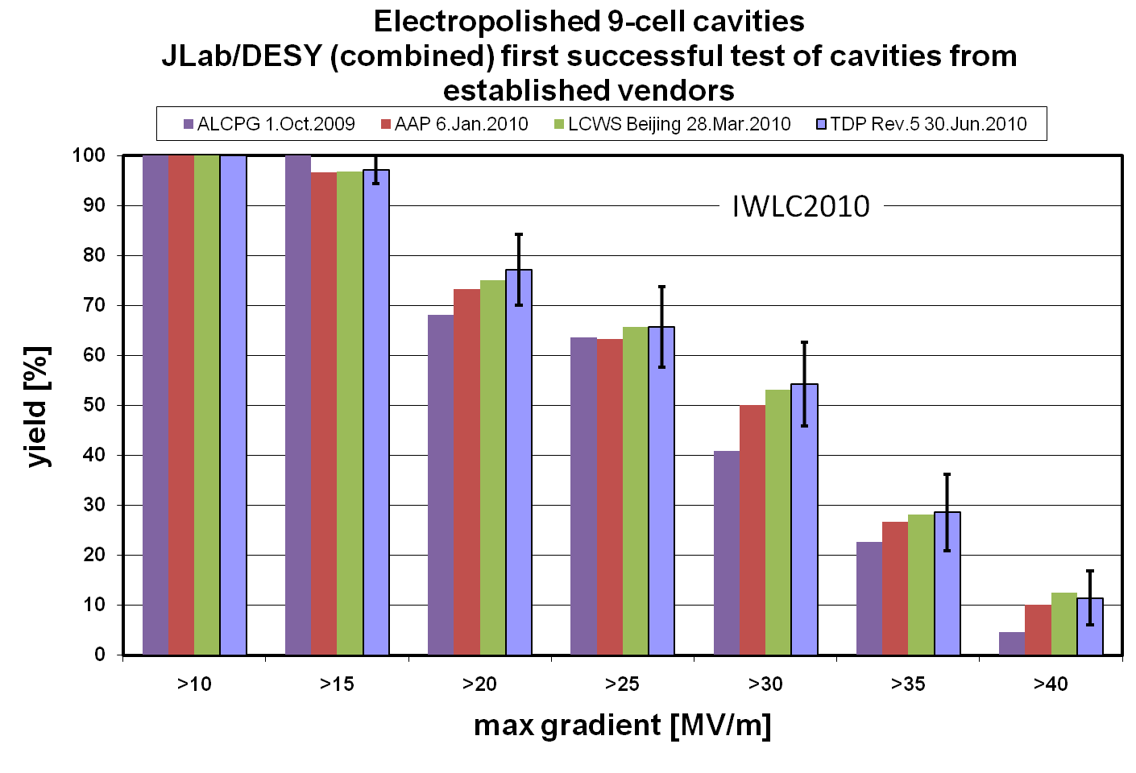
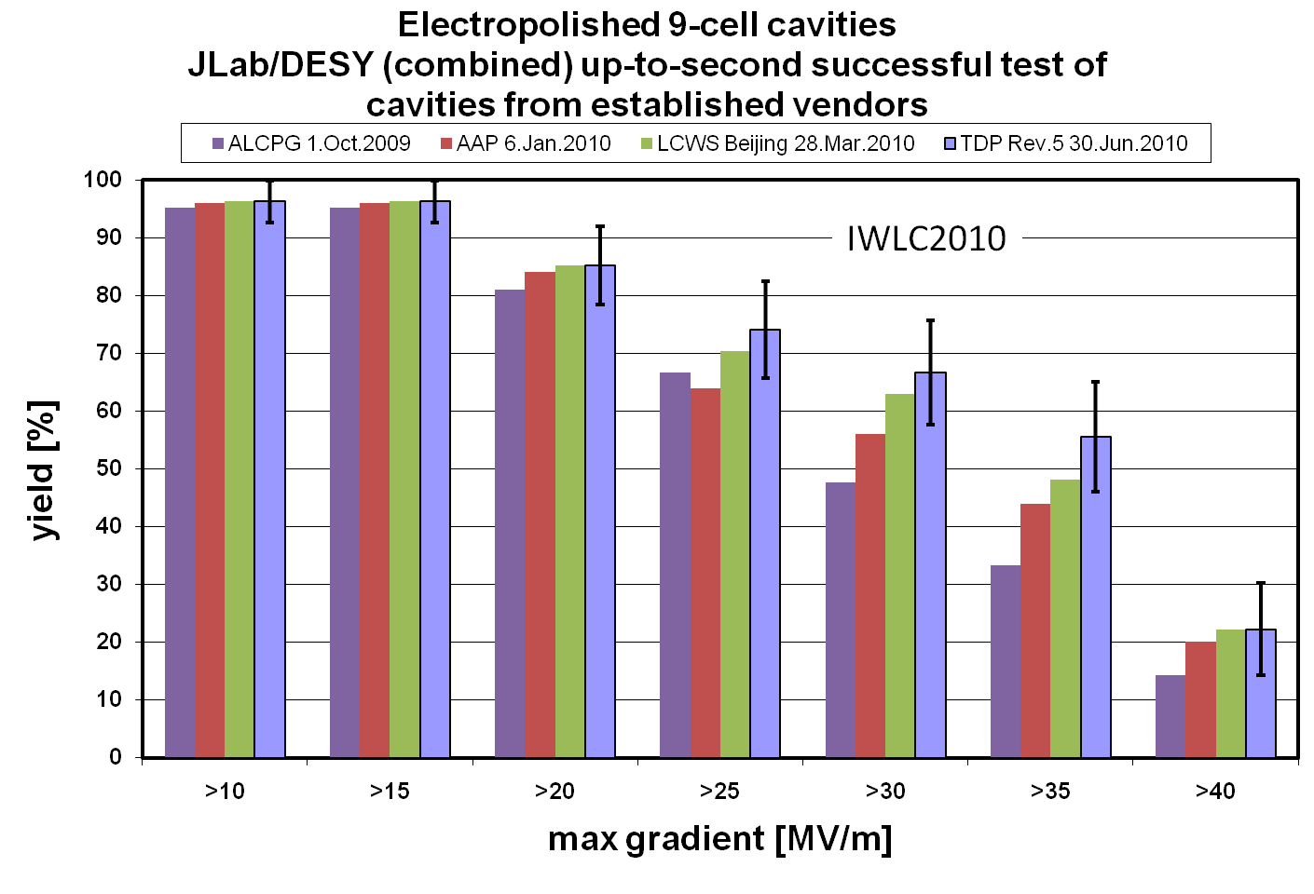
2.3.6 Reaching the TDP-1 gradient milestone of 50% yield at 35 MV/m
Optimized electropolishing and streamlined clean room assembly result in reproducible cavity gradient results. Feedback of knowledge from labs to industry responsible for improved fabrication in new industrial manufacturers.
2.3.7 Aiming at TDP-2 gradient goal and an example of 90% yield at 35 MV/m
After successful achievement of the 2010 goal of 50% production yield, the TDP-2 2012 goal remains a cavity gradient second pass yield of 90%. Though ambitious, our efforts will focus in two areas: at lower gradient, the modification of the production process to remove mechanical pits and other imperfections that now appear to be a leading cause of lower gradient quench limitations; and at higher gradients; improvement of the processing and assembly techniques that result in field emission. Though both of these efforts will start in our cavity R&D efforts with remediation of defects or emission seen in the first pass results, the goal will be to understand the problems well enough that our efforts can become predictive, rather than reactive.
For the mechanical defects, use of inspection systems such as the Kyoto camera, silicone pit modeling, or x-ray tomography to locate and categorize defects early in the production, and tracing of these defects to performance limiting locations as seen by T-mapping or second sound will require added inspection effort over the next years to create a database of defects and a more detailed understanding of the parameters that directly limit performance. For processing errors, more detailed understanding of the process itself, and the reasonable QA checks to make sure the processes are executed successfully each time, is required. This may include further tweaking of the standard process formula.
Finally, it should be noted that neither of the above R&D directions has been proven to be conclusively ‘the’ answer to the current yield limits. Current performance may be limited by another effect not yet understood, or the limitation could vary from vendor to vendor or laboratory to laboratory. Continued incremental improvements will rely on continued extensive inspections, until the exact root causes are proven.
2.3.8 Long-term cavity gradient R&D beyond TDR
Long-term R&D addresses the gradient need for the ILC 1 TeV upgrade. Aiming for gradient range of 40-60 MV/m provided by niobium cavities with improved cavity geometry and optimized material properties. Also fundamental R&D toward gradient up to 100 MV/m provided by new materials.

2.4 Cryomodule design and development (5 pages, Norihito Ohuchi, Paolo Pierini, Tom Peterson )

Cryomodule Design and Development
Norihito Ohuchi, Paolo Pierini and Tom Peterson

Most of the effort and resources spent on the ILC cryomodule activities since the publication of the RDR and the beginning of the Technical Design Phase has been devoted to the collaborative S1-Global program. Taking advantage of the experimental activities at KEK in the framework of this worldwide effort, several other ILC cryomodule design issues have been addressed, like the assessment of the thermal performance of the intermediate 5 K shields and the investigation of several tuner and magnetic shielding solutions. The experience gained from S1-Global, which integrates different variations of components (e.g. cavities, magnetic shielding, couplers and tuners) from several collaborating partners into a single cryomodule, is also very important for the assessment of all the "plug-compatible" interfaces of the cryomodule for the future ILC plans.

1) Construction and cold tests of S1-Global cryomodule
The S1-Global [1] project is dedicated to the realization of the S1 R&D objective within an international research collaboration. The ‘Realization of an average accelerating gradient of 31.5 MV/m with 8 cavities’ in the S1-Global (S1-G) cryomodule, composed of components contributed by the different collaborating partners, is the primary goal.
The general schedule for the S1-G project is shown in Fig. 1. The cryomodule design work started in May 2008 with the joint team of INFN, FNAL and KEK, and the design of this cryomodule was completed at the end of 2008. The S1-Global cryomodule consists of two 6-m cryomodules, Module-A and Module-C, shown in Fig. 2. Four cavities from FNAL and DESY are installed in Module-C, and four cavities in two different flavors of cavity-jackets developed by KEK are installed in Module-A. The total length of the S1-Global cryomodule is 14.9 m. The parameters of the two 6-m cryomodules are listed in Table 1. During 2009, INFN procured the Module-C components, KEK performed the modification of Module-A from one of the original STF modules [2], and DESY, FNAL and KEK produced and tested the 8 cavities and couplers needed for the S1-Global program. The S1-G cryomodule was assembled and installed in the KEK-STF tunnel during January to May 2010. At present, the cold tests are scheduled from June to December 2010. Figure 3 shows a picture of the completed S1-G cryomodule in the tunnel.
The contributions of the participating laboratories demonstrate the collaborative framework of S1-G:
- INFN: Design and construction Module-C and production of the blade tuners for the FNAL cavities.
- FNAL: Two TESLA type cavities [3], power couplers and integration of the INFN blade tuners in the cavity packages.
- DESY: Two TESLA type cavities, including Saclay-type tuners, and power couplers.
- SLAC: Two sets of VTO power distribution for Module-C, and processing of FNAL couplers.
- KEK: Four TESLA-like cavities, with two variations of tuner/jacket design, Module-A for KEK cavities, power distribution for Module-A, and infrastructure for tests.
In addition to the main target of demonstrating an average accelerating gradient of 31.5 MV/m with 8 cavities during the cryomodule testing, the S1-G program has the following R&D goals:
- The operation at an average accelerating gradient of 31.5 MV/m in pulsed RF conditions at 5Hz with 1 ms flat-top length, under stable conditions: 0.07% rms amplitude variation and 0.35 degree rms phase variation [4].
- To gain experience with the design, assembly and the alignment procedures for different types of cavity packages from participating parties.
- The measurement and comparison of the cryogenic performance for each cavity package and cryomodule (in terms of heat loads to the 2 K environment), in the static and high accelerating field dynamic conditions.
- The comparative studies of RF performances of the cavity packages (including tuner concepts) from the participating institutes.
- An advancement in the implementation of the ‘plug-compatible concept’ for the ILC activities.

The S1-G cryomodule has been so far cooled down to 2 K two times, and the temperature changes of all the cavities at the second cool-down are shown in Fig. 4. The cold tests of S1-G cryomodule are ongoing, and the summary report of the experimental activity will be reported after the completion of all scheduled tests.

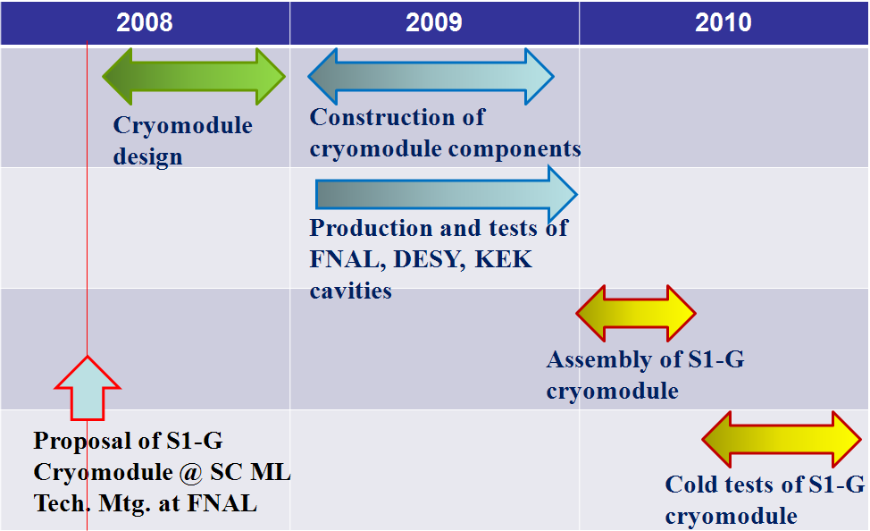
Figure 1: General schedule of S1-Global project.

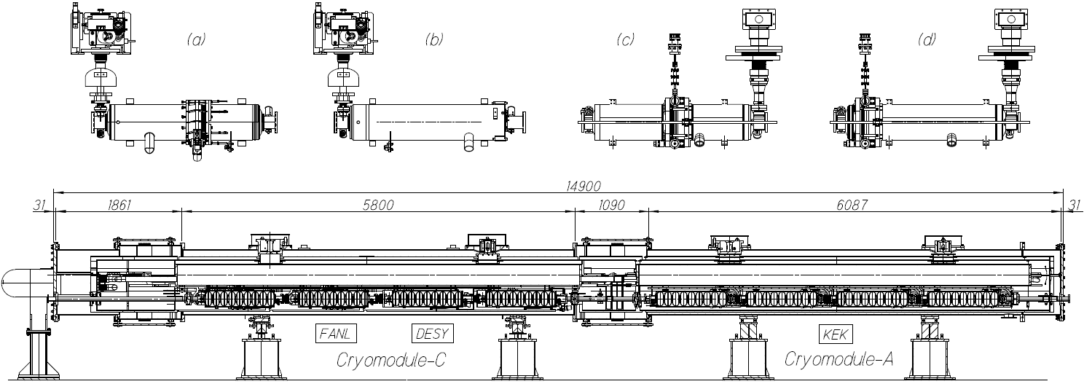
Figure 2: S1-G cryomodule and cavity package of each laboratory. (a): FNAL cavity with INFN Blade tuner, (b): DESY cavity with Saclay-type tuner, (c): KEK-a cavity with slide jack tuner and (d) KEK-b cavity.
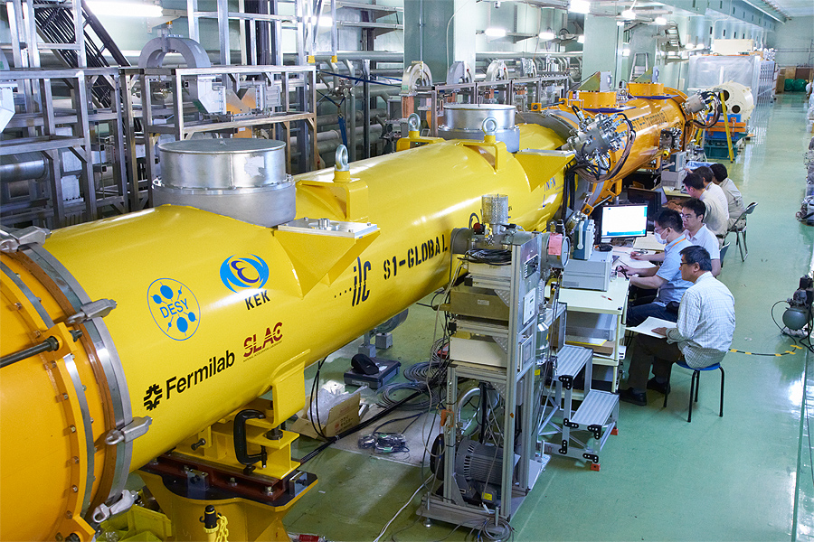
Figure 3: Completed S1-G cryomodule, in cold and low power test.

Table 1: S1-Global Cryomodule Parameters
 | Module-A | Module-C
Vacuum vessel length | 6087 mm | 5800 mm
Vacuum vessel O.D. | φ 965.2 mm | φ 965.2 mm
Gas return pipe length | 5830 mm | 6000 mm
Gas return pipe O.D. | φ 318.5 mm | φ 312.0 mm
2K LHe supply pipe O.D. | φ 76.3 mm | φ 76.1 mm
5K shield pipe O.D. [F/R] | φ 30/φ 30 mm | φ 60/φ 60.3 mm
80K shield pipe O.D. [F/R] | φ 30/φ 30 mm | φ 60/φ 60.3 mm
Cool-down pipe O.D. | φ 27.2 mm | φ 42.2 mm
Distance between couplers | 1337.0 mm | 1383.6 mm
Cavity package | KEK-a/KEK-b | FNAL/DESY
Cavity type | TESLA-like | TESLA-type
Tuner type | Slide jack | Blade/Saclay
Input coupler type | Disk window | Cylindrical window
Magnetic shield | Inside jacket | Outside jacket
Package length | 1247.6 | 1247.4/1283.4

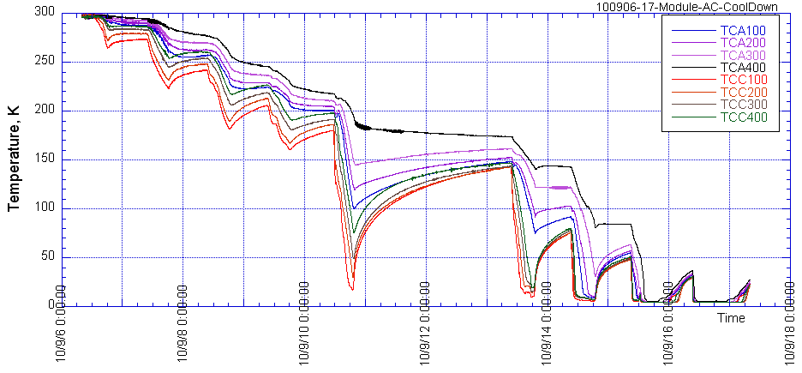
Figure 4: Cooling condition of 8 cavities at the second test term

2) 5K shield thermal performance test
The specific heat loads in the three cryogenic circuits of one ILC cryomodule (at the temperature levels of 2 K, 5 K and 40 K) are listed in Table 2, calculated from the values of one RF unit as shown in RDR [4]. In the 5 K circuit, the heat load by thermal radiation was evaluated to be at 1.41 W. The present ILC cryomodule scheme, derived from the TESLA Test Facility cryomodules [5], has two thermal shields circuits. The “5K” circuit contains helium pressurized above the 2.3 bar critical pressure which warms from 5 K to 8 K through the circuit. The “40 K” circuit contains helium warming from 40 K to 80 K. In case of removing the 5 K thermal radiation shield, investigated as a means to simplify the module and decrease the fabrication costs, thermal radiation from 40 K screen would directly impinge into the 2 K region, increasing sensibly the module 2 K heat load. However, by modifying the 40 K thermal shield flow scheme as shown in Fig. 5 [6] and by rearranging the thermal intercept strategy, this additional contribution could be mitigated. The improvement is obtained by using the forward line to lower the temperature of the thermal shield from 74 K to 46 K while using the return (warmer) line to provide the thermal intercepts of input couplers and current leads, thus increasing the average intercept temperature from 54 K to 66 K. With this thermal strategy, different with respect to the TTF modules, the radiation heat load from the 46 K shield towards the lower temperatures is reduced to 0.22 W. Therefore, in this case the removal of the 5 K level thermal radiation shield increases the heat load at 2 K only by this amount.
In order to have a confirmation of this analysis, an experimental study of the 5 K shield was performed with the 6-m long KEK-STF cryomodule [7]. The design of the KEK-STF cryomodule is based on the TTF-III cryomodule, with similar components and two thermal shields at 5 K and 80 K. Cross sections of the KEK-STF cryomodule are shown in Fig. 6. In order to measure the 2 K heat load at the cavities, four dummy cavity vessels were installed in the cryostat. The heat load on these four dummy jackets was measured first with the full 5 K shield installed and then after the removal of the lower portion of the 5 K shield. The parameters of the test cryomodule are listed in Table 3. The measured data were compared with thermal calculations.

Table 2: Heat Loads of one ILC cryomodule from RDR
 | 2 K | 5 K | 40 K
Static, W | 1.7 | 10.6 | 59.2
Dynamic, W | 9.7 | 4.4 | 94.3
Total, W | 11.4 | 15.0 | 153.5

The four dummy cavity jackets are supported from the gas return pipe with C-clamps and roller-bearings, in the same way as the real cavity helium vessels. These dummy jackets have the same size as the 9-cell cavity jacket in order to expose the same cold surface to the thermal radiation from the surrounding environment. The length of the dummy vessel is 1057 mm, and the outer diameter is 236 mm. Each dummy vessel contains 43.3 liters of liquid helium. The bare surfaces of the dummy jackets were exposed to the thermal radiation impinging from the shields while the gas return pipe was wrapped with 5 layers of multi-layer insulation, to minimize the radiation load. The thermal shields of the module are composed of several parts and, in order to evaluate the thermal performance of the 5 K shield, the lower part was removed. Heat loads were measured by the evaporation rates of the 2 K LHe circuit.
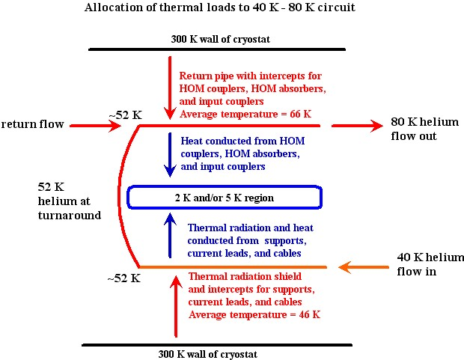
Figure 5: Proposed new cooling scheme of ILC cryomodule

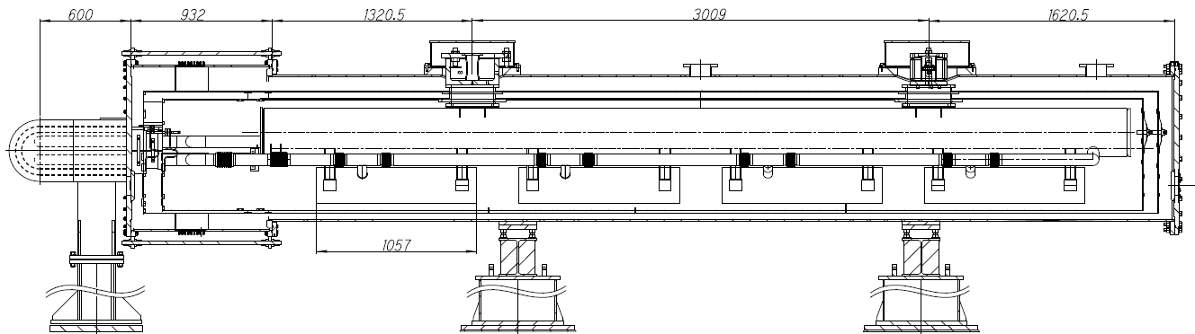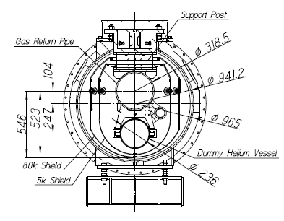
Figure 6: Cross Sections of KEK-STF Test Cryomodule B

Table 3: Parameters of KEK-STF Test Cryomodule B
Vacuum vessel | Steel-SS400 | Dummy helium jacket | SS304L
Length, mm | 5950 | Length, mm | 1057
Diameter, mm | 965.2 | Outer/Inner diameter, mm | 236/230
80K thermal shield material | Al | Gas return pipe | SS316
Cold mass, kg | 215 | Outer/Inner diameter, mm | 318.5/297.5
5K thermal shield material | Al | Liquid helium supply pipe | SS304L
Cold mass, kg | 190 | Outer/Inner diameter, mm | 76.3/72.1

The measured data are summarized in Table 4. Heat loss measurements were performed under the two thermal conditions by changing the level of liquid helium. The effect of the intercepted radiation from the 84 K thermal shield was evaluated by the difference between the heat loads with and without the lower portion of the 5 K shield. In the first thermal condition, this difference was found to be 0.78 W, in the second condition (lower liquid helium level), the difference was 0.80 W.
By means of an ANSYS model, and the heat loads of the measurements with the complete set of the upper and lower 5 K shield sections and without the 5 K lower shield were calculated. In the model, the thermal emissivity of 0.2 (corresponding to mechanically polished SS304 surface [8]) was assumed for the dummy vessel, and the emissivity of the Al thermal shield was 0.06 [8]. A stationary temperature profile was assumed as follows: the dummy vessels at 2 K, the 5 K shield parts at 5 K, the 80 K shield at 84 K and the vacuum vessel at the room temperature of 300 K. The ANSYS model evaluates the heat load at 2 K without the 5 K lower shield to be 0.849 W, and the load with the full 5 K shield 1.4×10⁻⁵ W. The calculated difference between these two cases is consistent with the measurement summarized in Table 4.
Using the ANSYS thermal model, the heat load was then re-calculated by assuming Super-Insulation on the cavity jackets (with an assumed emissivity of 0.03) and a lower temperature of the external thermal radiation shield of 46 K, according to the revised flow scheme proposed by Tom Peterson and presented above. The predicted heat load on the four jackets at 2 K is now 0.02 W, and the heat load on the gas return pipe and helium supply pipe is 0.037 W. The total heat load at 2 K by radiation therefore is 0.057 W. The ILC cryomodule has a double length compared to this test cryomodule. The heat load increment at 2 K by removing the lower 5 K shield portion is estimated to be 0.114 W for the full length ILC cryomodule, under the assumptions of implementing in the design the revised cooling scheme presented in Figure 5.

Table 4: Summary of the heat load measurements
 | LHe level  % | Temp. LHe, K | Temp. 5K shield, K | Temp. 80 K shield, K | Evaporation,  g/s | Heat load,  W
With 5 K shield | 77 | 1.93 | 4.82 | 84.5 | 0.132 | 3.07
W/O 5 K lower shield | 77 | 1.96 | 4.51 | 84.2 | 0.167 | 3.85
With 5 K shield | 63 | 1.93 | 4.81 | 84.9 | 0.048 | 1.11
W/O 5 K lower shield | 71 | 1.96 | 4.51 | 84.0 | 0.083 | 1.91

For future assessment of the ILC cryomodule thermal design, the cost implications of removing the lower part of the 5 K shield should be studied in detail, in particular concerning the following aspects:
1. Capital and assembly cost reductions of the lower shield components.
2. Capital and operational cost increase of the cryogenic system due to the additional heat load.
3. The effect on the assembly time and costs for providing the 5 K thermal intercept to other components, like main and HOM couplers..

For example, the cross sections of the cryomodule with the 5 K shield and without the lower part of the 5 K shield are shown in Fig. 7. In the proposed design, the cooling line at 5 K is preserved due to the need to provide the thermal intercepts of the input couplers, support posts and RF cables.
Figure 7: Cross section of the cryomodule with two thermal shields and without the lower part of 5 K shield

3) Magnetic shield
Different magnetic shield solutions are being developed by several institutions and are being studied from the point of view of cryomodule assembly operations. The magnetic shields of DESY and FNAL cavities are assembled outside of the cavity jacket, whereas the shield of KEK cavity is internal to the helium jacket. From the ongoing tests the four KEK cavities achieved higher average field gradients in the S1-G cryomodule than in the vertical tests, thus proving that the magnetic shield system inside the helium jacket has performances equivalent to the outer shields of the DESY and FNAL cavities. Figure 8 shows the relative complexity of the magnetic shields of DESY, FNAL and KEK cavities, which consist of 24, 10 and 6 parts, respectively. The number of components of the KEK shield can be further reduced to 3 pieces of both ends and one cylindrical center part.
During the S1-G cryomodule assembly, the DESY cavity jackets were wrapped by the Super Insulation and the magnetic shield components were then assembled externally, whereas the shield components of the FNAL cavities were assembled directly on the jackets and the Super Insulation was wrapped around them. Between the cavities, the beam pipes were shielded with the other portions of the magnetic shields and the connection of all RF and signal cables to HOM couplers and Piezos needed to be completed during this assembly. The assembly of the magnetic shields for all 8 cavities and the routing of the RF cables required the work of two persons for one week.
On the other hand, for the S1-G KEK cavities, the magnetic shield is introduced in the cavity during the fabrication process and no assembly procedure is required during the module installation. Furthermore, the beam pipes were not covered with the magnetic shield and the cable connection to HOM and Piezo was effortless and easy, requiring one day by a single technician. Additional work is required to install the magnetic shield in the jacket during the cavity production, however, this assembly is a very simple operation and the required time is considered to be short.
In view of pursuing lower costs for the cryomodule construction and assembly phases, the magnetic shield design should be re-considered within the ILC cavity package, and as the next step, the cost study of these two different systems should be performed.

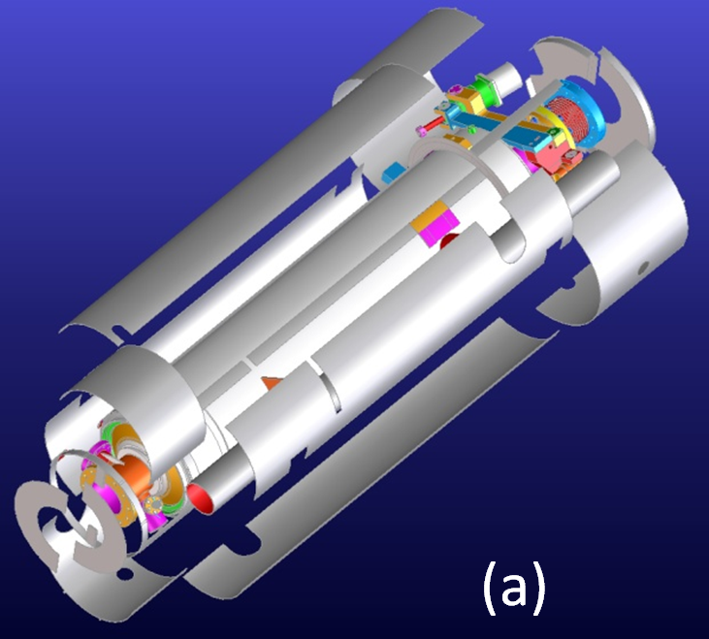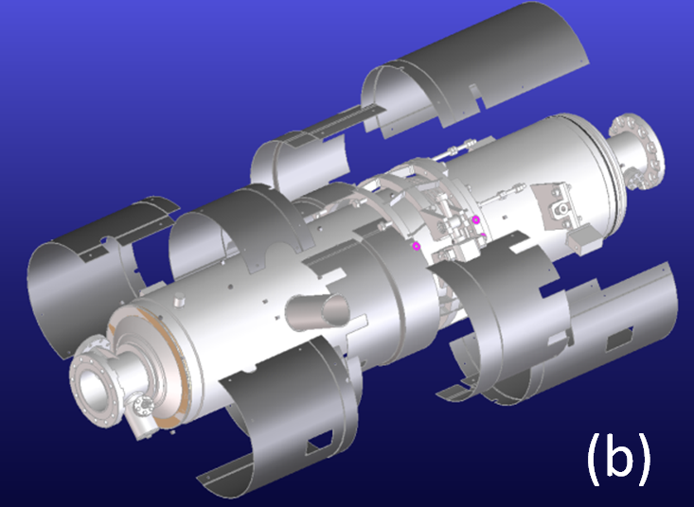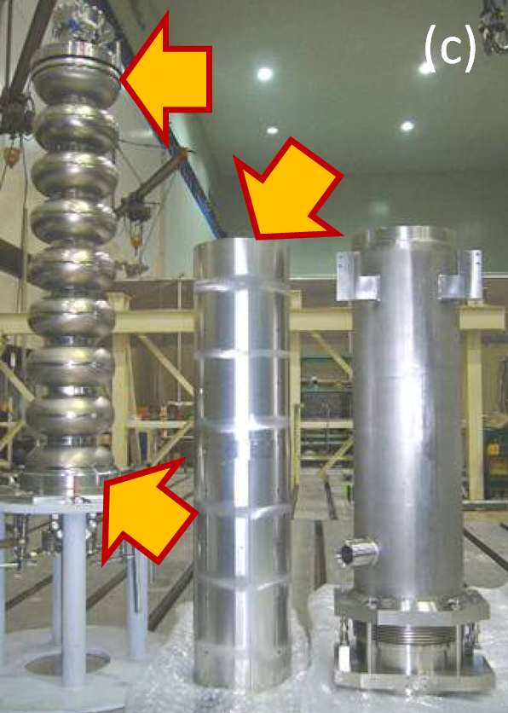
Figure 8: Magnetic shields of DESY cavity (a), FNAL cavity (b) and KEK cavity (c).

4) Plug compatible design
In order to develop an industrialized design of the ILC cryomodule, the plug compatible interfaces of the cryomodule have been defined in Table 5. A detailed and more exhaustive parameter list should be defined and agreed upon in future studies.

Table 5: Plug compatible interfaces of cryomodule
Interface | Item | Parameter
Cryomodule slot | Length | 12679.6 mm
Vacuum vessel | Length/Outer diameter/Support | 11830 mm / 965.2 mm / TBD
Vacuum bellow | Length | 849.6 mm
Vacuum flange | Diameter/Thickness/Connection | TBD
Input coupler connection flange on the vacuum vessel | Diameter/Thickness/Connection | TBD
Cavity support lug | Span/Lug width and thickness | 750 mm / TBD
Cooling pipes | Position/Diameter/Material | Cooling pipe parameters are specified by the cryogenic group.

5) Additional activities concerning cryomodule design and developments

Although not within the boundaries of the ILC and GDE activities, it is worth noting that the European XFEL Project is now in its construction phase, with commissioning planned in 2014 [9]. The XFEL superconducting linac consists of nearly 100 cryomodules with a design derived from the TTF Type III, on which the current ILC module concept is based. Several industrial vendors have been qualified through the production and testing, under realistic conditions, of prototypical models and the Project is moving forward to the start of the series production phase. The XFEL Project will therefore soon provide real experience of a relatively large series production in an industrial context, that will bring valuable information for the industrialization of ILC cryomodules.

At Fermilab, Cryomodule 1 (CM-1), an ILC Type 3 cryomodule made from parts provided by DESY, INFN, and Fermilab is now ready for cool-down and test at the New Muon Lab (NML) test facility at Fermilab. Dressed cavities for CM-2 are being tested in Fermilab’s Horizontal Test Cryostat. In addition, design work is proceeding on cryomodules for Project X, a high intensity proton linac proposed for Fermilab’s next generation of neutrino experiments and other studies. Project X cryomodules, being continuous wave and low beta for protons, differ in various ways from ILC-type cryomodules but will benefit greatly from the ILC experience.

[1] N. Ohuchi, et al, LINAC10, Tsukuba, September 2010, MO302; http://www.JACoW.org.
[2] N. Ohuchi, et al., EPAC08, Genoa, June 2008, MOPP144, p. 892 (2008); http://www.JACoW.org.
[3] B. Aune, et al., Phys. Rev. ST-AB, 3(9), Sept. 2000.
[4] N. Phinney, et al., ILC RDR Accel., ILC-Report-2007-001, p.III-171, (2007); http://www.linearcollider. org.
[5] C. Pagani, et al., “TESLA Cryogenic Accelerator Modules”, TESLA Report 2001-36.
[6] T. Peterson, “Cryomodule Thermal Intercept Optimization Strategy”, TILC08-Sendai, March 3-6, Sendai, 2008.
[7] N. Ohuchi, et al., presented at ICEC23, 21A-PS-3-05, Wroclaw, July 19-23, 2010.
[8] Hands, B.A., In: Cryogenic Engineering, Academic Press, USA(1986)107-112.
[9] http://www.xfel.eu

-----
Additional note (101117: by NO)

1) I modified the report from the comments by Akira and Tom.
For the description of 5 K shield, I would like to follow the comments by Tom. And then, I inserted the some sentences into the report.
2) And I cut off the Figure 4 which shows the cavity performances in the vertical tests, and this figure will be included in the section by Hayano-san. However, the S1-G work was the main work by cryomodule and cryogenic groups in these years, and then I would like to keep this work in the cryomodule part.
3) The cavity operation parameters are shown in the Low Level RF session of RDR.
4) About the heat load difference of two thermal conditions in 5 K shield tests, this difference is coming from the heat input in the conncetion transfer tube between cryomodule and 2 K cold box. In this report, I consider that this detail description is not necessary for this report. Then I refered this as two thermal conditions and I showed the refernce paper.

-----

2.5 High-Level RF development (8 pages, Shigeki Fukuda and Chris Nantista)

Note that I’ve changed the title of this section. It’s come to my attention that the acronym HLRF seems to have spontaneously arisen within the ILC organization as a high-power counterpart to LLRF (low-level rf). As it doesn’t seem to be in general use in the outside world, I suggest it be avoided in this document. (CN)

2.5 High-Power RF Development
In the Reference Design Report (RDR) [1], the high power rf equipment and layout had reached a fairly mature state. The klystrons, modulators, and related equipment were housed in a parallel utility tunnel, connected every 38 m to the main linac tunnel by a penetration through which waveguides carried up to 10 MW of L-band (1.3 GHz) power, to be distributed along three cryomodules. Extensive ongoing work has been required mainly due to the fundamental change in tunnel configuration. With the move to single-tunnel main linac housings, the production and distribution to the cavities of radio frequency (rf) power had to be rethought. Two proposed options are currently being pursued by ILC R&D programs. They are referred to by the acronyms KCS (Klystron Cluster System) and DRFS (Distributed RF System).

2.5.1 Klystron Cluster System
2.5.1.1 System Description
In the KCS scheme [2], rf production is moved to the surface. Unlike in the RDR, where it is brought down as AC wall-plug power, or the European XFEL, where it is brought down as DC cable power to underground klystrons, with KCS, the power used to accelerate the beam is transported between the surface and the underground tunnel as rf. This approach of sending power down as rf follows the example of the SLAC linac, which served the only previous linear collider, the SLC. The differences arise from having to accommodate a deep bored (as opposed to “cut-and-cover”) tunnel, which makes shafts expensive, and from the need to minimize surface impact over what will be a much larger footprint.
Thus the idea of clustering is adopted. Power from groups of approximately thirty four 10 MW klystrons is combined into a single low-loss, overmoded waveguide and transported down to the tunnel and along the linac (see Fig. 2.5.1.1.1). This is sufficient, allowing for a few percent extra transmission loss, to power approximately 1.06 km of ILC linac. At 38 m intervals, partial power is siphoned from this main waveguide in 10 MW decrements. From each such tap-off, the rf is distributed to the cavities (26 in three cryomodules) through a WR650 waveguide system, just as it would be from a local klystron (see Fig. 2.5.1.1.2).
To minimize the number of buildings and shafts required, each houses two klystron clusters with one feeding upstream and the other downstream, powering over two kilometers of linac per shaft. Besides the KCS main waveguide artery, some equipment from the service tunnel, such as front-end feedback electronics and beam instrumentation, is added to the linac tunnel, in shielded crates below the cryomodules. No increase in tunnel diameter is foreseen. In addition to the civil construction cost savings associated with going to a single tunnel, this scheme brings the heat load associated with the rf production equipment to the surface, greatly facilitating cooling.

2.5.1.2 Klystrons and Modulators
In the RDR, a 10 MW multi-beam-klystron (MBK) was identified as the ILC L-band power source. This choice was based on cost effectiveness, efficiency and relatively low operating voltage, and takes advantage of years of R&D for TELSA and the European XFEL. Prototypes had been built by CPI, Thales, and Toshiba. The KCS option retains this source. A Toshiba tube is being operated at SLAC for reliability/lifetime studies.
As a plug-compatible alternative to the MBK, the SLAC Klystron Department has been developing a sheet beam klystron (SBK) [3]. With a 40:1 beam aspect ratio, it was expected to achieve similar efficiency while allowing the use of permanent magnet focusing. A beam tester was built and operated. Unfortunately, after much design work aimed at understanding and addressing the problem of beam instabilities due to modes in the drift “tube” between cavities, this program has been discontinued. Increase of the drift height had necessitated a switch to solenoidal focusing which reduced the potential benefit of this approach.
The modulator requirements for the klystrons are 120 kV, 140 A, 1.6 ms pulses at a 5 Hz repetition rate. As an alternative to the RDR baseline design, SLAC is pursuing a Marx-topology modulator to fulfill this requirement [4]. A full-scale prototype, the SLAC P1 Marx, is currently undergoing lifetime testing, driving the above-mentioned 10 MW Toshiba MBK. In the accumulated 1,500 hours there have been no chronic problems. A second-generation Marx, the SLAC P2 Marx, is currently under development [5].
The Marx is made up of many identical and, ideally, redundant cells. If a cell becomes inoperable, it can be bypassed. Increasing the applied charge voltage or turning on ‘spare’ cells allows the modulator to continue operation. In addition, a modular design allows better utilization of high-volume manufacturing techniques, thereby reducing costs. Finally, portable cells allow maintenance staff to quickly replace inoperable cells with pre-tested replacements, reducing the mean repair time.
The SLAC P1 Marx operates in air, has no output transformer, and is air-cooled (see Fig. 2.5.1.2.1). The Marx utilizes an FPGA-based control system. A diagnostic module on each cell, along with the ground station and a cell control board, coordinates the timing of the cells. The diagnostic card has four analog input channels monitored at 20 kS/s with a resolution of 16 bits. A fast transient recorder can also be used at 30 MS/s with 8-bit resolution.
In the SLAC P1 Marx, sixteen, 11 kV Marx cells are arranged with a single “Vernier” Marx. The triggering sequence of the main Marx cells is designed to promptly turn-on eleven cells, then stagger turn-on the remaining five cells to coarsely compensate the storage capacitor droop. The Vernier Marx (with cells charged to ~1 kV) staggers its turn-on and turn-off to further regulate the output to the specified level of ±0.5%. Fig 2.5.1.2.2 shows the resulting rf waveform.
Building upon the success of the P1 Marx, the SLAC P2 Marx is currently in the final stages of design. It includes thirty-two, 3.75−4 kV cells. This modulator will be able to produce the specified power with up to two of the cells offline. Three notable differences distinguish it from P1. First, a nested droop correction scheme is employed in the P2 Marx. Each cell individually regulates its output, removing the need for a separate compensation element (like the Vernier in the P1 Marx). Second, there is no arraying of solid-state switches within a cell, simplifying the control and protection schemes. Third, the modulator layout is redesigned to have a single side access.

2.5.1.3 Main Waveguide and Tap-Offs
For low transmission loss and robustness against rf breakdown, overmoded circular waveguide operated in the TE₀₁ mode is used as the main high power rf conduit; the attenuation drops faster with radius for this mode than for others, and it has no electric fields terminating on the wall. The diameter chosen is 0.480 m, at which the added ohmic transmission loss along a KCS should be ~6.5%. With power levels on the order of 300 MW, this main transmission waveguide will likely be evacuated and thus need sufficient wall thickness, about 1 cm. Mode conversion considerations suggest radius, roundness, and alignment tolerances on the order of a millimeter and a straightness tolerance of half a degree. The flange joint between pipe sections will be designed to include sufficient longitudinal flexibility to take up local thermal expansion, while maintaining concentricity and straightness. An insulation jacket and water cooling will be used to keep much of the main waveguide’s heat load (averaging ~130 W/m) from the tunnel air.
Overmoded waveguide is not trivial to manipulate, as geometrical changes like bends tend to scatter power into parasitic modes. Each main waveguide will need to undergo probably three 90° bends, downward into the shaft, then toward and along the tunnel. These occur at maximum power, between the last tap-in and the first tap-off, and will unavoidably have surface electric fields, so the design will be a challenge. They must have excellent port-to-port mode preservation and high power handling without being excessively bulky. TE₀₁ mode bends exist at X-band, and design options for KCS are currently under consideration.
For tapping off rf power from the main circular TE₀₁-mode waveguide without breaking the azimuthal symmetry, and thus introducing surface electric fields, in the very high-power region, a special waveguide component was designed, referred to as the coaxial tap-off, or CTO [2]. The idea of this device involves stepping up the diameter from below to above the TE₀₂ cutoff in such a way that roughly half the power is converted, creating a mixture of the two modes. The radial distribution of electric field then varies longitudinally as the two modes beat, due to their different guide wavelengths. At an appropriate distance, this beating is terminated by reintroduction of a wall at the original radius, separating the inner volume from a coaxial outer volume and dividing the power between the two in circular and coaxial TE₀₁ modes.
To then extract the stripped power, the coaxial guide is shorted, and power is coupled through eight radial apertures into a wraparound waveguide and thence through two standard WR650 rectangular output ports (see Fig.2.5.1.3.1). The gap between the step and the dividing wall is varied over ~14 cm to achieve the many different fractional power couplings needed, ranging between 0.03 and 0.5, and a small customized ridge before the step is used to cancel any mismatch. The coaxial and wrap-around region should never see more than about 10 MW, whereas the power in the inner region tops 300 MW. If KCS is evacuated, a 5 MW pillbox window on each rectangular CTO port will transition to the pressurized distribution waveguide.
In the surface building, CTO’s are also used in reverse for combining. At each one, proper phasing and relative amplitude ratio between the power flowing in the circular waveguide and the klystron power being added must be achieved for efficient combining. The diameter of the CTO’s circular ports is smaller than that of the main waveguide. The two are interfaced by a matched double step taper at the end of the combining assembly and before and after each linac CTO. These steps, as well as steps and edges in the CTO, are radiused to ease pulsed heating.
A pair of 3-dB CTO’s has been fabricated, as well as shorting caps with which they can be used as launchers, two diameter step tapers, a vacuum pumpout spool and four 2.44 m sections of the 0.480 m diameter waveguide (see Fig. 2.5.1.3.2). A back-to-back cold test of the CTO’s showed good transmission. High-power tests are underway aimed at resonating the waveguide to achieve field levels equivalent to a 300 MW traveling wave and demonstrating transmission at the 4-5 MW level available from our test set-up’s Thales klystron. Initial tests with 14.5 psig nitrogen pressurization are being done in the hope that evacuation may not be necessary after all. However, such a conclusion would have to wait until a bend, the likely bottleneck, is so tested.

2.5.1.4 Local Waveguide Power Distribution System
The rf power extracted from each CTO along the linac tunnel is distributed to 26 cavities in three cryomodules (9-8-9, with a quad magnet in the center CM), constituting an rf unit. The waveguide power distribution system (PDS) through which it flows has evolved since the RDR (see Fig. 2.5.1.4.1). The 3-stub tuner has been eliminated, its dual functions now accomplished by phase shifters with a movable side wall and tunable coaxial fundamental power couplers (FPC’s), both of which are motorized. Feeding properly spaced cavities in pairs through a 3dB hybrid allows the combined reflected power to be directed to a load on the hybrid’s fourth port. Thus the expensive circulators can likely also be eliminated for most cavities. Finally, with the wide range of sustainable ILC cavity gradient limits (±20%) now to be accepted to increase production yield, power efficiency demands we tailor the distribution to the (sorted pairs of) cavities in each rf unit. Thus adjustable coupling from the main WR650 waveguide is included.
This latter function can be provided by a novel waveguide component developed at SLAC called the variable tap-off (VTO) [6]. This adjustable directional coupler works by means of mode rotation of a circular TE₁₁ mode accomplished via physical rotation of an oval middle section (see Fig. 2.5.1.4.1). A PDS incorporating four VTO’s was built and high-power tested for the first cryomodule that will be tested at FNAL [7] (see Fig. 2.5.1.4.2).
An alternate concept for providing adjustability to the PDS power division substitutes for the each VTO a pair of (folded) magic-T’s connected by U-bends. The phase length difference through the U-bends, controlled by means of changeable flange spacers determines the power split. Both tailoring options require accessing and unbolting normally pressurized waveguide for later changes. For the ILC, the need for such changes should be rare. For FNAL’s R&D facility, quick remote adjustment may be useful. For this purpose, a version of this second option with motorized U-bend phase shifters (see Fig. 2.5.1.4.3) is incorporated into a second PDS being prepared by SLAC for their second cryomodule [8]. Each phase shifters contains an inner waveguide turn-around inside a pressurizable outer shell, movable by means of motorized feed-throughs. The broadwall edges of the inner U-bend are shorted to the outer WR650 by stainless steel fingerstock. A prototype has been tested up to 2 MW, and eight more are in fabrication.

2.5.2 Distributed RF Scheme (DRFS)
2.5.2.1 Basic Concept of DRFS Compared with the RDR
Distributed RF Scheme (DRFS) was proposed as another possible cost-effective solution for a single main linac tunnel design in the proposal of SB2009 [8]. The basic concept of DRFS is illustrated in Fig. 2.5.2.1.1, schematically comparing with the RDR [1] design. The salient feature of DRFS is a complete single tunnel plan with no high power rf components on the surface, utilizing approximately 8,000 small modulating-anode (MA) klystrons of 800 kW output power, driven by DC power supplies (P/S) and MA modulators. The rf power for two super-conducting (sc) cavities is fed by a klystron through a rather simple power distribution system (PDS) without employing a circulator. By contrast, the RDR presented a two-tunnel plan in which a 10 MW multibeam klystron (MBK) feeds power to 26 cavities through a complicated PDS using 26 circulators in RDR rf units comprised of 3 cryomodules.

(Fig. 2.5.2.1.1)
Figure caption of Fig. 2.5.2.1.1: Schematic drawing comparing between RDR and DRFS.

The advantage of DRFS is that it represents a complete single tunnel plan in which there are no high power rf facilities on the surface. One klystron feeds power to only two cavities, facilitating optimization cavity performance. In the case of local sc cavity failures, it is easy to separate them from the operation, giving DRFS good operability. There is small probability of big failures that prevent beam operation. On the other hand there are concerns about the construction cost, maintainability, and heat loss problems, since all heat loads are also in the single underground tunnel. This will be described in Sec. 2.5.2.3. DRFS is a newly proposed plan, though it uses matured technology, and it is important that its feasibility should be demonstrated in the test station, and it will be described in Sec. 2.5.2.4.

2.5.2.2 DRFS Configuration in the Tunnel
Since DRFS is a complete single tunnel plan, its configuration strongly depends on the tunnel shape and the layout of cryomodule in the tunnel. If the tunnel cross section is assumed circular, constructed by tunnel boring machine (TBM), two configurations are designed and investigated; one in which the cryomodule is hung from the ceiling and one in which the cryomodule is installed on the floor. The current likely configuration of DRFS is based on the latter, which is shown in Fig. 2.5.2.2.1. The diameter of the tunnel cross section is 5.7 m, and the tunnel is divided into three regions horizontally: a cryomodule region, a passage and maintenance space including egress, and a region of high power rf equipment, separated from the other regions by a radiation shielding wall with access doors. It is shown that all required components, including stand-by power supply, are in the high power equipment region. Waveguides of the PDS are laid under the floor. The tunnel is also divided into three regions in the vertical direction and accomodates all required functions, including water supply, ventilation and the space to exhaust an accidental helium leak. It is necessary to investigate this configuration in more detail to assure sufficient working space during installation and maintenance, and this will be done after optimization of the rf component sizes.

(Fig. 2.5.2.2.1)
Figure caption of Fig. 2.5.2.2.1: DRFS configurations in the tunnel shown in 3D: (a) cross-section view and (b) bird’s eye view.

2.5.2.3 Operability and Availability of DRFS
Since DRFS can control two-sc-cavity units with low level rf (LLRF), operability is better than in the RDR. Some of the advantages in DRFS are described in Sec. 2.5.2.1. On the other hand, 13 DRFS klystrons are operated on a common DC P/S and MA modulator, so required applied high voltage is determined by the maximum power in the unit, if fixed overhead for LLRF control is assumed. From sc cavity manufacturing, accelerating gradient variation of 31.5 MV/m ±20% should be accepted, and in order to achieve an efficient system, sorting of the cavities is inevitable for DRFS. Assuming that 3,400 cavities are manufactured every year in the construction period and they are sorted in bins with a 4%-range variation of field gradient, the resultant number in a bin is 680 and they are sorted in an RDR unit (3 cryomudules) with 4% higher power without sacrificing the sc field gradient. Therefore in DRFS, this kind of sc cavity sorting is prescribed. In order to achieve high availability in DRFS, we assumed 110,000 hours of MTBF (mean time before failure) for MA klystrons and introduced back-up DC P/S’s and MA modulators as described in SB2009 [1]. This configuration is changed, as shown in Fig. 2.5.2.3.1, in consideration of the DC P/S size and cost. In this case, the basic configuration of the DRFS baseline (or the high current case) includes 2 regular DC P/S’s and MA modulators plus another back-up in two RDR units. So far, for other availability and installation issues, the basic scenario is kept the same as SB2009, as long as we employ the configuration of Fig. 2.5.2.2.1.

(Fig. 2.5.2.3.1)
Figure caption of Fig. 2.5.2.3.1: Two-RDR-unit system of DRFS in the baseline case is shown. Red boxes represent the DC P/S’s, pink boxes represent MA modulators for active components, blue the DC P/S, and bright blue the MA modulator for back-up components.

Another important issue for DRFS is radiation. There is a concern about semiconductor damage from the radiation in the high power rf components. As shown in Fig. 2.5.2.2.1, DRFS employs a radiation shield wall which has the same shield thickness investigated by DESY [10]; it is necessary to investigate the effect more precisely. We have a plan to perform an experiment utilizing an existing accelerator.

2.5.2.4 R&D Status of DRFS
A DRFS demonstration to show feasibility is planned at KEK to extend over three consecutive years. The first demonstration is scheduled at the end of FY2010 to employ a two-unit DRFS in the S1-Global project in KEK. The first prototype DRFS klystrons, a P/S and an MA modulator will be installed and operated to feed power to 4 cavities. LLRF control is a main R&D theme, to evaluate the feedback technology when there are no circulators.
Prototype klystrons of DRFS were manufactured in 2010, and factory tests satisfied the required original specification: 750 kW. As shown in Sec. 2.5.2.3, output power is increased to 800 kW to accept the gradient variation of 32.5 MV/m ±20%, and factory tests cleared this revised specification. Output characteristics of prototype klystrons are shown in Fig. 2.5.2.4.1. Results for first tube are as follows: output power of 813 kW at 64.2 kV with efficiency of 57.4% for microperveance of 1.36 and output power of 806 kW at 67.1 kV with efficiency of 60.1% for microperveance of 1.15. Since the DRFS klystron is an MA klystron, beam perveance can be controlled by the ratio between (cathode − MA electrode) voltage and (cathode – anode) voltage. A prototype power supply and MA modulator are delivered to KEK and are operated in an acceptance test, after which all DRFS high power components will be moved near the cryomodule in the S1-Global tunnel and operated as the demonstration at the end of 2010. The configuration of test arrangement in S1-global is shown in Fig. 2.5.2.4.2.

(Fig. 2.5.2.4.1)
Figure caption of Fig. 2.5.2.4.1: Results of first DRFS klystron are shown. Output power and efficiency as functions of applied voltage are shown at upper left. Output power as a function of input power is shown at upper right. A photo of the klystrons is shown at lower left and waveforms in the test are shown at lower right.

(Fig. 2.5.2.4.2)
Figure caption of Fig. 2.5.2.4.2: Layout of the DRFS test configuration in S1-Global. At first, high power rf components are tested and evaluated on the first floor with a matched load on the PDS (shown in blue circle), and then systems are moved near the cryomodule in the tunnel (shown in red circle).

The second demonstration is a continuation to check the long term stability by installing one of the above DRFS units in the “quantum-beam project” at KEK. The third demonstration, planned for FY2012 to FY2013, entails installation of a 4-unit DRFS feeding rf power to 8 sc cavities in the STF-II project at KEK. During these R&D schedule periods, key elements of DRFS high power system components will be developed. Spark gap development in the crowbar circuit, HV relay in the DRFS P/S system and permanent magnet R&D for the klystron are such items. Some of this work has been already begun in collaboration with industry.
Since the DRFS concept is well established and employed in many projects, we think there are no basic difficulties, but there are some problems to be solved when system installation is involved. The purpose of the R&D should be focused in this direction. R&D for cost reduction is another important issue, and after successful operation, design efforts to reduce the cost of each component are required.

2.5.3 RDR configuration in single tunnel as back-up
In SB2009, in order to reduce project cost, a single tunnel configuration for the ILC main linacs is called for. Because the options described in the preceding two sections are in the R&D stage, a back-up plan was put forward in which the equipment of the RDR high power rf system, which is better studied, is incorporated into the linac tunnel. One possible RDR single tunnel configuration is almost identical to that of DESY’s XFEL, with pulse transformers, 10 MW MBK’s and PDS’s in a single tunnel of diameter 5.2 m and modulators on the surface. Another single tunnel plan for the RDR system has all high power components in a single tunnel of diameter 6.5 m, as shown in Fig. 2.5.3.1. For a mountainous site, this type of complete single tunnel plan is preferable. The pros and cons of this latter option are largely shared with DRFS, since both are complete single tunnel plans.

(Fig. 2.5.3.1)
Figure caption of Fig. 2.5.3.1: Cross-section view of RDR configuration in a single tunnel of 6.5 m diameter.
.

References:
[1] RDR, Reference Design Report, Accelerator, ILC-Report-2007-001, 2007,
http://lcdev.kek.jp/RDR/RDRall.pdf
[2] Christopher Nantista and Chris Adolphsen, “Klystron Cluster Scheme for ILC High Power RF Distribution,” presented at the 2009 Particle Accelerator Conference (PAC09), Vancouver, B.C., Canada. May 4–8, 2009; SLAC-PUB-13696.
[3] D. Sprehn, et al., “Development of a 10 MW Sheet Beam Klystron for the ILC,” presented at the 23rd Particle Accelerator Conference (PAC09), Vancouver, B.C., Canada, May 4−8, 2009.
[4] C. Burkhart, et al., “ILC Marx Modulator Development Program Status,” presented at the 1st International Particle Accelerator Conference (IPAC10), Kyoto, Japan, May 23-28, 2010.
[5] M.A. Kemp, et al., “Status Update on the Second-Generation ILC Marx Modulator Prototype,” IEEE Power Modulator Conference, Atlanta, GA, May 2010.
[6] Christopher D. Nantista and Chris Adolphsen, “A Variable Directional Coupler for an Alternate ILC High-Power RF Distribution Scheme,” presented at the 2006 Linear Accel. Conf. (LINAC06), Knoxville, TN, Aug. 21–25, 2006; SLAC-PUB-12372.
[7] Christopher Nantista et al., “Progress in L-Band Power Distribution System R&D at SLAC,” presented at the XXIV Linear Accelerator Conference (LINAC08), Victoria, B.C., Canada. Sept. 29–Oct. 3, 2008; SLAC-PUB-13438.
[8] Chris Adolphsen, “ILC RF System R&D,” presented at the 1st International Particle Accelerator Conference (IPAC10), Kyoto, Japan, May 23-28, 2010.
[9] SB2009 Proposal Document, Release1, ILC Global Design Effort, 2009,
http://lcdev.kek.jp/SB2009/SB20091217B.pdf
[10] B. Mukherjee, E. Negodin, T. Hott and S. Simrock, ”Efficacy testing of shielding materials for XFEL using the radiation fields produced at FLASH”, TESLA-FEL 2008-06, 2008.

---
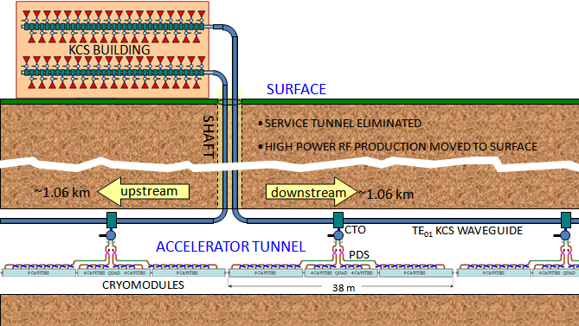
Figure 2.5.1.1.1: Basic layout scheme of the Klystron Cluster System (KCS). Many high power rf sources in a surface building combine into a large circular waveguide which carries the accelerating rf down to and along the main linac tunnel. Two systems share a shaft roughly every two kilometers.

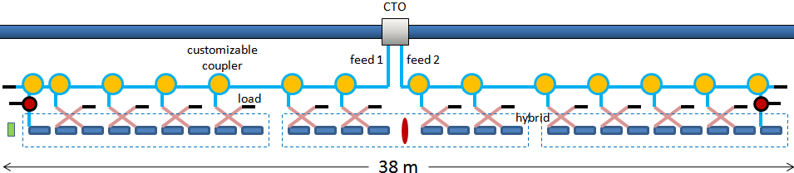
Figure 2.5.1.1.2: Local distribution of accelerating rf power from a KCS main waveguide tapoff to 26 superconducting cavities in 3 cryomodules. Division amongst matched cavity pairs is customized for efficiency.

---

Figure 2.5.1.2.1: Photograph of the SLAC P1 Marx modulator showing its cantilevered support structure, high-voltage grading rings, and sixteen installed cells.

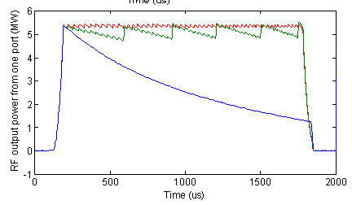
Figure 2.5.1.2.2: RF waveforms from one of the two klystron ports: Blue: no droop compensation, Green: with only delay cells, Red: with delay cells and vernier, producing a flat pulse with a 3% saw-tooth pattern.

---

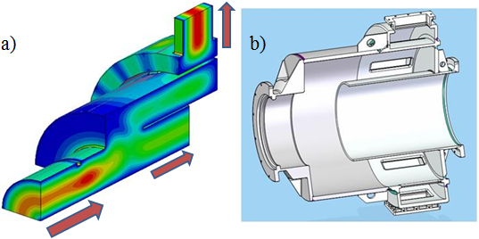
Figure 2.5.1.3.1: a) Simulation model with field plots (electric on cut plane, magnetic on surface) and b) mechanical design of a 3-dB Coaxial Tap-Off (CTO). For other couplings, only the gap length and matching ridge are modified.

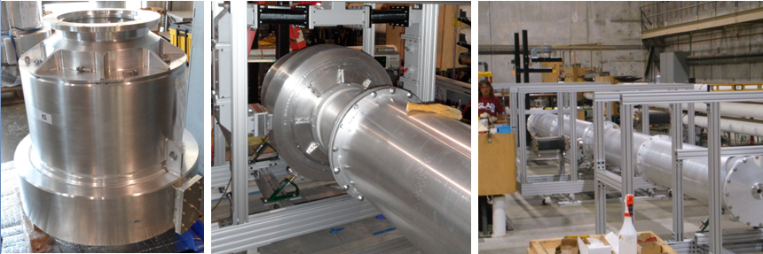
Figure 2.5.1.3.2: KCS R&D hardware. From left to right: a CTO, a CTO fed through a waveguide T and connected through a taper to the 0.480 m diameter circular waveguide, and a four section 10 m run of KCS main waveguide.

---

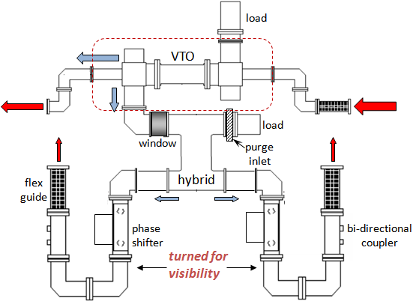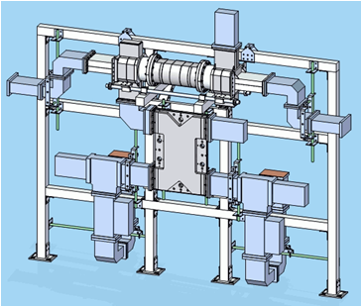
Figure 2.5.1.4.1: Updated modular PDS waveguide layout. Power for two cavities at a time is coupled from a main WR650 feed and divided through a hybrid. Reflections from the cavities combine into the hybrid load, allowing elimination of circulators (included after the hybrid in the 3D view), except for the odd cavity in a nine-cavity cryomodule.

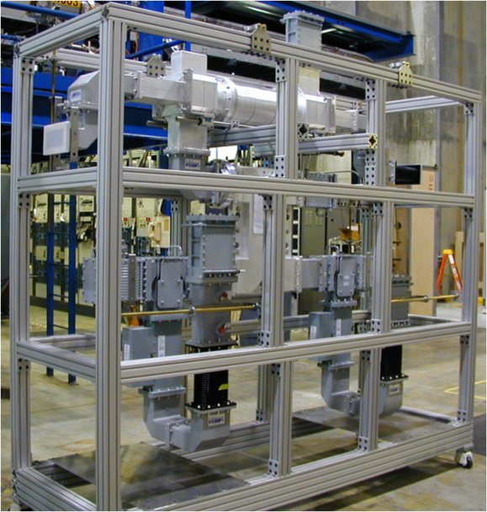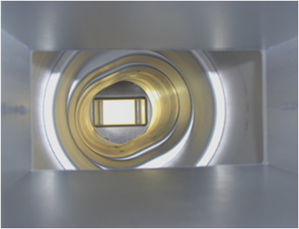
Figure 2.5.1.4.2: One of four PDS modules built and tested at SLAC for the first cryomodule of FNAL’s L-band NML Test Accelerator, and a view through the VTO polarization rotator.

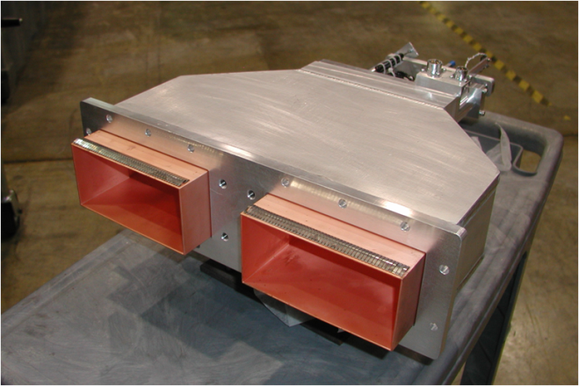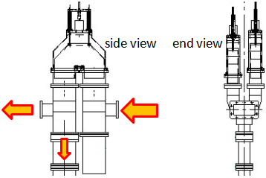
Figure 2.5.1.4.3: Motorized U-bend phase shifter and its application in a second PDS for FNAL. Two phase shifters connecting a pair of folded magic-T’s perform the VTO function of tailoring power division to pairs of cavities.

---

---

(a) (b)

---

---

Fig. 2.5.2.4.1

---

Fig. 2.5.2.4.2

---

Fig. 2.5.3.1

---

2.6 System integrations tests (5 pages, Hitoshi Hayano (STF) , Serge Nagaitsev (NML), John Carwardine/Nick Walker (FLASH)

to be filled

