Introduction

SCRF Technology
(Total estimate page count: 35)
(Editorial Board contacts: Akira Yamamoto and Marc Ross)

Putting Superconducting RF Technology to the test for ILC
(Estimated page count: 4, and principle authors: A. Yamamoto, J. Kerby, M. Ross)

2.1.1 SCRF Development in the Technical Design Phase
Superconducting RF (SCRF) Technology R&D is a primary global ILC technical activity of the Technical Design Phase (TDP). This activity builds on and extends the pioneering work done in the decade or so leading up to the ITRP choice of SCRF technology in 2004. In that decade, TESLA Collaboration R&D on 1.3 GHz technology succeeded in reducing the cost per MeV by a factor of 20 over the early 1990’s state-of-the-art SCRF. This was achieved by increasing the operating accelerating gradient by a factor of five from 5 MV/m to 25 MV/m, and reducing the cost per meter of the complete accelerating module by a factor of four for large-scale production.

The pace of progress has increased substantially during the TDP and vertical low-power test results now often exceed 40 MV/m, approaching the physical critical field limit for niobium. During the first half of the TDP, the ILC GDE established and deployed a reliable, semi-industrial process for consistent production of 35 MV/m cavities worldwide (see section 2.2). This critical step, implemented through the global GDE SCRF team, was the single most important action taken, enabling the community to move beyond an unstable R & D fabrication process toward a mature technology suitable for a practical project plan. In the last three years, some 60 cavities have been built for the purpose of proving the ILC gradient. Of these, more than half were subjected to the defined, standard process; the others being used for developing the process or qualifying the equipment in use. The production yield, i.e. the fraction of cavities which meet or exceed the performance criteria, for the process can be used to estimate construction project performance.

Advancement in SCRF cavity performance has followed two tracks: 1) control of field emission typically caused by surface deformation or contaminant particles and 2) reduction of localised heating caused by non-uniformities located near the cavity equator welds. Great strides along both of these lines were made prior to 2007, including the development of electro-polishing, the perfection of high-pressure rinsing, the adoption of broad ‘rhombic-pattern’ electron-beam welding and the qualification of several base-material scanning and testing procedures. Because of this success, forward-looking accelerating gradient parameter choices, (35 MV/m, average with 90% production yield), were made for the 2007 Reference Design. These are the primary goals which are to be demonstrated during the TDP.

Field emission is a major cause of variability in cavity performance. The first step to suppress it, following the formation of the GDE SCRF team in 2007, was taken in response to advice from the TESLA Technology Collaboration (TTC) on rinses intended to clear away the debris left behind by the electro-polishing process []. Their detailed advice was quite effective and the incidence of strong field emission was greatly reduced following adoption of ethanol and degreaser chemical rinses.

Development of surface diagnostic techniques capable of quantitative evaluation of surface defects has proceeded in parallel. The most important of these is the development of the high-resolution ‘Kyoto-KEK’ camera. The camera can be precisely positioned inside the cavity and provides images of the electro-polished mirror-like niobium surfaces that can be accurately referenced to external features. This allows a definitive correlation between camera image characteristics and external temperature-mapping measurements made during low-power test. In another significant step forward, resulting from the study of this correlation on a number of cavities, we are now able to conclude that all observed hot-spots that cause severe, (below 20 MV/m), gradient limits have a corresponding internal surface feature. The converse does not appear to be true, i.e. not all observed surface blemishes limit cavity performance.

2.1.2 Main Linac SCRF Operational Performance
Nowhere is the increased pace of progress more evident than in the expansion of global test infrastructures and in the fostering of cavity fabrication companies in each region. Midway through the four year Technical Design Phase, four institutional cavity process and test facilities, (one in Europe, two in the Americas and one in Asia), are actively providing ILC cavities fabricated by four companies (two in Europe, one in the Americas and one in Asia). We expect to roughly double the number of qualified cavity fabrication vendors in the remaining half of the Technical Design Phase. Fully functional high-technology cavity production capability in each region is a must since that gives the ILC project a strong global basis.

In addition to fabrication and processing sites, the last few years have also seen the development of cryomodule assembly and SCRF linac beam test facility infrastructure in each region. These tools make up the link between individual cavity testing and full linac performance. Following qualification in the low - power vertical test, cavities are connected in a string to allow the passage of the beam and provided with coaxial power couplers. The string is placed in the 12 m long cryomodule which are in turn joined together in the accelerator enclosure tunnel. To characterise the performance of the finished linac complex we test the assembled cryomodules and groups of cryomodules with beam in test linac facilities. For each of the above, we have established qualification performance criteria that culminate in a final linac system performance specification. These are summarised in table 2.1.1.

Table 2.1.1. Cavity performance specification and R&D goal.
Cost-relevant design parameter(s) for TDR | ML cavity gradient Project Specification | 9-cell Cavity R&D Goal
9-cell Cavity Gradient in Vertical Test, including 2nd pass, with Q₀≥ 8E9 | 35 MV/m, average w/ Spread: 28–42 MV/m  (≤ ±20 %) | 35 MV/m at 90 % yield  (equivalent to ≥ 38 MV/m, average)
9-cell Cavity Gradient in Cryomodule Test | 34 MV/m, average | CM Gradient Test ≤ 3 % , below Vertical Test
ML  Operational Gradient  with Q₀ ≥ 1E10 | 31.5 MV/m average, w/ Spread: 25–38 MV/m  (≤ ±20%) | Operational gradient limit ≤1.5 MV/m , below Cryomodule Test.  Controls margin ≤ 3 %
Required RF power overhead for control (see RF Power Table link, below) | ~10-15% (TBD)

In the table, both the Specification and the R & D Goal are described in terms of an average cavity gradient to be achieved with an allowance for peak-to-peak gradient spread. Cavity performance is listed for two test stages, Vertical low-power Test and Cryomodule Test, corresponding to tests done with single cavities and tests done after a cavity has been connected to a cavity string and inserted into a cryostat, respectively. The Main Linac (ML) Operational Gradient refers to the gradient at which the cavity can operate indefinitely following installation in the main linac. The table lists an R & D Goal of not more than 3% deterioration of cavity gradient from Vertical Test to Cryomodule Test, assuming the 35 MV/m with the 90 % yield to 34 MV/m on average, respectively. It also lists an R & D goal operational limit of not more than 1.5 MV/m below the limit seen in the Cryomodule Test and an operational Controls Margin gradient of not more than 3%.

The construction of ILC SCRF linac beam test facilities in each of the three regions is the largest investment in new SCRF infrastructure. These projects (Section 2.6) will be complete or will be nearing completion by the end of the Technical Design Phase. These cornerstone facilities, shown in Table 2.1.2, complete the SCRF high-technology capability that provides the global basis for the ILC. In each case, the facility also serves to advance regional projects, only indirectly related to ILC. This adds resources and strength and diversifies the development effort. Five cryomodules based on the ILC technology, along with 80 very similar cryomodules for the European XFEL, will be constructed during the period leading up to 2014. This includes the ‘S1 Global’ cryomodule recently built and tested at KEK with cavities contributed by institutions in each region, (Section 2.4).

Table 2.1.2 Regional ILC SCRF Technology Development and Testing Centres
Region | Cavity Development |  | Cryomodule Assembly and Test | SCRF Linac Beam Test
Region | # Vendors | Institutional Process and Test Facilities | Cryomodule Assembly and Test | Facilities | Beam on date
Americas | 3 | Fermilab / Argonne and Jefferson Lab | HTS | ILCTA – New Muon Lab | 2011
Asia | 3 | KEK | STF | STF | 2013
Europe | 2 | DESY | Saclay and DESY | FLASH | 2005

The table shows the number of cavity fabrication companies that are either qualified or expected to be qualified during the TDP, the institutional process and low-power testing centres which have throughput capability of dozens of cavities per year, the cryomodule assembly and high-power testing centres and linac beam test facilities, with expected initial operation date.

2.1.3 Challenges for SCRF Technology

Underpinning the overall strategy of the SCRF R&D plan is the desire to produce the best possible cost-optimised solution for the Main Linac, consistent with the technology state-of-the-art. Good progress has been made in TD Phase 1 (TDP-1) towards these goals, and they remain fundamentally unchanged in TD Phase 2 (TDP−2), which also sees a shift in emphasis towards development of industrial mass-production models, (Section 6). The milestones for the TD Phase SCRF goals outlined are summarized in Error! Reference source not found.able 2.1.3
.
Table 2.1.3. Milestones for the SCRF R&D Programme
Stage | Subjects | Milestones to be achieved | Year
S0 | 9-cell cavity | 35 MV/m, max., at Q₀ ≥ 8×10⁹, with a production yield of 50% in TD PHASE 1, and 90% in TD PHASE 2 ^{1), 2)} | 2010/  2012
S1 | Cavity-string | 31.5 MV/m, on average, at Q₀ ≥ 10¹⁰, in one cryomodule, including a global effort | 2010
S2 | Cryomodule-string | 31.5 MV/m, on average, with full-beam loading and acceleration | 2012
- The process yield of 50 % in TDP-1, in the R&D Plan (release 2), has been revised to be the production yield of 50 % in the TDP-1.
- A quantitative evaluation of radiation emission is to be included in the milestone list in near future.

The interim TDP1 R&D milestone of cavity production yield, >50% at 35 MV/m (including cavities which have undergone a 2nd surface treatment and test process), has been achieved (Section 2.3). We consider strategies for gradient improvement, categorizing and prioritizing tasks leading toward the Technical Design Report. These are listed as:

- Short term R&D goals:
  - manufacturing process including quality control, preparation with surface treatment including a time/cost effective process, and further studies towards the understanding and (further) reduction of field emission.
- Long term R&D goals:
  - Cost effective mass production technology such as seamless hydro-forming, large-grain with Chemical Polishing (CP),
  - Further fundamental R&D to reach much higher gradient to be adaptable for future upgrade toward 1 TeV, such as alternative cavity shapes, etc.
For the latter, we expect to capitalise on the tremendous progress and investment of the last few years. In the coming months, we will outline the cost-cutting and performance – enhancing strategies to be implemented using the new infrastructure.

Development of World-Wide infrastructure
(Estimated page count: 5, and principle authors: M. Champion, H. Hayano, D. Reschke)

2.2.1. Development of Infrastructure at STF SCRF at KEK
For cavity process and treatment at STF, a new electro-chemical polishing (EP) facility was constructed and became operational in 2008. The system includes the EP system, BCP (Buffered Chemical Polishing) utilities for small parts and flange surface etching, ultra-sonic rinsing, a high pressure rinsing system (HPR) and a clean room for cavity assembly. Optimization of the EP and HPR system has been the subject continuous study following initial commissioning. Ten temperature monitoring channels are attached to various points on the cavity surface for every EP treatment both during the EP itself and during water rinsing in order to make sure the temperature stays below 35 degrees. A specific study was done to try to optimise the EP current density by setting a reasonably low current density (30 to 35 mA/cm2) to suppress sulfur generation. The ultra-sonic rinse solution was tested to ensure removal of sulfur particles from the cavity surface. As a result of survey, a 2% solution of FM-20 detergent is now used. Effluent water from the HPR is routinely monitored by a particle counter and TOC (Total Organic Component) device for the contamination monitoring. Figure 2.2.1. shows the EP facility established at KEK during the TDP-1 period.

Figure 2.2.1. The EP facility established at KEK-STF.
The vertical test stand (VT) for the low – power cavity field testing was also commissioned in 2008. For the VT, the first 4m deep cryostat was installed in the STF building, together with radiation shielding and helium pumping system. The VT test is now routinely operated once per week. It uses a 2000 liter helium Dewar for cooling. Figure 2.2.2. shows the KEK-STF vertical test facility.

Figure 2.2.2. The vertical test stand established at KEK-STF.
A full temperature mapping and X-ray mapping system are used for every vertical cavity test. 352 carbon-resistor temperature sensors and 142 PIN diode X-ray sensors are installed around each cell and around the end group HOMs. Observed temperature rise and X-ray intensity data are summarized by a ‘map plot’ in real time, in order to identify heat spots easily, and to facilitate the connection with the surface inspection that follows each test, as shown in Fig. 2.2.3.

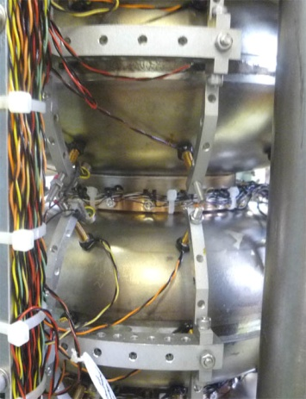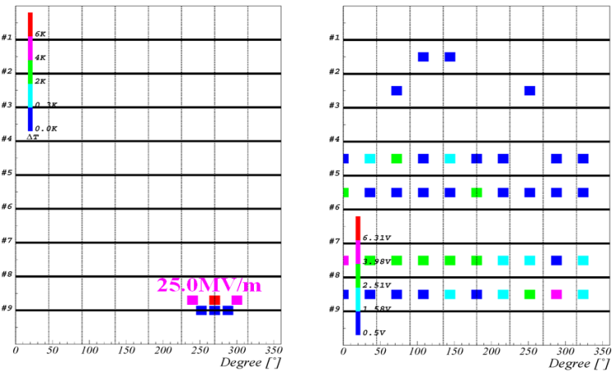

Figure 2.2.3. Cavity vertical test temperature mapping inspection. Sensor installation (left) and temperature rise mapping and X-ray intensity map results (right) are shown.

The development and subsequent upgrade of a cavity surface inspection camera system was done in collaboration with Kyoto University. A newly developed high performance C-MOS camera combined with LED illumination resulted in improved resolution, 10 times brighter and much more long life illumination. Also, in order to inspect various styles of cavities, for example those installed in their EP-jig or helium jacket, a camera cylinder rotation mechanism was developed, an advance beyond simple cavity rotation. Automated image capturing and defect finding software was developed and is the subject of optimisation. Figure 2.2.4. shows the cavity surface inspection camera and an observed inner-surface electron beam welding seam from it.

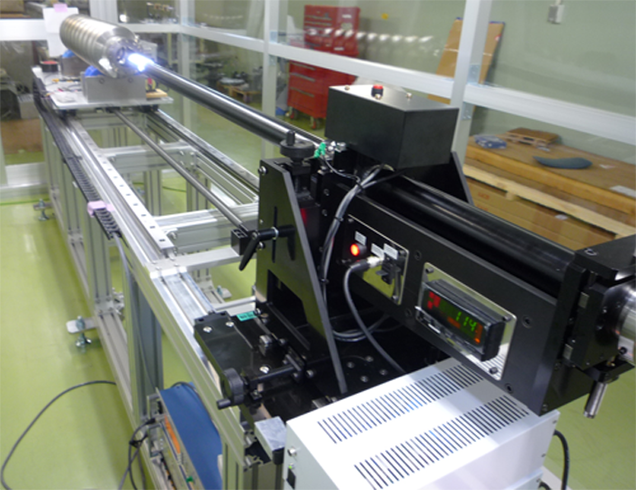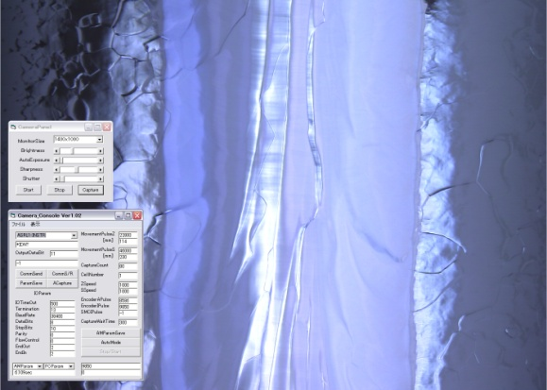

Figure 2.2.4: Improved inspection camera (left) and automated image capture software (right) are shown.

In case a cavity has clearly visible defects inside and its performance is limited by these defects, a surface repair tool is required. A miniature grinding mechanism with very small CCD observation camera that fits within the 78mm diameter of the cavity is shown in Fig. 2.2.5. Recently, this device, together with a technique to get precise internal defect information by creating a mold or replica, have made repair practical at STF. One good example is the 9-cell cavity “MHI-08”. A pit type defect (0.7 mm x 0.5 mm in size and about 115 µm depth) was found using the inspection camera at precisely the 16 MV/m quench location indicated by the thermal monitor system. After grinding and ensuing 50µm surface removal by EP, the cavity gradient performance was improved to 27 MV/m with no observed heating at that location. After an additional two more EP cycles, a gradient of 38MV/m was attained in the 4th low – power VT field test.
Figure 2.2.5. Local grinding tool with expandable motor stage from 50mm diameter cylinder tube

The installation of an automated cavity tuning machine is now underway at STF. The automatic machine was developed in collaboration with DESY and FNAL. The machine has the capability of field flatness tuning and cell-to-cell alignment correction through linked operation between the automated software, bead-pull, 6 jaws cell deforming, and cavity eccentric measurement system. Cavity tuning is expected to take only two hours after the machine is commissioned. Figure 2.2.6. shows the cavity tuning machine assembled at KEK-STF.

Figure 2.2.6. An automate cavity tuning machine assembled at KEK-STF..

A cavity fabrication facility has been planned to study fabrication industrialization at KEK. To lead the industrialization technology development, R&D has to be done through the initiative of the laboratory and at the laboratory. The facility in KEK will include an electron beam welder (EBW), a trimming machine, a press machine and a chemistry facility. The EBW will be delivered in March 2011. The press machine and the trimming machine are already installed and were commissioned in 2010. A fabrication study for industrialization was started for cells and end group components. In order to reduce machining steps, the use of a press machine for the various fabrication processes is now under investigation. Cultivation of new industrial partners is also promoted by this R&D. The cavities fabricated by this facility will be used for ILC-type cryomodules and tested at STF in 2013-2014.

2.2.2. Development of Infrastructure in the Americas

Infrastructure development in the Americas has included a focus on new industrial capabilities to add to existing ones and the development of new diagnostic and test facilities at laboratories. Nearly 100 9-cell cavities sourced from industry in both Europe and the United States have been procured through the Americas regional team for the purposes of improving both infrastructure at the laboratories and capabilities in industry. The typical process for developing a vendor includes production and test of several single cell prototypes and, after successful test of these, progression to production of full 9 cell cavities. At the time of the RDR there was one vendor in the United States qualified to build 9 cell cavities; as of this writing not only has that vendor tuned up their production process to successfully make multiple 9 cell cavities, but a second vendor has recently had their first 9 cell cavity tested. It reached a gradient of 29 MV/m with no field emission. In addition, single cell cavities have been tested from a third Americas region vendor, and we have processed and tested single cell cavities fabricated in India as well.

In parallel with the cavity effort, processing facilities were developed at FNAL/ANL based strongly on the existing capabilities at Jefferson Lab to develop the throughput capacity for both the cavities required for cryomodules and those being used for R&D. This has included the creation of EP and HPR systems and associated rooms at Argonne that are now complete, and the ongoing installation and commissioning of furnaces at Fermilab and Cornell removes the last large bottleneck in the production of cavities and allows capacity for further R&D. To operate the FNAL/ANL facility technicians were located and trained at JLab for extended periods. Throughout this effort, the processing and test of cavities at JLab has continued, and the performance of 9-cell cavities coming from JLab has been consistently excellent. The engineering of this processing facility, and the standardization of the chemical processing steps, has now led to a chemical polishing facility being assembled in industry.

In 2007 the Vertical Test System at Fermilab was commissioned, and since has been utilized at an increasing rate such that two cool-downs per week are now possible, for either 9-cell or 1-cell tests. A unique facility in the Americas, the Horizontal Test Facility at Fermilab for the testing of dressed cavities, was brought on-line in 2008 and has been used since at a rate of approximately 1 per month to qualify the cavity dressing process before assembly into an ILC-style cryomodule, known as CM2.

Production, test and diagnostic facilities at the Americas region laboratories have been enhanced not only by propagation of tools developed elsewhere, such as the Kyoto-KEK camera system, but also through local efforts such as creation of the controls system for the automatic tuning machine (since delivered to DESY and KEK and deployed at Fermilab), second sound quench detection location development, Questar optical inspection system development, automation and software development of the optical inspection process, development of a silicone moulding technique for the 3-D imaging of surface features, development and commissioning of a vertical EP facility, and creation of a fast thermometry system for measurements of quench location / hot spots. Industrial X-ray tomography has been utilized to view voids in the cavity material, typically around the equator welds, that currently appear to be a leading indicator of fabrication difficulties that could lead to quench limitations during tests. With respect to remediation efforts, laser re-melting has been shown to smooth 1-cell cavity surfaces successfully and is minimally invasive, while tumbling techniques are under continued study both as a remediation and a preventative measure.

In addition to cavity fabrication and processing, a full cryomodule assembly facility capable of a throughput of 1 cryomodule per month has been created. The design isstrongly based on the system at DESY in Halle 3, and has been used to date to assemble CM1, and to dress multiple cavities currently undergoing HTS testing in preparation for CM2 assembly.

Leading up to the completion of the TDP phase, the Americas region has additional VTS and HTS facilities on order to increase capacity, and should be well positioned to process and test tens of cavities, finally assembling them into cryomodules in 2011 and beyond. Our diagnostic and test capabilities will continue to be used to diagnose faults earlier and earlier in the fabrication and processing chain, and to feed information back to our vendors.

Figures for Americas Infrastructure: four (or five) photos and the first ILC-spec cavity result (11.2010)

2.2.3. Development of European Infrastructure
-- E.Elsen, S. Aderhold, D. Reschke, H. Weise –

The European SCRF activities are naturally centered on the imminent mass production for the European XFEL. The contracts for the production of some 600 cavities, couplers and tuners have been extended to industry. This development marks an important milestone since the cavity treatment process had to be agreed upon in all detail and specified for mass production. It is also an important milestone for the ILC since although a higher operating gradient is required for the ILC the manufacture with final electro-polishing is deemed identical for European XFEL and ILC. Cryomodules have been produced by various vendors and performed excellently at the FLASH facility so that a sufficient industrial base has become available. Contracts for the production of almost some 80 cryostats will be placed in January 2011.
The cavities will be manufactured with the Nb provided by the European XFEL GmbH. Initial cold tests of the fabricated cavities will be made at DESY; RF-couplers procured, tested and conditioned by LAL Orsay, will be mounted at CEA/Saclay, who will also carry out the string and overall accelerator module assembly. Subsequently the cryomodules will be returned to DESY for test and installation into the European XFEL.
The manufacturing contracts include 24 cavities that will be available for additional treatment for highest gradients and supplemented with couplers and tuners. These cavities are part of the ILC-HiGrade program that addresses the high gradient in the context of cavity mass production.
While the bulk treatment consists in electro-polishing the order for the European XFEL allows for both BCP and EP for the final treatment of the surfaces. The manufacturers are required to meticulously follow the process description and to document the individual steps. A comparison of the two techniques for final surface treatment can be done based on the statistics of several hundred cavities each.
The two manufacturers selected in the tendering process will be supplied with CE certified tools developed by DESY and Fermilab to assess the field and mechanically tune the individually cells for field flatness. These automated tools can be operated by non-RF experts and will provide a standardized log of the recorded data at the same time. The automation has considerably reduced the tuning time.
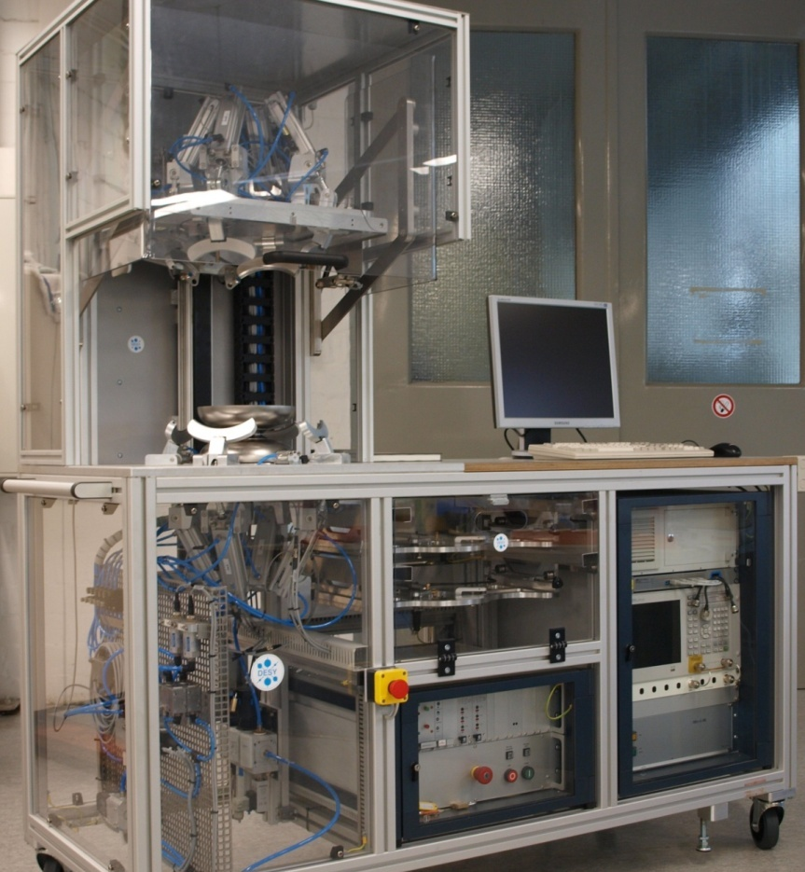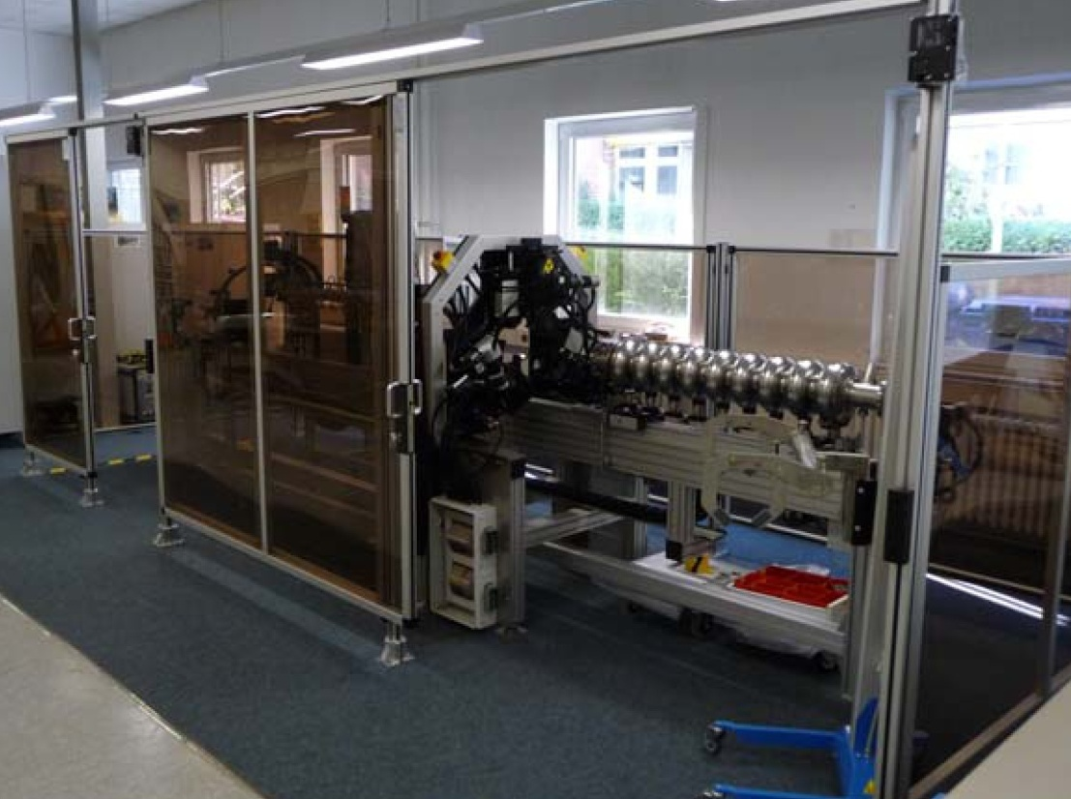

Fig. 2.3.xx The tool for room temperature RF measurement of half cells as required during cavity production, and the tool for field flatness tuning of completed cavities; both tools will be used in an industrial environment
DESY
The first cold test of the cavities proper will be performed at DESY, which thus provides the first feedback on the achieved gradient after manufacture. Most of the cavities will be delivered with the He-vessel mounted except for the ILC-HiGrade cavities.
Much of the existing infrastructure at DESY has been developed at the time of the TESLA collaboration and has been used ever since. Evidently this infrastructure had to be augmented to allow for bulk testing. The Advanced Module Test Facility (AMTF) has recently been built to allow for series test of cavities delivered from the manufacturer.

Fig. 2.3.xx Layout of the AMTF hall at DESY
Here four cavities at a time will be mounted on the so-called insert, which is subsequently lowered into the vertical cryostat and individually tested for performance, which includes a test of peak field performance.
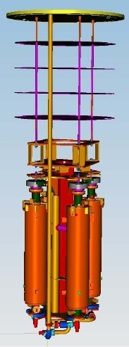

Fig. 2.3.xx The cavity insert holds four cavities at a time for the test in the vertical cryostat.
The facility has been planned for minimal physical handling of the cavities to guarantee high throughput and reproducibility. The test procedure has been standardized and aims for rapid characterization of the cavity performance. It is expected that most of the cavities will pass this test and fulfill the gradient requirement for the European XFEL of 22.4 MV/m. Given the current understanding the treatment of cavities of higher gradient will be no different. Cavities that fail the acceptance test will have to be diagnosed in detail and are subject to post-processing. The reason for failure is typically field emission from the inclusion of particulates in the Niobium surface, or a quench resulting from surface irregularities. The vertical cryostats will be equipped with OSTs, i.e. sensors for detection of second sound signals originating from the source of the cavity quench. The analysis of the second sound propagation time enables the reconstruction of the quench origin by triangulation.
ILC-HiGrade is also preparing an automated optical scanner, which will map the surface close to the electron-beam weld of cell hemispheres and the iris between two cells. The optical scanner uses the Kyoto-KEK developed camera which resolves surface features down to ~10 µm.

Fig. 2.3.xx A 3-d technical drawing of the automated optical scanner for surface inspection.
To facilitate the post-processing the long existing infrastructure at DESY has also been improved. The cleanroom standards have been augmented and the handling steps have been streamlined. The failing cavities lend themselves to an additional short BCP-processing, which removes a Nb-layer of around 10 µm from the surface. Specific action can be taken to address surface features located in the optical scan.
The accepted cavities will be shipped to Saclay for further assembly. The actual shipping procedure has been verified: the shipping tools have been developed and the forces on the cavities during transport have been measured and found acceptable.
CNRS Orsay/LAL
The high-power couplers will be manufactured in industry and are delivered to LAL for conditioning. Eight couplers will be conditioned per week with a maximum RF power of 5 MW. After acceptance test the couplers will be shipped directly to the assembly site in Saclay.
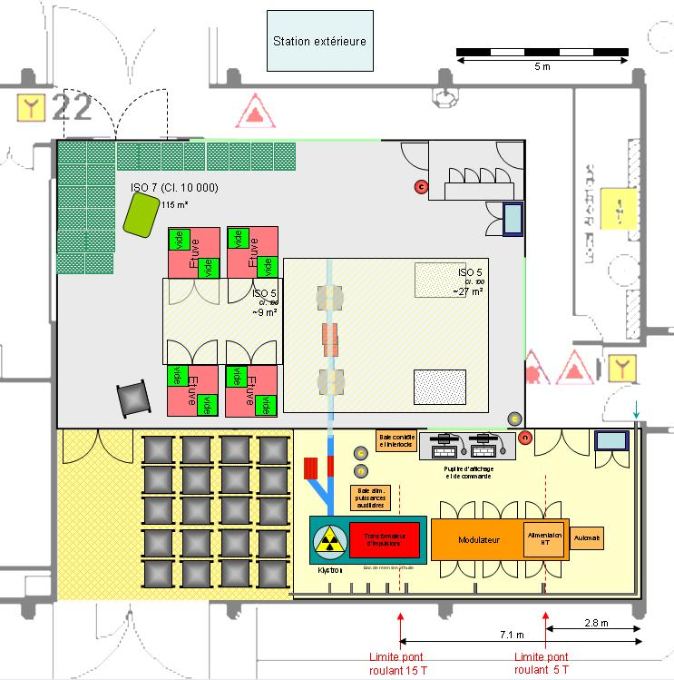

Fig. 2.3.xx Coupler conditioning facility at Orsay
CEA
CEA/Saclay have equipped existing lab space to house the infrastructure for cryomodule assembly. All components will be “washed” before assembly. A large ISO 4 cleanroom and supplemental ISO 5 and ISO 7 cleanrooms have been installed to allow for mounting of the supplied couplers and for assembly of the cavities to a string. Once assembled the string will be precision aligned. The cantilever system will be used to insert the string into the cryomodule.
The infrastructure will initially be used for the components of Spiral 2 and then for mass production for the European XFEL.
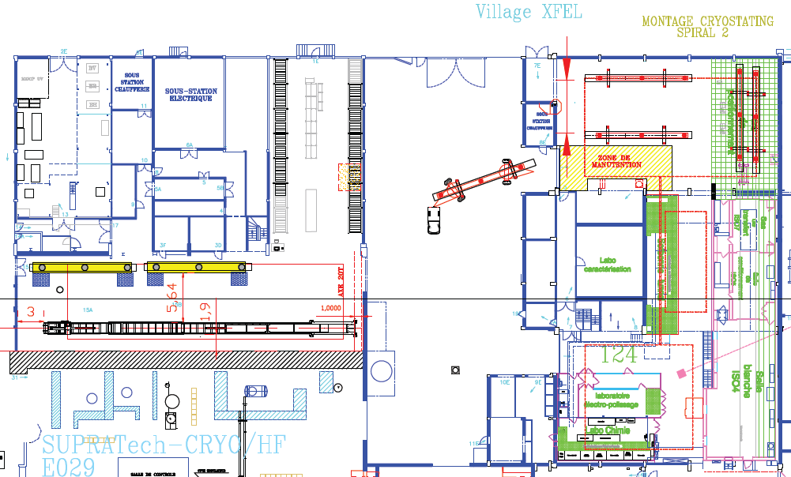

Fig. 2.3.xx Layout of the cryomodule assembly facility at Saclay
FLASH operation
FLASH at DESY is worldwide the only SCRF linac at 1.3 GHz continuously serving a user community. Special high-current runs (9 mA) have been made to exercise ILC-like operation of the linac at highest gradient, longest bunch train and highest bunch charge. These tests have demonstrated that in fact the low-level RF concept does work. The vector sum (over the cavities) can be kept constant over the entire pulse train despite of a large variation in gradient as is discussed elsewhere in this report.

Progress towards reproducible manufacture of high-gradient cavities
R.L. Geng, C. Ginsburg, J. Kerby
2.3.1 Introduction
The gradient choice for the ILC superconducting radio-frequency (SCRF) cavities is important for the beam energy reach and the machine cost. At the time of RDR publication, a choice of 35 MV/m was made for cavity vertical qualification test. This choice was supported by the demonstration of ≥35 MV/m in several 9-cell TTF-shape cavities, resulted from DESY-KEK collaboration. These cavities were surface processed by electropolishing (EP), heat treated at 600-800 °C in a vacuum furnace for hydrogen removal and baked at 120 °C for 48 hours after the final EP.
Achieving 35 MV/m in 9-cell cavities reproducibly is important as the total number of cavities required for the ILC is far more than any SCRF based machines built or planned. A global R&D program (S0 program) was established in 2006 to address this challenge. The S0 program, coordinated by the GDE cavity group, has broad global participation from ANL, Cornell, DESY, FNAL, JLab, and KEK. Significant progress in understanding the gradient limit and gradient scatter has been made by instrumented cavity testing at cryogenic temperatures and high-resolution optical inspection of the cavity RF surface. This is accompanied by steady progress in reproducibility at 35 MV/m and in improved practical gradient limit in 9-cell cavities. At the time of RDR, Europe was the only region to have demonstrated 35 MV/m cavity fabrication and processing. Today, 35 MV/m cavity fabrication and processing has also been demonstrated in Asia and America region. A solid SCRF technical base for the ILC on a global scale is now in place.
The global efforts in ILC gradient R&D are rewarded not only by improved gradient yield and reproducibility but also an extended gradient envelope. By mid 2010, a major SCRF gradient R&D milestone of 50% yield at 35 MV/m has been achieved. The average gradient in the state-of-the-art 9-cell cavities is raised to ~ 40 MV/m, a steady increase compared to the then state-of-the-art 35 MV/m in 2005.

2.3.2 Globally coordinated gradient R&D program – S0 program
The ILC gradient R&D is a global effort with participation of ANL, Cornell, DESY, FNAL, JLab, and KEK. Information is exchanged regularly at the monthly GDE ILC Cavity Group meeting, and diagnostic tools, production procedures and process parameters at times verified by exchanging cavities across the labs and regions. There are growing interests and capabilities of cavity gradient R&D in other labs such as IHEP, PKU, and TRIUMF. Encouraging cavity results are emerging. From history, these R&D initiatives usually drive industrial interest and capability for SCRF cavity manufacture and processing. A global SCRF industry is emerging driven in large part by the demand for higher cavity gradient for the ILC.

2.3.3 Understanding the source of gradient limitation and scatter
The initial S0 effort focused on the issue of field emission, which was identified to be the main cause of gradient variability. Following the recommendation of the Tesla Technology Collaboration 2005 report, R&D priority was given to improved post-EP cleaning procedures. Three methods are now established for effective field emission reduction: (1) Ethanol rising was successfully developed and applied at DESY; (2) Ultrasonic cleaning with detergent was introduced and optimized at JLab; (3) Fresh EP was found effective for field emission reduction at KEK. Some of the methods have been successfully transferred across facilities at different labs.
As a result of the R&D effort, sources of field emission are now understood. Besides the traditional particulate field emitters, niobium oxide granule is found to be a major field emitter introduced by the electropolishing process itself. Wiping and brushing of end group components immediately after EP processing reduces niobium oxide granules (often accompanied by increased sulfur-bearing compounds) in the hidden areas where HPR cleaning is less effective due to lack of direct water jet bombardment. Streamlined clean room assembly procedures are now routinely used, minimizing re-contamination by particulates generated by the assembly process itself. “Field emission free” performance up to 40 MV/m has been demonstrated in several electro-polished 9-cell cavities. Efforts are continuing to develop improved and new cleaning techniques toward the goal of eradicating field emission up to the theoretical quench limit of a niobium cavity.
Our understanding of the source of limiting quench behaviour is much improved thanks to temperature mapping measurements and accompanying high-resolution optical inspection. It is noted that many of the thermometry and inspection instrumentations have been successfully adopted in most labs participating the S0 studies. Kyoto-KEK cameras and Cornell OST systems are two examples. For the ILC 9 cell cavities, a quench limit at < 25 MV/m is found to be caused predominantly by highly localized geometrical defects in the zone adjacent to the electron beam weld seam at the cavity equator. These defects can be roughly categorized as circular pits or bumps with a typical diameter in the range of 200-800 μm. Detailed morphology of the defect can be quite complicated as revealed by replica mould measurements and by microscopic inspection of small samples cut out from real cavities. It is suspected that local magnetic field enhancement at sharp edges are usually observable on the RF surface of as-built cavities. This quench limit due to geometrical defects is insensitive to repeated EP, and there is emerging evidence to show that these geometrical defects already exist prior to any chemistry is done to the cavity surface. It is now generally recognized that, in order to overcome quench limits below 25 MV/m, improved QA/QC in material and fabrication are important.
Further studies are needed to understand the source of quenches at higher gradients in the nominal range of > 30 MV/m. It is clear that higher quench limits are also caused by highly localized defects near the equator electron beam weld, but unlike the geometrical defects, there is typically no observable feature at the predicted quench site. It has been suggested that locally suppressed superconductivity due to compositional irregularities may be responsible. Additional capabilities of compositional analysis “in-situ” at the predicted quench location are expected to shed light on this issue, and off-line microscopic analysis of small samples cut out at predicted quench location (as has been done at DESY) may also going to provide important information for further gradient improvement.

2.3.4 Gradient yield definition and global cavity result database
At the start of the Technical Design Phase, goals of a 50% process yield by 2010 and a 90% production yield at 35MV/m, with a Q0 of greater than 8e9, were defined. As the TDP progressed, the need for a clearer definition of the production yield was recognized, and the need for a globally consistent and available database for recording test results was recognized. In 2009 the GDE ILC Cavity Group proposed a clear definition of gradient yield, which adopted the concept of the first pass and second pass yield and established rules for cavity selection. In parallel the ILC Global Cavity Database Team was created as a part of the S0 effort. The team included members from Fermilab, DESY, Jlab, Cornell, and KEK, and took on the task of not only creating the database, but also defining the rules for how the data should be included, and how the data would be presented. The results of this effort are a clear, objective, and publicly accessible database where the progress of cavity R&D can be tracked. In fact since mid 2009 the database group has done just that, presenting status at each major ILC workshop, meeting or review.
The most recent results for first pass and second pass results, presented in a time phased manner at the IWLC2010 meeting in Geneva, Switzerland, are shown in figure x.xx. By way of definition, plots only includes results from a vendor / laboratory combination who have previously demonstrated through test the ability fabricate and process a cavity that achieves > 35MV/m in a vertical test. A first pass result is one where the fabrication and processing have been completed according to the standard recipe leading up to the first test; a second pass result sums all first pass results greater than 35MV/m and second pass results where the a poorer performing cavity had some remediation applied based on diagnostics from the first test. Apparent from the graphs is the improvement with time of the yield curves, particularly for second pass results. This improvement is attributable to improved diagnostic and remediation tools that have been developed in the past years. Repeatability in EP processing, which was demonstrated in the past two years, plays an important role in improving the second pass yield by raising the gradient performance of cavities quench limited between 25-35 MV/m. A smaller gain is seen in the first pass results. This is consistent with our limited ability to recognize fabrication flaws early in fabrication by means other than vertical testing; improvement of our understanding of the critical fabrication parameters and the development of predictive quality assurance checks are an R&D direction in the upcoming TDP phase.

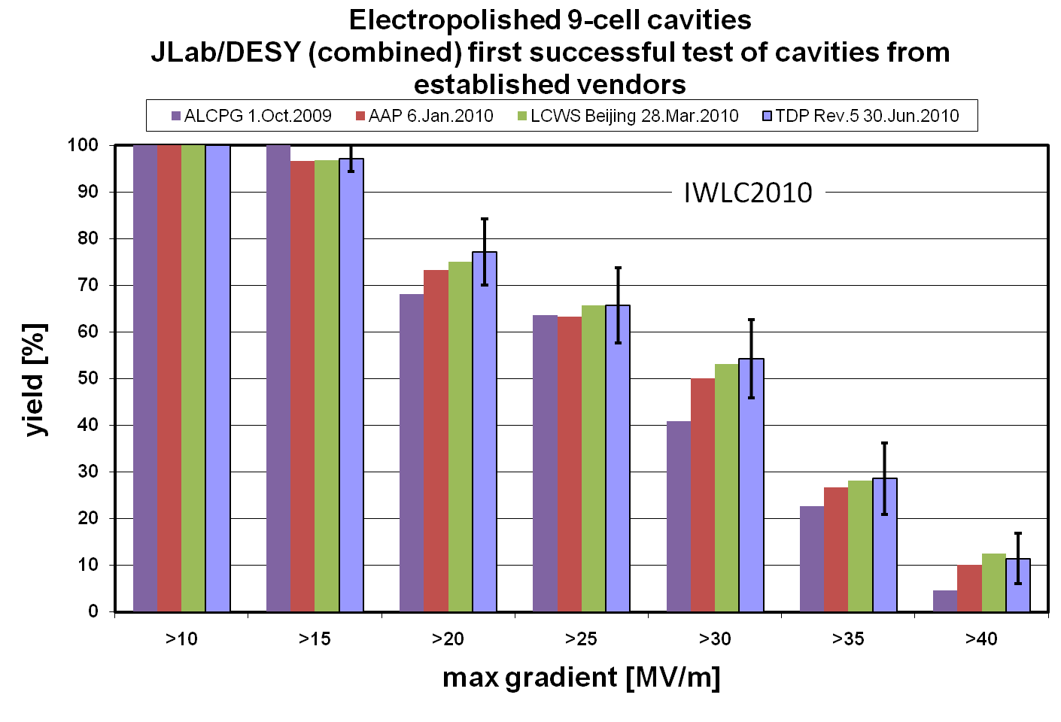
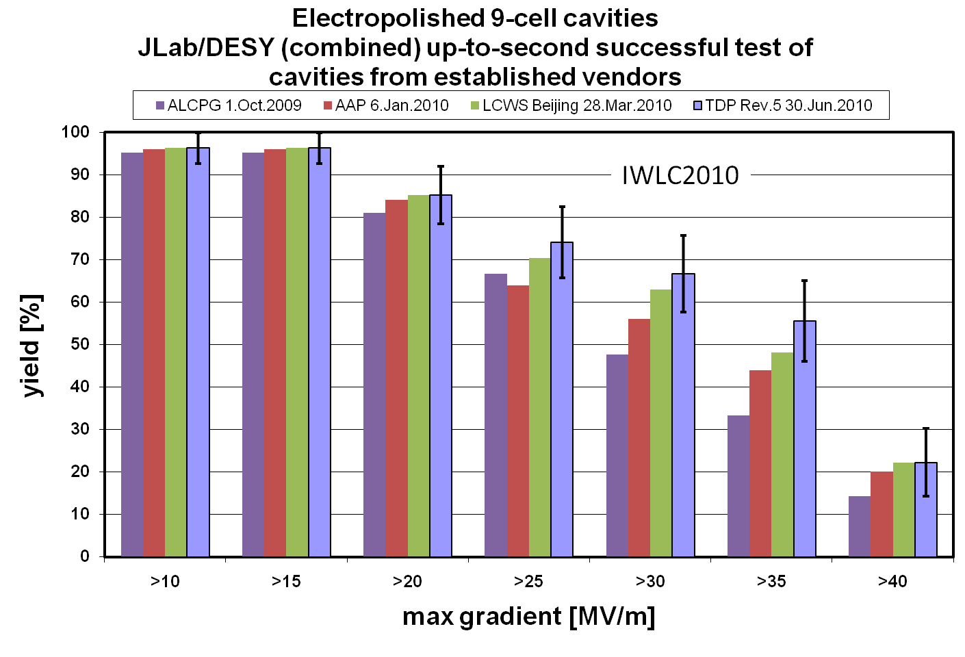

2.3.5 Achieving the TDP-1 gradient milestone of 50% yield at 35 MV/m
The improved understanding of gradient limit goes hand-in-hand with the improvements achieved in cavity gradient yield. Field emission was much reduced due to the application of post-EP cleaning procedures such as ethanol rinsing and ultrasonic cleaning with detergent, with a further reduction in field emission achieved by applying the procedure of continued acid circulation after the EP voltage is turned off. This procedure reduces sulfur-bearing niobium oxide granules and hence reduces inherent contaminants on the as-polished surface. Optimized electropolishing and streamlined clean room assembly resulted in reproducible cavity processing and hence reproducible cavity gradient results.
As a result of the continued improvement and optimization of the cavity processing processes and the continued understanding of the gradient limit, the TDP-1 gradient goal of 50% processing yield at 35 MV/m was accomplished in June 2010 (Fig. xx.xx).

2.3.6 Aiming at TDP-2 gradient goal and an example of 90% yield at 35 MV/m
After successful achievement of the 2010 goal of 50% processing yield, the TDP-2 2012 goal remains a cavity gradient second pass yield of 90%. This is an ambitious goal, but appears possible. Recently, a 90% yield has been demonstrated based on very limited statistics (10 cavities built by one of the most experienced cavity manufacturers and processed and tested at JLab). Our efforts in TDP-2 will focus in two areas: at lower gradient, the modification of the production process to remove mechanical pits and other imperfections that now appear to be a leading cause of lower gradient quench limitations; and at higher gradients; improvement of the processing and assembly techniques that result in improved surface homogeneity and reduced field emission. Though both of these efforts will start in our cavity R&D efforts with remediation of defects or emission seen in the first pass results, the goal will be to understand the problems well enough that our efforts can become predictive, rather than reactive. Our ultimate goal is to feedback knowledge from labs to industry for improved fabrication in industrial manufacturers.
For mechanical defects, use of inspection systems such as the Kyoto-KEK camera, silicone pit modeling or moulding, or x-ray tomography to locate and categorize defects early in the production, and tracing of these defects to performance limiting locations as seen by T-mapping or second sound will require added inspection effort over the next years to create a database of defects and a more detailed understanding of the parameters that directly limit performance. For processing errors, more detailed understanding of the process itself, and the reasonable QA checks to make sure the processes are executed successfully each time, is required. This will include further tweaking of the standard process formula.
Finally, it should be noted that neither of the above R&D directions has been proven to be conclusively ‘the’ answer to the current yield limits. Current performance limitation could vary from vendor to vendor or laboratory to laboratory. Continued incremental improvements will rely on continued extensive inspections, until the exact root causes are proven.

2.3.7 Long-term cavity R&D for very high gradient beyond TDR
Long-term R&D addresses the gradient need for the ILC 1 TeV upgrade. With the improved cavity cell shapes and optimized material properties, one can expect 9-cell niobium cavities with gradients in the range of 40-60 MV/m. There are three proposed cell shapes for very high gradients. The low-loss shape developed at KEK has shown excellent gradient results of ~ 50 MV/m in many single-cell cavities. Several 9-cell cavities have been prototyped and gradients of > 35 MV/m have been demonstrated in 9-cell cavities without and with en groups. The re-entrant shape developed at Cornell has shown the record gradient of ~ 60 MV/m in a single-cell cavity. The first 9-cell re-entrant cavity has been built and efforts are under way to push for very high gradient. A new “low surface field” shape has been designed at SLAC. Planning is underway at JLab to prototype the first single-cell and multi-cell low surface field shape cavities.
In addition to the cell shape development, one can also expect benefit from continued optimization of niobium material. There is evidence that heat treatment, at various stages such as post-forming or post-fabrication, may have significant room for improvement for achieving very high gradients. As the shape improvement and material improvement are two independent paths and both are compatible with the EP processing procedure, one can expect significant gradient improvement toward the range of 40-60 MV/m by using the current baseline cavity processing procedures.
It is generally agreed that gradient up to 100 MV/m in superconducting RF cavities is theoretically possible by switching to other superconducting materials, but significant fundamental R&D is required. Active programs now exist in this direction pursued by several groups at ANL, Cornell and JLab etc. It is recognized that the most promising path lies in the thin film coating of new material on copper or aluminum substrates pre-formed into suitable cavity shapes. Given the potential high return, R&D of new superconducting RF material and cavity system development should be intensified after the TDR in order to support the physics scenario of ≥ 1 TeV for the ILC.

Cryomodule design and development
(Estimate page count: 5, and principle authors: N. Ohuchi, P. Pierini, T. Peterson)

Most of the effort and resources spent on ILC cryomodule activities since the publication of the RDR and the beginning of the Technical Design Phase have been devoted to the collaborative S1-Global program. Taking advantage of experimental activities at KEK in the framework of this worldwide effort, several ILC cryomodule design issues have been addressed, like the assessment of the thermal performance of the intermediate 5 K shields and the investigation of diverse tuner and magnetic shielding solutions. The experience gained from S1-Global, which integrates different variations of components (e.g. cavities, magnetic shielding, couplers and tuners) from several collaborating partners into a single cryomodule, is also very important for the assessment of all the "plug-compatible" interfaces of the cryomodule for the future ILC plans.

2.4.1. Progress in the S1-Global cryomodule program hosted at KEK
The S1-Global [1] project is dedicated to the realization of the cryomodule R&D objective (S1) within the framework of GDE international research collaboration. The ‘Realization of an average accelerating gradient of 31.5 MV/m with 8 cavities’ in the S1-Global (S1-G) cryomodule, composed of components contributed by the different collaborating partners, is the primary goal.
The general plan for the S1-G project is shown in Fig. 2.4.1. The cryomodule design work started in May 2008 with the joint team of INFN, FNAL and KEK, and the design of this cryomodule was completed at the end of 2008. The S1-Global cryomodule consists of two 6-m cryomodules, Module-A and Module-C, shown in Fig. 2.4.2. Four cavities from FNAL and DESY are installed in Module-C, and four cavities in two different kinds of cavity-jackets developed by KEK are installed in Module-A. The total length of the S1-Global cryomodule is 14.9 m. The parameters of the two 6-m cryomodules are listed in Table 2.4.1. During 2009, INFN procured the Module-C components, KEK performed the modification of Module-A from one of the original STF modules [2], and DESY, FNAL and KEK produced and tested the 8 cavities and couplers needed for the S1-Global program. The S1-G cryomodule was assembled and installed in the KEK-STF tunnel from January to May 2010. At present, the cold tests are in progress, (June 2010 through February 2011). Figure 2.4.3 shows a picture of the completed S1-G cryomodule in the STF tunnel. The contributions of the participating laboratories demonstrate the collaborative framework of S1-G:

- INFN: Design and construction Module-C and production of the blade tuners for the FNAL cavities.
- FNAL: Two TESLA type cavities [3], power couplers and integration of the INFN blade tuners in the cavity packages.
- DESY: Two TESLA type cavities, including Saclay-type tuners, and power couplers.
- SLAC: Two sets of VTO power distribution for Module-C, and processing of FNAL couplers.
- KEK: Four TESLA-like cavities, with two variations of tuner/jacket design, Module-A for KEK cavities, power distribution for Module-A, and infrastructure for tests.

In addition to the main target of demonstrating an average accelerating gradient of 31.5 MV/m with 8 cavities during the cryomodule testing, the S1-G program has the following R&D goals:

- The operation at an average accelerating gradient of 31.5 MV/m in pulsed RF conditions at 5Hz with 1 ms flat-top length, under stable conditions: 0.07% rms amplitude variation and 0.35 degree rms phase variation [4].
- To gain experience with the design, assembly and the alignment procedures for different types of cavity packages from participating parties.
- The measurement and comparison of the cryogenic performance for each cavity package and cryomodule (in terms of heat loads to the 2 K environment), in the static and high accelerating field dynamic conditions.
- The comparative studies of RF performances of the cavity packages (including tuner concepts) from the participating institutes.
- Advancement in the implementation of the ‘plug-compatible concept’ for the ILC activities.

The S1-G cryomodule has been cooled down to 2 K twice since June 2010. The temperature changes of all the cavities at the second cool-down are shown in Fig. 2.4.4. The cold tests of S1-G cryomodule are ongoing, and the summary report of the experimental activity is to be reported after the completion of all scheduled tests.

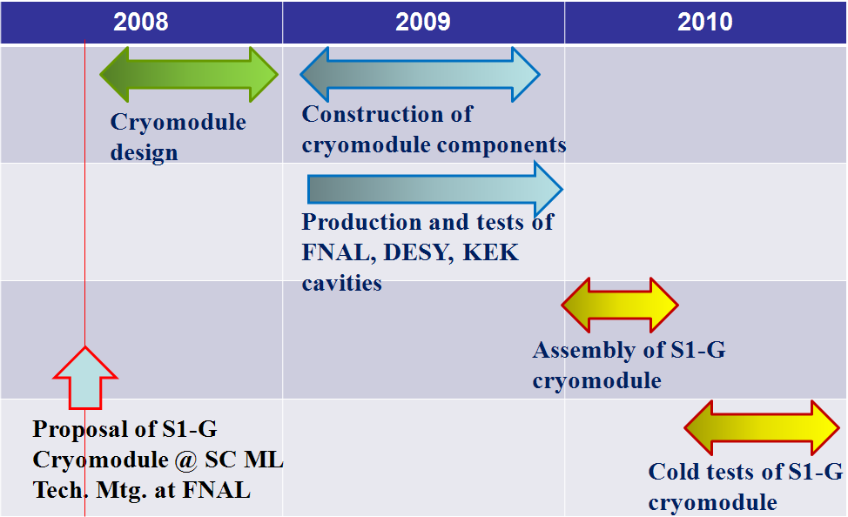

Figure 2.4.1. General schedule of S1-Global project.

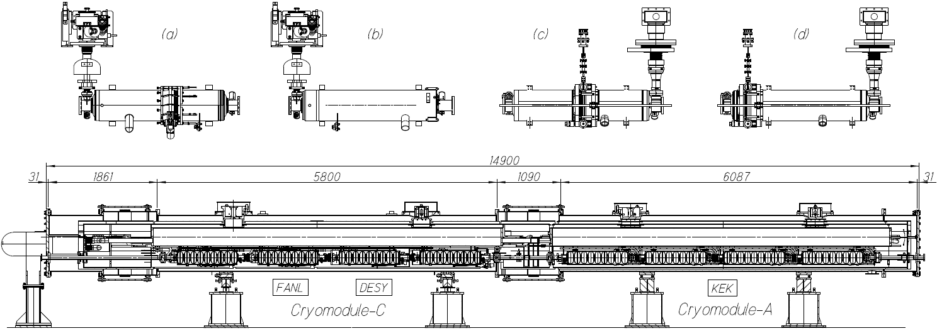

Figure 2.4.2. S1-G cryomodule and cavity package of each laboratory. (a): FNAL cavity with INFN Blade tuner, (b): DESY cavity with Saclay-type tuner, (c): KEK-a cavity with slide jack tuner and (d) KEK-b cavity.
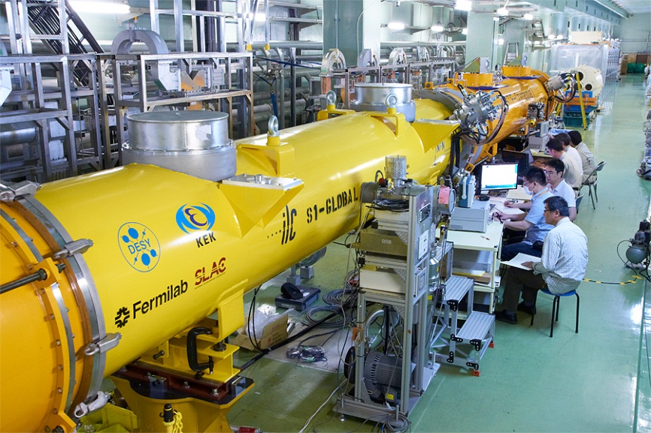

Figure 2.4.3. Completed S1-G cryomodule, in cold and low power test.

Table 2.4.1: S1-Global Cryomodule Parameters
 | Module-A | Module-C
Vacuum vessel length | 6087 mm | 5800 mm
Vacuum vessel O.D. | φ 965.2 mm | φ 965.2 mm
Gas return pipe length | 5830 mm | 6000 mm
Gas return pipe O.D. | φ 318.5 mm | φ 312.0 mm
2K LHe supply pipe O.D. | φ 76.3 mm | φ 76.1 mm
5K shield pipe O.D. [F/R] | φ 30/φ 30 mm | φ 60/φ 60.3 mm
80K shield pipe O.D. [F/R] | φ 30/φ 30 mm | φ 60/φ 60.3 mm
Cool-down pipe O.D. | φ 27.2 mm | φ 42.2 mm
Distance b/w couplers | 1337.0 mm | 1383.6 mm
Cavity package | KEK-a/KEK-b | FNAL/DESY
Cavity type | TESLA-like | TESLA-type
Tuner type | Slide jack | Blade/Saclay
Input coupler type | Disk window | Cylindrical window
Magnetic shield | Inside jacket | Outside jacket
Package length | 1247.6 | 1247.4/1283.4

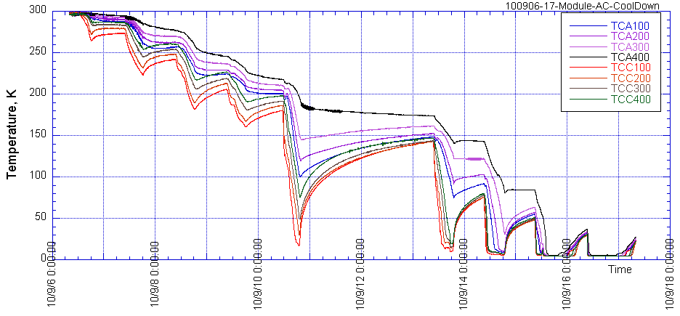
Figure 2.4.4: Cooling condition of 8 cavities at the second test term

2.4.2 Progress in E- XFEL project hosted at DESY and R&Ds at Fermilab
It may be worth to note that the European XFEL Project is now in its construction phase, with commissioning expected in 2014 [9]. The XFEL superconducting linac consists of nearly 100 cryomodules with a design derived from the TTF Type III, on which the ILC module design concept is based. The industrial vendors have been qualified, and the project is moving forward to the start of the series production. The XFEL Project will therefore soon provide much experience from a relatively large series of production in an industrial context and that will bring valuable information for the industrialization of ILC cryomodules.

At Fermilab, Cryomodule 1 (CM-1), an ILC Type 3 cryomodule made from parts provided by DESY, INFN, and Fermilab has now been cooled-down and tests are underway at the New Muon Lab (NML) test facility at Fermilab. Dressed cavities for CM-2 are being tested in Fermilab’s Horizontal Test Cryostat. In addition, design work is proceeding on cryomodules for Project X, a high intensity proton linac proposed for Fermilab’s next generation of neutrino experiments and other studies. Project X cryomodules, being continuous wave and low beta for protons, differ in various ways from ILC-type cryomodules but will benefit greatly from the ILC experience.

2.4.3 Cryomodule design with Plug-compatibility
In order to develop an industrialized design of the ILC cryomodule, the plug- compatible interfaces of the cryomodule have been defined in Table 2.4.2. A detailed and more exhaustive parameter list should be defined and agreed upon in future studies.

Table 2.4.2: Plug compatible interfaces of cryomodule
Interface | Item | Parameter
Cryomodule slot | Length | 12679.6 mm
Vacuum vessel | Length/Outer diameter/Support | 11830 mm / 965.2 mm / TBD
Vacuum bellow | Length | 849.6 mm
Vacuum flange | Diameter/Thickness/Connection | TBD
Input coupler connection flange on the vacuum vessel | Diameter/Thickness/Connection | TBD
Cavity support lug | Span/Lug width and thickness | 750 mm / TBD
Cooling pipes | Position/Diameter/Material | Cooling pipe parameters are specified by the cryogenic group.

2.4.4. Study of thermal balance with and without 5K radiation shield
The specific heat loads in the three cryogenic circuits of one ILC cryomodule (at the temperature levels of 2 K, 5 K and 40 K) are listed in Table 2.4.3, calculated from the values of one RF unit as shown in RDR [4].

Table 2.4.2. Heat Loads of one ILC cryomodule from RDR
 | 2 K | 5 K | 40 K
Static load, (W) | 1.7 | 10.6 | 59.2
Dynamic load, (W) | 9.7 | 4.4 | 94.3
Total load, (W) | 11.4 | 15.0 | 153.5

In the 5 K circuit, the heat load by thermal radiation was evaluated to be at 1.41 W. The present ILC cryomodule scheme, derived from the TESLA Test Facility cryomodules [5], has two thermal shields circuits. The “5K” circuit contains helium pressurized above the 2.3 bar critical pressure which warms from 5 K to 8 K through the circuit.

The “40 K” circuit contains helium gas warming from 40 K to 80 K. In case of removing the 5 K thermal radiation shield, investigated as a means to simplify the module and decrease the fabrication costs, thermal radiation from 40 K screen would directly impinge into the 2 K region, increasing sensibly the module 2 K heat load. However, by modifying the 40 K thermal shield flow scheme as shown in Fig. 2.4.5 [6] and by rearranging the thermal intercept strategy, this additional contribution could be mitigated. The improvement is obtained by using the forward line to lower the temperature of the thermal shield from 74 K to 46 K while using the return (warmer) line to provide the thermal intercepts of input couplers and current leads, thus increasing the average intercept temperature from 54 K to 66 K. With this thermal strategy, different with respect to the TTF modules, the radiation heat load from the 46 K shield towards the lower temperatures is reduced to 0.22 W. Therefore, in this case the removal of the 5 K level thermal radiation shield increases the heat load at 2 K only by this amount.

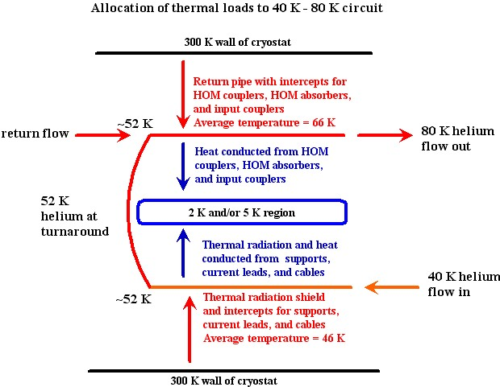

Figure 2.4.5. Proposed new cooling scheme of ILC cryomodule

In order to have a confirmation of this analysis, an experimental study of the 5 K shield was performed using a 6-m long KEK-STF cryomodule [7]. The KEK-STF cryomodule design is based on the TTF-III cryomodule design with similar components and two thermal shields at 5 K and 80 K. Figure 2.4.6 shows cross-sections of the KEK-STF cryomodule. In order to measure the 2 K heat load at the cavities, four dummy cavity vessels were installed in the cryostat. The heat load into these four dummy jackets was measured first with the full 5 K shield installed and then after the removal of the lower portion of the 5 K shield. The test cryomodule parameters are summarised in Table 2.4.4. Experimental results were compared with thermal calculations.

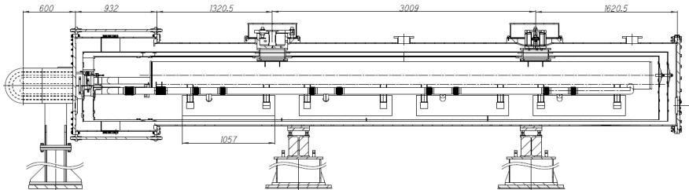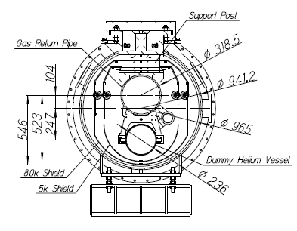

Figure 2.4.6. Cross Sections of KEK-STF Test Cryomodule B

Table 2.4.4. Parameters of KEK-STF Test Cryomodule B
Vacuum vessel | Steel-SS400 | Dummy helium jacket | SS304L
Length, mm | 5950 | Length, mm | 1057
Diameter, mm | 965.2 | Outer/Inner diameter, mm | 236/230
80K thermal shield material | Al | Gas return pipe | SS316
Cold mass, kg | 215 | Outer/Inner diameter, mm | 318.5/297.5
5K thermal shield material | Al | Liquid helium supply pipe | SS304L
Cold mass, kg | 190 | Outer/Inner diameter, mm | 76.3/72.1

The four dummy cavity jackets are supported from the gas return pipe with C-clamps and roller-bearings, in the same way as the real cavity helium vessels. These dummy jackets have the same size as the 9-cell cavity jacket in order to expose the same cold surface to the thermal radiation from the surrounding environment. The length of the dummy vessel is 1057 mm, and the outer diameter is 236 mm. Each dummy vessel contains 43.3 liters of liquid helium. The bare surfaces of the dummy jackets were exposed to the thermal radiation impinging from the shields while the gas return pipe was wrapped with 5 layers of multi-layer insulation, to minimize the radiation load. The thermal shields of the module are composed of several parts and, in order to evaluate the thermal performance of the 5 K shield, the lower part was removed. Heat loads were measured by the evaporation rates of the 2 K LHe circuit.

The measured data are summarized in Table 2.4.4. Heat loss measurements were performed under the two thermal conditions by changing the level of liquid helium. The effect of the intercepted radiation from the 84 K thermal shield was evaluated by the difference between the heat loads with and without the lower portion of the 5 K shield. In the first thermal condition, this difference was found to be 0.78 W, in the second condition (lower liquid helium level), the difference was 0.80 W.

By means of an ANSYS model, and the heat loads of the measurements with the complete set of the upper and lower 5 K shield sections and without the 5 K lower shield were calculated. In the model, the thermal emissivity of 0.2 (corresponding to mechanically polished SS304 surface [8]) was assumed for the dummy vessel, and the emissivity of the Al thermal shield was 0.06 [8]. A stationary temperature profile was assumed as follows: the dummy vessels at 2 K, the 5 K shield parts at 5 K, the 80 K shield at 84 K and the vacuum vessel at the room temperature of 300 K. The ANSYS model evaluates the heat load at 2 K without the 5 K lower shield to be 0.849 W, and the load with the full 5 K shield 1.4×10⁻⁵ W. The calculated difference between these two cases is consistent with the measurement summarized in Table 2.4.5.

Table 2.4.5: Summary of the heat load measurements
 | LHe level  % | Temp. LHe, K | Temp. 5K shield, K | Temp. 80 K shield, K | Evaporation,  g/s | Heat load,  W
With 5 K shield | 77 | 1.93 | 4.82 | 84.5 | 0.132 | 3.07
w/o 5 K lower shield | 77 | 1.96 | 4.51 | 84.2 | 0.167 | 3.85
With 5 K shield | 63 | 1.93 | 4.81 | 84.9 | 0.048 | 1.11
w/o 5 K lower shield | 71 | 1.96 | 4.51 | 84.0 | 0.083 | 1.91

Using the ANSYS thermal model, the heat load was then re-calculated by assuming Super-Insulation on the cavity jackets (with an assumed emissivity of 0.03) and a lower temperature of the external thermal radiation shield of 46 K, according to the revised flow scheme proposed by Tom Peterson and presented above. The predicted heat load on the four jackets at 2 K is now 0.02 W, and the heat load on the gas return pipe and helium supply pipe is 0.037 W. The total heat load at 2 K by radiation therefore is 0.057 W. The ILC cryomodule has a double length compared to this test cryomodule. The heat load increment at 2 K by removing the lower 5 K shield portion is estimated to be 0.114 W for the full length ILC cryomodule, under the assumptions of implementing in the design the revised cooling scheme presented in Fig. 2.4.7.

For future assessment of the ILC cryomodule thermal design, the cost implications of removing the lower part of the 5 K shield should be studied in detail, in particular concerning the following aspects:

- Capital and assembly cost reductions of the lower shield components.
- Capital and operational cost increase of the cryogenic system due to the additional heat load.

The effect on the assembly time and costs for providing the 5 K thermal intercept to other components, like main and HOM couplers. For example, the cross sections of the cryomodule with the 5 K shield and without the lower part of the 5 K shield are shown in Fig. 2.4.7. In the proposed design, the cooling line at 5 K is preserved due to the need to provide the thermal intercepts of the input couplers, support posts and RF cables.

Figure 2.4.7: Cross section of the cryomodule with two thermal shields and without the lower part of 5 K shield

2.4.3. Study of the Magnetic Shield assembly
Different magnetic shield solutions are being developed by several institutions and are being studied from the point of view of cryomodule assembly operations. The magnetic shields of DESY and FNAL cavities are assembled outside of the cavity jacket, whereas the shield of KEK cavity is internal to the helium jacket. From the ongoing tests the four KEK cavities achieved higher average field gradients in the S1-G cryomodule than in the vertical tests, thus proving that the magnetic shield system inside the helium jacket has performances equivalent to the outer shields of the DESY and FNAL cavities. Figure 2.4.8 shows the relative complexity of the magnetic shields of DESY, FNAL and KEK cavities, which consist of 24, 10 and 6 parts, respectively. The number of components of the KEK shield can be further reduced to 3 pieces of both ends and one cylindrical centre part.

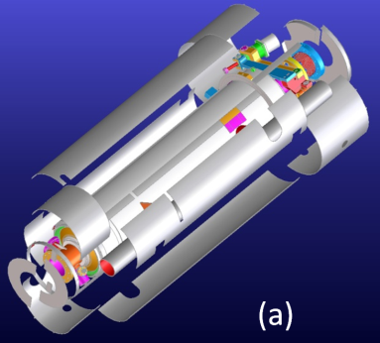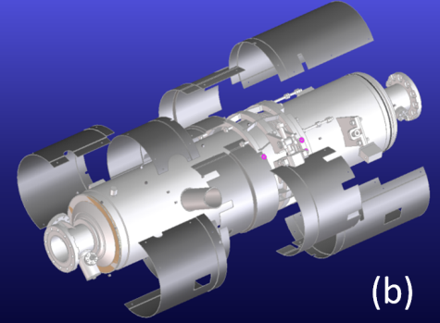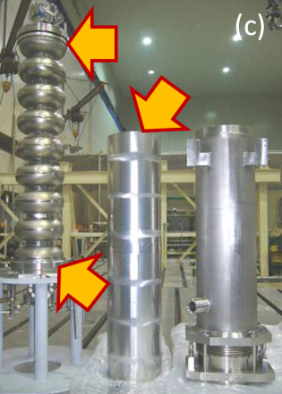
Figure 2.4.8: Magnetic shields of DESY cavity (a), FNAL cavity (b) and KEK cavity (c).

During the S1-G cryomodule assembly, the DESY cavity jackets were wrapped by multi-layers of Super Insulation and the magnetic shield components were then assembled externally, whereas the shield components of the FNAL cavities were assembled directly on the jackets and the Super Insulation was wrapped around them. Between the cavities, the beam pipes were shielded with the other portions of the magnetic shields and the connection of all RF and signal cables to HOM couplers and piezo-electric movers needed to be completed during this assembly. The assembly of the magnetic shields for all 8 cavities and the routing of the RF cables required the work of two persons for one week.
On the other hand, for the S1-G KEK cavities, the magnetic shield is introduced in the cavity during the fabrication process and no assembly procedure is required during the module installation. Furthermore, the beam pipes were not covered with the magnetic shield and the cable connection to HOM and Piezo was effortless and easy, requiring one day by a single technician. Additional work is required to install the magnetic shield in the jacket during the cavity production, however, this assembly is a very simple operation and the required time is considered to be short.

In view of pursuing lower costs for the cryomodule construction and assembly phases, the magnetic shield design should be re-considered within the ILC cavity package, and as the next step, the cost study of these two different systems should be performed.

[1] N. Ohuchi, et al, LINAC10, Tsukuba, September 2010, MO302; http://www.JACoW.org.
[2] N. Ohuchi, et al., EPAC08, Genoa, June 2008, MOPP144, p. 892 (2008); http://www.JACoW.org.
[3] B. Aune, et al., Phys. Rev. ST-AB, 3(9), Sept. 2000.
[4] N. Phinney, et al., ILC RDR Accel., ILC-Report-2007-001, p.III-171, (2007); http://www.linearcollider. org.
[5] C. Pagani, et al., “TESLA Cryogenic Accelerator Modules”, TESLA Report 2001-36.
[6] T. Peterson, “Cryomodule Thermal Intercept Optimization Strategy”, TILC08-Sendai, March 3-6, Sendai, 2008.
[7] N. Ohuchi, et al., presented at ICEC23, 21A-PS-3-05, Wroclaw, July 19-23, 2010.
[8] Hands, B.A., In: Cryogenic Engineering, Academic Press, USA(1986)107-112.
[9] http://www.xfel.eu

High-Power RF development
(Estimate page count: 8, and principle authors: S. Fukuda, C. Nantista)
(edit updated: Dec. 18-22, by Akira Yamamoto)

In the Reference Design Report (RDR) [1], the high power rf equipment and layout had reached a fairly mature state. The klystrons, modulators, and related equipment were housed in a parallel utility tunnel, connected every 38 m to the main linac tunnel by a penetration through which waveguides carried up to 10 MW of L-band (1.3 GHz) power, to be distributed along three cryomodules. Extensive ongoing work has been required mainly due to the fundamental change in tunnel configuration. With the move to single-tunnel main linac housings, the production and distribution to the cavities of radio frequency (rf) power had to be rethought. Two proposed options are currently being pursued by ILC R&D programs. They are referred to by the acronyms KCS (Klystron Cluster System) and DRFS (Distributed RF System).

2.5.1 Klystron Cluster System
2.5.1.1 System Description
In the KCS scheme [2], rf production is moved to the surface. Unlike in the RDR, where it is brought down as AC wall-plug power, or the European XFEL, where it is brought down as DC cable power to underground klystrons, with KCS, the power used to accelerate the beam is transported between the surface and the underground tunnel as rf. This approach of sending power down as rf follows the example of the SLAC linac, which served the only previous linear collider, the SLC. The differences arise from having to accommodate a deep bored (as opposed to “cut-and-cover”) tunnel, which makes shafts expensive, and from the need to minimize surface impact over what will be a much larger footprint.

Thus the idea of clustering is adopted. Power from groups of approximately thirty-four 10 MW klystrons is combined into a single low-loss, overmoded waveguide and transported down to the tunnel and along the linac as shown in Fig. 2.5.1.1.1. This is sufficient, allowing for a few percent extra transmission loss, to power approximately 1.06 km of ILC linac. At 38 m intervals, partial power is siphoned from this main waveguide in 10 MW decrements. From each such tap-off, the rf is distributed to the cavities (26 in three cryomodules) through a WR650 waveguide system, just as it would be from a local klystron.

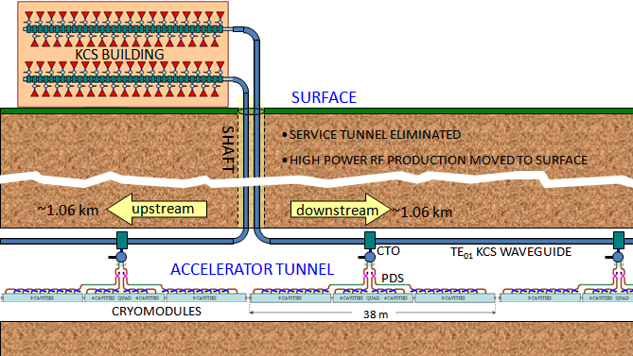

Figure 2.5.1.1.1: Basic layout scheme of the Klystron Cluster System (KCS). Many high power rf sources in a surface building combine into a large circular

To minimize the number of buildings and shafts required, each houses two klystron clusters with one feeding upstream and the other downstream, powering over two kilometers of linac per shaft. Besides the KCS main waveguide artery, some equipment from the service tunnel, such as front-end feedback electronics and beam instrumentation, is added to the linac tunnel, in shielded crates below the cryomodules. No increase in tunnel diameter is foreseen. In addition to the civil construction cost savings associated with going to a single tunnel, this scheme brings the heat load associated with the rf production equipment to the surface, greatly facilitating cooling.

2.5.1.2 Klystrons and Modulators
In the RDR, a 10 MW multi-beam-klystron (MBK) was identified as the ILC L-band power source. This choice was based on cost effectiveness, efficiency and relatively low operating voltage, and takes advantage of years of R&D for TELSA and the European XFEL. Prototypes had been built by CPI, Thales, and Toshiba. The KCS option retains this source. A Toshiba tube is being operated at SLAC for reliability/lifetime studies.

As a plug-compatible alternative to the MBK, the SLAC Klystron Department has been developing a sheet beam klystron (SBK) [3]. With a 40:1 beam aspect ratio, it was expected to achieve similar efficiency while allowing the use of permanent magnet focusing. A beam tester was built and operated. Unfortunately, after much design work aimed at understanding and addressing the problem of beam instabilities due to modes in the drift “tube” between cavities, this program has been discontinued. Increase of the drift height had necessitated a switch to solenoidal focusing which reduced the potential benefit of this approach.

The modulator requirements for the klystrons are 120 kV, 140 A, 1.6 ms pulses at a 5 Hz repetition rate. As an alternative to the RDR baseline design, SLAC is pursuing a Marx-topology modulator to fulfil this requirement with a reliable and cost-effective approach [4]. A full-scale prototype, the SLAC P1 Marx, is currently undergoing lifetime testing, driving the above-mentioned 10 MW Toshiba MBK. In the accumulated 1,500 hours there have been no chronic problems. A second-generation Marx, the SLAC P2 Marx, is currently under development [5].

The Marx is made up of many identical and, ideally, redundant cells. If a cell becomes inoperable, it can be bypassed. Increasing the applied charge voltage or turning on ‘spare’ cells allows the modulator to continue operation. In addition, a modular design allows better utilization of high-volume manufacturing techniques, thereby reducing costs. Finally, portable cells allow maintenance staff to quickly replace inoperable cells with pre-tested replacements, reducing the mean repair time.

The SLAC P1 Marx operates in air, has no output transformer, and is air-cooled as shown in Fig. 2.5.1.2.1. The Marx utilizes an FPGA-based control system. A diagnostic module on each cell, along with the ground station and a cell control board, coordinates the timing of the cells. The diagnostic card has four analog input channels monitored at 20 kS/s with a resolution of 16 bits. A fast transient recorder can also be used at 30 MS/s with 8-bit resolution. In the SLAC P1 Marx, sixteen, 11 kV Marx cells are arranged with a single “Vernier” Marx. The triggering sequence of the main Marx cells is designed to promptly turn-on eleven cells, then stagger turn-on the remaining five cells to coarsely compensate the storage capacitor droop. The Vernier Marx (with cells charged to ~1 kV) staggers its turn-on and turn-off to further regulate the output to the specified level of ±0.5%.

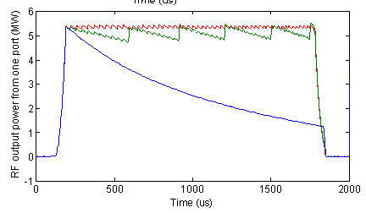

Figure 2.5.1.2.1 (a) : Photograph of the SLAC P1 Marx modulator showing its cantilevered support structure, high-voltage grading rings, and sixteen installed cells. (b) RF waveforms from one of the two klystron ports: Blue: no droop compensation, Green: with only delay cells, Red: with delay cells and vernier, producing a flat pulse with a 3% saw-tooth pattern.

Building upon the success of the P1 Marx, the SLAC P2 Marx is currently in the final stages of design. It includes thirty-two, 3.75−4 kV cells. This modulator will be able to produce the specified power with up to two of the cells offline. Three notable differences distinguish it from P1. First, a nested droop correction scheme is employed in the P2 Marx. Each cell individually regulates its output, removing the need for a separate compensation element (like the Vernier in the P1 Marx). Second, there is no arraying of solid-state switches within a cell, simplifying the control and protection schemes. Third, the modulator layout is redesigned to have a single side access.

2.5.1.3 Main Waveguide and Tap-Offs
For low transmission loss and robustness against rf breakdown, overmoded circular waveguide operated in the TE₀₁ mode is used as the main high power rf conduit; the attenuation drops faster with radius for this mode than for others, and it has no electric fields terminating on the wall. The diameter chosen is 0.480 m, at which the added ohmic transmission loss along a KCS should be ~6.5%. With power levels on the order of 300 MW, this main transmission waveguide will likely be evacuated and thus need sufficient wall thickness, about 1 cm. Mode conversion considerations suggest radius, roundness, and alignment tolerances on the order of a millimeter and a straightness tolerance of half a degree. The flange joint between pipe sections will be designed to include sufficient longitudinal flexibility to take up local thermal expansion, while maintaining concentricity and straightness. An insulation jacket and water cooling will be used to keep much of the main waveguide’s heat load (averaging ~130 W/m) from the tunnel air.

Overmoded waveguide is not trivial to manipulate, as geometrical changes like bends tend to scatter power into parasitic modes. Each main waveguide will need to undergo probably three 90° bends, downward into the shaft, then toward and along the tunnel. These occur at maximum power, between the last tap-in and the first tap-off, and will unavoidably have surface electric fields, so the design will be a challenge. They must have excellent port-to-port mode preservation and high power handling without being excessively bulky. TE₀₁ mode bends exist at X-band, and design options for KCS are currently under consideration.

For tapping off rf power from the main circular TE₀₁-mode waveguide without breaking the azimuthal symmetry, and thus introducing surface electric fields, in the very high-power region, a special waveguide component was designed, referred to as the coaxial tap-off, or CTO [2]. The idea of this device involves stepping up the diameter from below to above the TE₀₂ cutoff in such a way that roughly half the power is converted, creating a mixture of the two modes. The radial distribution of electric field then varies longitudinally as the two modes beat, due to their different guide wavelengths. At an appropriate distance, this beating is terminated by reintroduction of a wall at the original radius, separating the inner volume from a coaxial outer volume and dividing the power between the two in circular and coaxial TE₀₁ modes.

To then extract the stripped power, the coaxial guide is shorted, and power is coupled through eight radial apertures into a wraparound waveguide and thence through two standard WR650 rectangular output ports as shown in Fig.2.5.1.3.1. The gap between the step and the dividing wall is varied over ~14 cm to achieve the many different fractional power couplings needed, ranging between 0.03 and 0.5, and a small customized ridge before the step is used to cancel any mismatch. The coaxial and wrap-around region should never see more than about 10 MW, whereas the power in the inner region tops 300 MW. If KCS is evacuated, a 5 MW pillbox window on each rectangular CTO port will transition to the pressurized distribution waveguide.

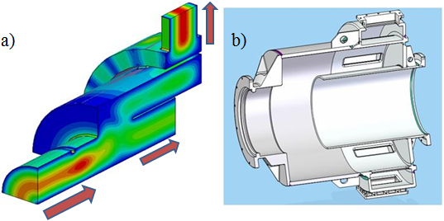

Figure 2.5.1.3.1: a) Simulation model with field plots (electric on cut plane, magnetic on surface) and b) mechanical design of a 3-dB Coaxial Tap-Off (CTO). For other couplings, only the gap length and matching ridge are modified.

In the surface building, CTO’s are also used in reverse for combining. At each one, proper phasing and relative amplitude ratio between the power flowing in the circular waveguide and the klystron power being added must be achieved for efficient combining. The diameter of the CTO’s circular ports is smaller than that of the main waveguide. The two are interfaced by a matched double step taper at the end of the combining assembly and before and after each linac CTO. These steps, as well as steps and edges in the CTO, are radiused to ease pulsed heating.
A pair of 3-dB CTO’s has been fabricated, as well as shorting caps with which they can be used as launchers, two diameter step tapers, a vacuum pumpout spool and four 2.44 m sections of the 0.480 m diameter waveguide as shown in Fig. 2.5.1.3.2. A back-to-back cold test of the CTO’s showed good transmission. High-power tests are underway aimed at resonating the waveguide to achieve field levels equivalent to a 300 MW travelling wave and demonstrating transmission at the 4-5 MW level available from our test set-up’s Thales klystron. Initial tests with 14.5 psig nitrogen pressurization are being done in the hope that evacuation may not be necessary after all. However, such a conclusion would have to wait until a bend, the likely bottleneck, is so tested.

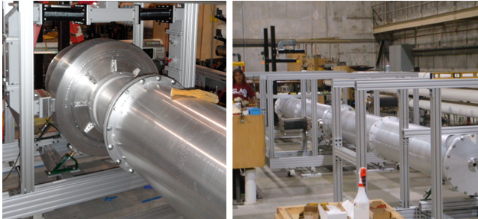

Figure 2.5.1.3.2: KCS R&D hardware. From left to right: a CTO and a fed through a waveguide T and connected through a taper to the 0.480 m diameter circular waveguide, and a four section 10 m run of KCS main waveguide.

2.5.1.4 Local Waveguide Power Distribution System
The rf power extracted from each CTO along the linac tunnel is distributed to 26 cavities in three cryomodules (9-8-9, with a quad magnet in the center CM), constituting an rf unit. The waveguide power distribution system (PDS) through which it flows has evolved since the RDR as shown in Fig. 2.5.1.4.1. The 3-stub tuner has been eliminated, its dual functions now accomplished by phase shifters with a movable side wall and tunable coaxial fundamental power couplers (FPC’s), both of which are motorized. Feeding properly spaced cavities in pairs through a 3dB hybrid allows the combined reflected power to be directed to a load on the hybrid’s fourth port. Thus the expensive circulators can likely also be eliminated for most cavities. Finally, with the wide range of sustainable ILC cavity gradient limits (±20%) now to be accepted to increase production yield, power efficiency demands we tailor the distribution to the (sorted pairs of) cavities in each rf unit. Thus adjustable coupling from the main WR650 waveguide is included. This latter function can be provided by a novel waveguide component developed at SLAC called the variable tap-off (VTO) [6]. This adjustable directional coupler works by means of mode rotation of a circular TE₁₁ mode accomplished via physical rotation of an oval middle section (see Fig. 2.5.1.4.1 (a)). A PDS incorporating four VTO’s was built and high-power tested for the first cryomodule that will be tested at FNAL [7].

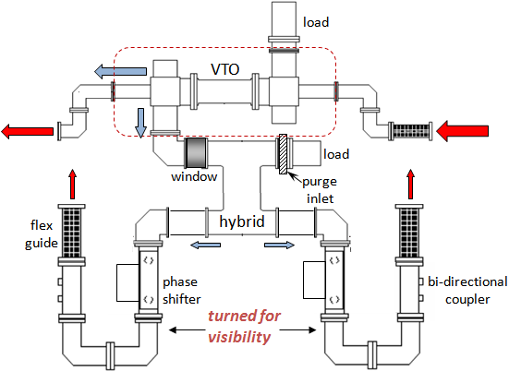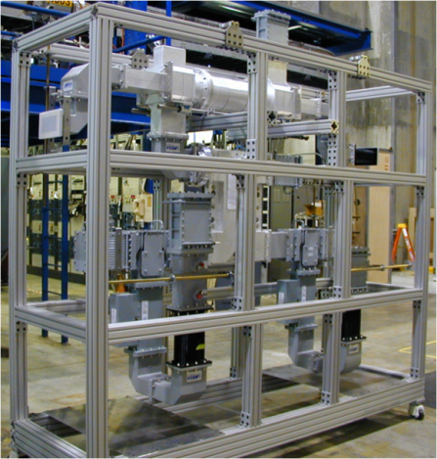

Figure 2.5.1.4.1(a): Updated modular PDS waveguide layout. Power for two cavities at a time is coupled from a main WR650 feed and divided through a hybrid. Reflections from the cavities combine into the hybrid load, allowing elimination of circulators (included after the hybrid in the 3D view), except for the odd cavity in a nine-cavity cryomodule. (b) One of four PDS modules built and tested at SLAC for the first cryomodule of FNAL’s L-band NML Test Accelerator.

2.5.2 Distributed RF Scheme (DRFS)
2.5.2.1 Basic Concept of DRFS Compared with the RDR
Distributed RF Scheme (DRFS) was proposed as another possible cost-effective solution for a single main linac tunnel design in the proposal of SB2009 [8]. The basic concept of DRFS is illustrated in Fig. 2.5.2.1.1. The salient feature of DRFS is a complete single tunnel plan with no high power rf components on the surface, utilizing approximately 8,000 small modulating-anode (MA) klystrons of 800 kW output power, driven by DC power supplies (P/S) and MA modulators. The rf power for two super-conducting (sc) cavities is fed by a klystron through a rather simple power distribution system (PDS) without employing a circulator. By contrast, the RDR presented a two-tunnel plan in which a 10 MW multibeam klystron (MBK) feeds power to 26 cavities through a complicated PDS using 26 circulators in RDR rf units comprised of 3 cryomodules.

Fig. 2.5.2.1.1: Schematic layout of the distributed RF system (DRFS).

The advantage of DRFS is that it represents a complete single tunnel plan in which there are no high power rf facilities on the surface. One klystron feeds power to only two cavities, facilitating optimization cavity performance. In the case of local sc cavity failures, it is easy to separate them from the operation, giving DRFS good operability. There is small probability of big failures that prevent beam operation. On the other hand there are concerns about the construction cost, maintainability, and heat loss problems, since all heat loads are also in the single underground tunnel. This will be described in Sec. 2.5.2.3. DRFS is a newly proposed plan, though it uses matured technology. The technical feasibility is being demonstrated in part of the S1-Global program progressed at KEK, and it will be described in Sec. 2.5.2.4.

2.5.2.2 DRFS Configuration in the Tunnel
Since DRFS is a complete single tunnel plan, its configuration strongly depends on the tunnel shape and the layout of cryomodule in the tunnel. If the tunnel cross section is assumed circular, constructed by tunnel boring machine (TBM), two configurations are designed and investigated; one in which the cryomodule is hung from the ceiling and one in which the cryomodule is installed on the floor. The current likely configuration of DRFS is based on the latter, which is shown in Fig. 2.5.2.2.1. The diameter of the tunnel cross section is 5.7 m, and the tunnel is divided into three regions horizontally: a cryomodule region, a passage and maintenance space including egress, and a region of high power rf equipment, separated from the other regions by a radiation shielding wall with access doors. It is shown that all required components, including stand-by power supply, are in the high power equipment region. Waveguides of the PDS are laid under the floor. The tunnel is also divided into three regions in the vertical direction and accommodates all required functions, including water supply, ventilation and the space to exhaust an accidental helium leak. It is necessary to investigate this configuration in more detail to assure sufficient working space during installation and maintenance, and this will be done after optimization of the rf component sizes.

(a) (b)

Fig. 2.5.2.2.1: DRFS configurations in the tunnel shown in 3D: (a) cross-section view and (b) bird’s eye view.

2.5.2.3 Operability and Availability of DRFS
Since DRFS can control two-sc-cavity units with low level rf (LLRF), operability is better than in the RDR. Some of the advantages in DRFS are described in Sec. 2.5.2.1. On the other hand, 13 DRFS klystrons are operated on a common DC P/S and MA modulator, so required applied high voltage is determined by the maximum power in the unit, if fixed overhead for LLRF control is assumed. From sc cavity manufacturing, accelerating gradient variation of 31.5 MV/m ±20% should be accepted, and in order to achieve an efficient system, sorting of the cavities is inevitable for DRFS. Assuming that 3,400 cavities are manufactured every year in the construction period and they are sorted in bins with a 8%-range variation of field gradient, the resultant number in a bin is 680 and they are sorted in an RDR unit (3 cryomudules) with 4% higher power without sacrificing the sc field gradient. Therefore in DRFS, this kind of sc cavity sorting is prescribed. In order to achieve high availability in DRFS, we assumed 110,000 hours of MTBF (mean time before failure) for MA klystrons and introduced back-up DC P/S’s and MA modulators as described in SB2009. This configuration is shown in Fig. 2.5.2.3.1, in consideration of the DC P/S size and cost. In this case, the basic configuration of the DRFS baseline (or the high current case) includes 2 regular DC P/S’s and MA modulators plus another back-up in two RDR units. So far, for other availability and installation issues, the basic scenario is kept the same as SB2009, as long as we employ the configuration of Fig. 2.5.2.2.1.

Fig. 2.5.2.3.1: Two-RDR-unit system of DRFS in the baseline case is shown. Red boxes represent the DC P/S’s, pink boxes represent MA modulators for active components, blue the DC P/S, and bright blue the MA modulator for back-up components.

Another important issue for DRFS is radiation. There is a concern about semiconductor damage from the radiation in the high power rf components. As shown in Fig. 2.5.2.2.1, DRFS employs a radiation shield wall which has the same shield thickness investigated by DESY [10]; it is planned to investigate the effect more precisely.

2.5.2.4 R&D Status of DRFS
A DRFS demonstration to show feasibility is planned at KEK to extend over three consecutive years. The first demonstration is scheduled at the end of FY2010 to employ a two-unit DRFS in the S1-Global project in KEK. The first prototype DRFS klystrons, a P/S and an MA modulator will be installed and operated to feed power to 4 cavities. LLRF control is a main R&D theme, to evaluate the feedback technology when there are no circulators.

Prototype klystrons of DRFS were manufactured in 2010, and factory tests satisfied the required original specification: 750 kW, as shown in Fig. 2.5.4.1. (left) . The output power is increased to 800 kW to accept the gradient variation of 32.5 MV/m ±20%, and factory tests cleared this revised specification. Output characteristics of prototype klystrons are shown in Fig. 2.5.2.4.1 (right). Results for first tube are as follows: output power of 813 kW at 64.2 kV with efficiency of 57.4% for microperveance of 1.36 and output power of 806 kW at 67.1 kV with efficiency of 60.1% for microperveance of 1.15. Since the DRFS klystron is an MA klystron, beam perveance can be controlled by the ratio between (cathode − MA electrode) voltage and (cathode – anode) voltage. A prototype power supply and MA modulator are delivered to KEK and are operated in an acceptance test, after which all DRFS high power components will be moved near the cryomodule in the S1-Global tunnel and operated as the demonstration at the end of 2010. The configuration of test arrangement in S1-global is shown in Fig. 2.5.2.4.2.

Fig. 2.5.2.4.1: A photo of the klystrons is shown (left) and waveforms in the test are shown (right).

Fig. 2.5.2.4.2: Layout of the DRFS test configuration in S1-Global. At first, high power rf components are tested and evaluated on the first floor with a matched load on the PDS (shown in blue circle), and then systems are moved near the cryomodule in the tunnel (shown in red circle).

The second demonstration is a continuation to check the long term stability by installing one of the above DRFS units in the “quantum-beam project” at KEK. The third demonstration, planned for FY2012 to FY2013, entails installation of a 4-unit DRFS feeding rf power to 8 sc cavities in the STF-II project at KEK. During these R&D schedule periods, key elements of DRFS high power system components will be developed. Spark gap development in the crowbar circuit, HV relay in the DRFS P/S system and permanent magnet R&D for the klystron are such items. Some of this work has been already begun in collaboration with industry. Since the DRFS concept is well established and employed in many projects, we think there are no basic difficulties, but there are some problems to be solved when system installation is involved. The purpose of the R&D should be focused in this direction. R&D for cost reduction is another very important issue, and after successful operation, design efforts to reduce the cost of each component are strongly required.

2.5.3 RDR configuration in single tunnel as back-up
In SB2009, in order to reduce project cost, a single tunnel configuration for the ILC main linacs is called for. Because the options described in the preceding two sections are in the R&D stage, a back-up plan was put forward in which the equipment of the RDR high power rf system, which is better studied, is incorporated into the linac tunnel. One possible RDR single tunnel configuration is almost identical to that of DESY’s XFEL, with pulse transformers, 10 MW MBK’s and PDS’s in a single tunnel of diameter 5.2 m and modulators on the surface. Another single tunnel plan for the RDR system has all high power components in a single tunnel of diameter 6.5 m. For a mountainous site, this type of complete single tunnel plan is preferable. The pros and cons of this latter option are largely shared with DRFS, since both are complete single tunnel plans.

References:
[1] RDR, Reference Design Report, Accelerator, ILC-Report-2007-001, 2007,
http://lcdev.kek.jp/RDR/RDRall.pdf
[2] Christopher Nantista and Chris Adolphsen, “Klystron Cluster Scheme for ILC High Power RF Distribution,” presented at the 2009 Particle Accelerator Conference (PAC09), Vancouver, B.C., Canada. May 4–8, 2009; SLAC-PUB-13696.
[3] D. Sprehn, et al., “Development of a 10 MW Sheet Beam Klystron for the ILC,” presented at the 23rd Particle Accelerator Conference (PAC09), Vancouver, B.C., Canada, May 4−8, 2009.
[4] C. Burkhart, et al., “ILC Marx Modulator Development Program Status,” presented at the 1st International Particle Accelerator Conference (IPAC10), Kyoto, Japan, May 23-28, 2010.
[5] M.A. Kemp, et al., “Status Update on the Second-Generation ILC Marx Modulator Prototype,” IEEE Power Modulator Conference, Atlanta, GA, May 2010.
[6] Christopher D. Nantista and Chris Adolphsen, “A Variable Directional Coupler for an Alternate ILC High-Power RF Distribution Scheme,” presented at the 2006 Linear Accel. Conf. (LINAC06), Knoxville, TN, Aug. 21–25, 2006; SLAC-PUB-12372.
[7] Christopher Nantista et al., “Progress in L-Band Power Distribution System R&D at SLAC,” presented at the XXIV Linear Accelerator Conference (LINAC08), Victoria, B.C., Canada. Sept. 29–Oct. 3, 2008; SLAC-PUB-13438.
[8] Chris Adolphsen, “ILC RF System R&D,” presented at the 1st International Particle Accelerator Conference (IPAC10), Kyoto, Japan, May 23-28, 2010.
[9] SB2009 Proposal Document, Release1, ILC Global Design Effort, 2009,
http://lcdev.kek.jp/SB2009/SB20091217B.pdf
[10] B. Mukherjee, E. Negodin, T. Hott and S. Simrock, ”Efficacy testing of shielding materials for XFEL using the radiation fields produced at FLASH”, TESLA-FEL 2008-06, 2008.

System integrations tests
(Estimate page count: 5, and principle authors: H. Hayano, S. Nagaitsev, J. Cawardine)

2.6.1 NML Facility at Fermilab
Fermilab is currently constructing the “SRF Test Accelerator at the New Muon Lab” (NML). NML consists of a photo-emitted RF electron gun, followed by a bunch compressor, low energy test beamlines, SCRF accelerating structures, and high energy test beamlines. The initial primary purpose of NML will be to test superconducting RF accelerating cryomodules for the ILC and for Fermilab’s “Project X” – a proposal for a high intensity proton source. The unique capability of NML will be to test these modules under conditions of high intensity electron beams with ILC-like beam parameters. In addition NML incorporates a photoinjector which offers significant tunability and especially the possibility to generate a bright electron beam with brightness comparable to state-of-the-art accelerators. This opens the exciting possibility of also using NML for fundamental beams research and tests of new concepts in beam manipulations and acceleration, instrumentation, and the applications of beams.

Building infrastructure – cryogenics, electrical power, RF power, water cooling, electronics racks, shielding, etc. are currently being installed. A single SC cavity is currently installed and tested, and a single SCRF cryomodule (type “TTF III+”) is in the building and cool-down commenced in November, 2010. The electron gun will be installed and commissioned starting in January, 2011. Beamline construction will start in late CY2011 and we expect to start delivering beam in late CY2012.

The NML injector beamline is shown in Figure 2.6.1. It consists of a 1.3 GHz RF photo-emitted electron gun, followed by 2 SCRF accelerating cavities, a bunch compressor and beam diagnostics. The primary injector beamline will operate at ~40 MeV and is ~22 m in length. It will be capable of producing ILC-like beam structure: bunch charge = 3.2 nC, 3 MHz bunch repetition rate, bunch train length = 1 ms, 5 Hz bunch train repetition rate, and peak current in excess of >10 kA. Single bunch charge can be well over 20 nC. In addition, there is floor space for 2 reconfigurable 40 MeV test beamlines for a variety of experiments.

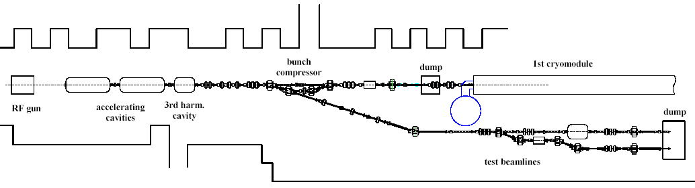

Figure 2.6.1: NML Injector beamline layout.

The acceleration section will initially consist of 3 ILC-type SCRF cryomodules (a single ILC “RF unit” powered by a single 10 MW klystron), capable of accelerating beam to ~750 MeV. A building expansion, almost completed, will allow for a total of up to 6 cryomodules and up to ~1500 MeV beam energy. A plan for the high energy downstream beamlines is shown in Fig. 2.6.2. There will be floor space and infrastructure available for up to 3 high energy test beamlines (18 – 34 m in length) and a storage ring up to ~10 m in diameter. High energy beam dumps are being designed to absorb the 75 KW of beam power.

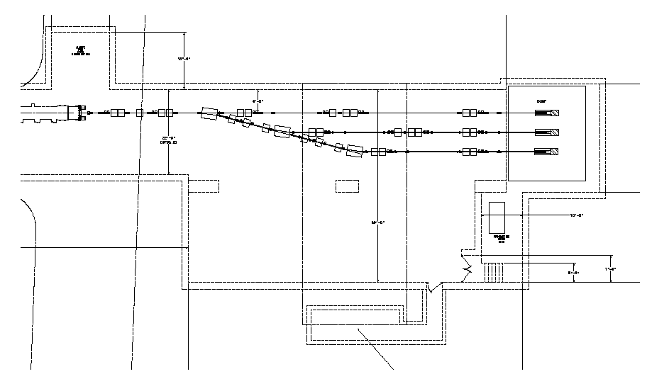
50’
10m
100 KW dump
spectrometer
cryomodule
matching section

Figure 2.6.2: High energy beamline layout.

In summary, in addition to providing realistic tests of a new generation of RF cryomodules, the new NML facility offers excellent opportunities to advance ILC system integration tests, as well as the accelerator science and technology on several fronts. Eventually, NML will become a truly open users’ facility with unique capabilities to advance accelerator research by groups from various institutions, to enhance accelerator education and to promote accelerator technology development for industrial applications.

2.6.2. Superconducting RF Test Facility (STF) at KEK
ILC cryomodule development, test and accelerator integration activities are done in STF at KEK. An accelerator tunnel of 100m length is used for cryomodule test and system integration. The three high power RF power stations and the cryogenics plant for the cryomodule are located in the nearby surface building, (60m x 30m).

Cryomodule Test in STF Phase-1
The STF phase-1 test cryomodule consists of two 6m horizontal cryostats units which are half the length of ILC design. Each of them can accommodate 4 cavities. The type A 6 m cryomodule is designed to accommodate TESLA-style cavities, and the type B 6 m cryomodule is for low-loss (LL) cavities. A cool-down test was carried out for the TESLA-style cavity in cryomodule A and one LL cavity in cryomodule B in early 2008. Another cool down test using 4 TESLA-style cavities in cryomodule A followed in 2008. One cavity out of the four reached 31.5 MV/m, the nominal ILC operational gradient. The other three stayed around 20 MV/m. The study of LD (Lorentz Detuning) measurement and compensation, and the stabilization of field amplitude and phase of cavities was demonstrated by digital feedback control using piezo actuator LD compensation. Amplitude and phase stability of 0.04 % rms and 0.02 degree rms (respectively) was demonstrated. This stability performance is well within the ILC specification. Several tests of LLRF (Low-level RF control ) and power distribution were performed, including simulated beam loading signal mixture, special filtering techniques and IF ( Intermediate frequency ) -mixture ADC detection, and QL ( loaded Q-value ) control using waveguide shorts and phase shifters, etc.

S1-Global Cryomodule RF test
The idea of the S1-Global is to realise the ILC operational gradient 31.5 MV/m in one cryomodule (8 cavities) through an international research collaborative effort using world top-level performance cavities. The eight cavities were contributed from FNAL, DESY and KEK, and installed in two ‘half length cryomodules’ each 6 m long. A new cryomodule was designed and constructed by INFN, and modifications were made to the existing 6-m STF cryomodule A by KEK. They were installed and connected in the STF tunnel as discussed above (Sect. 2.4.1). The assembly started in January 2010, and cool down testing started in June 2010. A series of experiments are now on-going. The average maximum gradient of the cryomodule was observed to be 28MV/m, compared to the maximum averaged gradient in cavity vertical test of 30MV/m, as shown in Fig. 2.6.3. LD characteristics for the 4 kinds of tuner system were also measured for each cavity, and new LD compensation scheme was tried. The resulting experimental performance is now under analysis. Tests of thermal performance, tuner performance, cavity high gradient operation using vector-sum control, LD compensation using RDR scheme, and DRFS (Distributed RF System) are planned through February 2011.

Figure 2.6.3: Cavity performance in the S1-G cryomodule. Blue bars show the gradient measured by vertical test, and red bars show the achieved gradient in the cryomodule. The average gradient is 30MV/m and 28MV/m, respectively.

    - The TTF/FLASH ‘9mA’ Experiment
The ‘9mA’ program was proposed by the GDE in 2008 and subsequently taken up by DESY with a view to performing system tests in support of both the ILC ‘S2’ beam test program and the European XFEL development. Operationally, the program is led by DESY, while the scientific program is coordinated jointly by DESY and the ILC/GDE. International participation in the program, notably from Argonne, Fermilab, and KEK, has concentrated on Low Level RF and Accelerator Controls.
The primary goal for TD Phase-I was to demonstrate reliable operation of the TTF/FLASH linac with ILC-like high power beams. Other specific goals are listed in Table 1, and these broadly address linac integration and operation with ILC-like beams. Aside from the primary demonstration of reliable operation under ILC-like conditions, the critical R&D task is to assess operational requirements for gradient margin and rf power overhead, which provide direct input to the ILC main linac design parameters. In the following sections, we will briefly describe the FLASH facility, results and accomplishments from the two main beam studies periods to date, and give an outlook for future 9mA studies.

Goals for the 9mA experiment
Long bunch-train high beam loading demonstration
- 800ms pulse: 2400 bunches at 3MHz, 3nC per bunch
- Vector Sum control of up to 24 cavities
- +/- 0.1% energy stability
- Beam energy 700-1000MeV
Study operation at the limits
- Energy stability limitations and trade-offs
- Cavity gradient margins and rf power overhead

FLASH Overview
The Tesla Test Facility (TTF) at DESY was constructed by the international TESLA collaboration to demonstrate the feasibility of a linear collider based on superconducting accelerating structures of high performance and cost-competitive with conventional copper structures. Technical feasibility of superconducting accelerating structures was demonstrated in 2000 when an 800μs-long 8mA beam was accelerated through a single cryomodule to 168MeV.
TTF has subsequently been upgraded several times. In 2005, TTF became FLASH (Free-electron LASer in Hamburg) and began operation as an FEL photon user facility, and since then has accumulated more than 25,000 hours of accelerator operation. The most recent upgrades in 2009/2010 included raising the maximum operating energy to 1.25GeV.
The main elements of FLASH as it was prior to the 2009/2010 upgrades are shown in Figure x.1 are a 5MeV laser-driven photo-cathode rf gun, two stages of bunch compression, and six cryomodules (ACC1 to ACC6), each containing eight TESLA-type 1.3GHz superconducting RF cavities. Four klystrons supply rf power to the electron gun, eight cavities in ACC1, 16 cavities in ACC23, and 24 cavities in ACC456, respectively. Low-level RF controllers associated with each klystron regulate the vector sum of the fields in each group of cavities. The rf unit comprising the 24 cavities in ACC456 is of particular interest for the 9mA studies because of the close resemblance to the rf configuration in the ILC Reference Design. In this configuration, the beam energy at the end of the linac can be as high as 1GeV. Electron bunches are then transported either through a series of undulators for FEL photon generation or through a bypass line and then finally to a high power beam dump.
Design beam parameters for FLASH are quite close to those of the ILC, both of which are listed in Table 2 together with design parameters for the European XFEL and performance goals for the 9mA experiment itself. Even so, achieving these beam parameters is a major challenge for FLASH, since the average power and pulse length are well beyond typical parameters for FEL user operation (less than 30 bunches per pulse and less than 1nC per bunch).
Extrapolation from the 9mA experiment to an ILC involves not just beam parameters, but also operating gradients of the superconducting cavities. Gradient limits for the 48 FLASH cavities are shown in Figure 2. Gradient limits of the 24 cavities in ACC456 range from 23MV/m to 32MV/m, with the first four cavities in ACC6 all having gradient limits above 30MV/m, and hence the maximum operating gradients are comparable to those planned for the ILC.

Parameter |  | Design parameters |  |  | 9mA Goal
Parameter |  | XFEL | ILC | FLASH | 9mA Goal
Bunch charge | nC | 1 | 3.2 | 1 | 3
Bunch repetition rate | MHz | 5 | 2.7 | 9 | 3
Number of bunches |  | 3250 | 2625 | 7200 | 2400
Pulse length | μs | 650 | 970 | 800 | 800
Average current | mA | 5 | 9 | 9 | 9
Average beam power | kW |  |  | 36 | 36

Beam studies
There have been two periods of dedicated 9mA studies with high power beams: 48hrs in September 2008, and then a 2-week period during September 2009.
In September 2008, the linac operated at a 1MHz bunch repetition rate with 3nC/bunch, and pulse lengths of 550 bunches were reached before the studies were cut short by a vacuum event in the final section of the beam transport line. This vacuum event prompted development by DESY of several new diagnostics for monitoring beam position and monitoring beam spill. Beam position monitors using in-air magnetic-loops and diamond/sapphire blades were installed immediately before the beam dump, and four-quadrant beam loss monitors using Cerenkov fibers and ion chambers were installed along the last several meters of the beam transport line. These new diagnostics were installed immediately prior to the 2-week 9mA study period in September 2009. It was during these two weeks of studies that the primary study goal for TD Phase-I was achieved. Highlights of the studies results and achievements are described in the next section.

Achievements during TD Phase 1
A major milestone was reached during the September 2009 studies when high power beam operation was demonstrated over a range of beam currents and pulse length. Highlights are listed in Table 3, and achieved machine parameters are shown in Table 4. Reaching and operating the linac with high power levels was unquestionably challenging, particularly with respect to minimizing bunch-by-bunch fractional beam loss and with regard to exception handing. These, however, are operational issues, and are not indicative of any fundamental issues associated with operating a high power superconducting linac. On the contrary, the test results achieved in September 2009 are considered by the GDE to be sufficient to have demonstrated the feasibility of a high power superconducting electron linac. The requirement to minimize beam scraping plays into many different operational aspects, since beam scraping can occur from mis-steering, energy changes, beam size, and beam stabilization.

Metric | Goal | Achieved
Bunches per pulse | 800 x 3nC (1MHz) | 800 x 3nC
Bunches per pulse | 2400 x 3nC (3MHz) | 1800 x 3nC  2100 x 2.5nC  ~2400 x 2nC
Charge per pulse | 7200nC @ 3MHz | 5400nC @ 3MHz
Beam power | 36kW  (7200nC, 5Hz, 1GeV) | 22kW  (5400nC, 5Hz, 800MeV)

Achievements Highlights
- 15 contiguous hours running with 3mA and 800us bunch trains
- Running at ~9mA with bunch trains of 500-600us for several hours
- Full pulse length (800us, ~2400 bunches) at ~6mA for shorter periods
- Energy deviations within long bunch trains: <0.5% p-p (7mA)
- Energy jitter pulse-pulse with long bunch trains: ~0.13% rms (7mA)

Energy stability
Beam energy must be stabilized over two timescales: long-term pulse-to-pulse stability over minutes and hours, and energy deviations within a bunch-train. Representative measurements of energy stability over both timescales are listed in Table 2.
The main challenge for stabilizing energy deviations within the bunch train is compensation of transients from beam loading and Lorentz-force detuning, which are a function of beam current and cavity gradient respectively. Both effects are largely repetitive from pulse to pulse, and they can be compensated using ‘iterative learning feed-forward’ to progressively modify the rf power feed-forward drive waveforms to minimize these repetitive transients on the cavity field vector sum. Examples of energy deviations within long bunch trains for low beam current (0.3mA) and for 7.5mA are shown in Figure xx.

Effects of beam loading
The effect of beam loading on individual cavity gradients can be seen in Figure x.3 for 3mA and 7.5mA. Although the vector sums are flat, the individual cavities charge/discharge at a rate that depends on the beam current. These gradient ‘tilts’ can minimized by tailoring individual cavity forward power ratios and Loaded-Qs to the operating gradient and beam current. The extent to which this can be accomplished will be a subject of study during TD Phase II. Examples of energy stability over the bunch-train at 0.3mA and 7.5mA are shown in Figure 4.

Outlook
Since September 2009, there have been several major upgrades to the FLASH accelerator to increase the reach and performance of FEL user operation. Upgrades included installation of a seventh cryomodule to raise the maximum energy to 1.25GeV and a 3rd harmonic cavity in the injector to linearise bunch compression and increase the peak bunch current. Significant upgrades have also been made to the Low Level RF systems, with the introduction of fast beam-based feedback during the bunch trains, improvements in pulse-to-pulse learning feed-forward and beam loading compensation, and expansion of exception handling. The 9mA studies will reap substantial benefit from these upgrades and the resulting performance improvements, such as the more than 10-fold reduction in rms energy jitter (Figure 5).
During TD Phase-II, 9mA studies will shift emphasis from demonstrating feasibility of operations to studying ‘operation at the limits,’ such as required gradient margins and rf power overhead. Key issues will be tight control of beam loading induced gradient tilts, accurate compensation of Lorentz Force detuning using fast piezo tuners, and tight control of beam-loading- induced transients.
In summary, accomplishments during TD Phase-I have demonstrated reliable operation of the FLASH linac with high power ILC-like beams, and hence the primary 9mA experiment goals for TD Phase-I have been achieved. Future upcoming 9mA studies will be directed towards characterizing operation with these high power beams, and in particular, to assess the minimum gradient margin and rf power overhead required for reliable operation of the ILC.

Figure 1 – FLASH layout (2009)
Figure 2 – FLASH cavity gradient limits (2009)
Figure 3 – Achieved energy stability during bunch train at different currents
Figure 4 – Beam loading induced gradient tilts at different currents
Figure 5 – Improvements in energy stability from beam-based feedback

