**3. POSITRON SOURCE**

**3.1 Overview**

The ILC Positron Source generates the positron beam. The production scheme uses the electron main linac beam passing through a long helical undulator to generate a multi-MeV photon drive beam which then impinges onto a thin metal target to generate positrons in electromagnetic showers. The positrons are captured, accelerated, separated from the shower constituents and un-used drive beam photons and transported to the Damping Rings. The baseline design is for 30% polarized positrons. There are spin rotators before injection into the damping rings to preserve the polarization and there is also sufficient beamline space to allow for an upgrade to a polarization of ~60%.(citations)

The positron source performs several critical functions:

1. • generation of a high power multi-MeV photon production beam. This requires suitable short period, high K-value helical undulators.
2. • production of the positron bunches in a metal target that can reliably deal with the beam power and radioactive environment induced by the production process. This requires high power target systems.
3. • capture, accelerate and transport of the positron bunch to the Damping Rings with minimal beam loss. This requires high gradient normal conducting RF and special magnets to efficiently capture the positrons. The long transport lines also require large aperture magnets to efficiently transport the large transverse emittance positron beams.

The Positron Source also has sufficient instrumentation, diagnostics and feedback (feedforward) systems to ensure optimal operation.

**3.2 Beam Parameters**

The key parameters of the Positron Sourceare given in **Table 3.1**. The source produces 2 x 1010 positrons per bunch at the IP with the nominal ILC bunch structure and pulse repetition rate. It is designed with a 50% overhead and can deliver up to 3 x 1010 at injection into the 0.075 m-rad transverse damping ring dynamic aperture. The main electron linac beam has energy of 150-250 GeV and passes through ~150 meters long helical undulator, with a period of 1.15 cm and a K value of 0.92. For the 150GeV nominal drive beam, the first harmonic cut-off of the photon drive beam is 10.1 MeV and the beam power is ~63 kW. Approximately 4.4 kW of this power is deposited in the target in an area ~ 1 mm rms. A windowless high speed rotaing target is required to handle the high beam power and heat deposition.

The Positron Source undulator is long enough to provide adequate yield for electron beam energy over 150 GeV. For lower energy operation, the electron complex operates at a 10 Hz repetition rate with 5 Hz of 150 GeV electrons on the target to produce positrons and 5 Hz of electrons at the desired energy for collisions.

**Table 3.1 Nominal Positron Source Parameters**

|  |  |  |  |
| --- | --- | --- | --- |
| **Parameter** | **Symbol** | **Value** | **Units** |
| Positrons per bunch at IP | *nb* | 2 x 1010 | number |
| Bunches per pulse | *Nb* | 1312 | number |
| Pulse Repetition Rate | *frep* | 5 | Hz |
| Positron Energy (DR injection) | *E0* | 5 | GeV |
| DR Dynamic Aperture | *γ(Ax* +*A*y) | <0.07 | m-rad |
| DR Energy Acceptance | *Δ* | 0.75 | % |
| DR Longitudinal Acceptance | *Al* | 3.4 x 37.5 | cm-MeV |
| Electron Drive Beam Energy(\*) | *Ee* | 150/175/250 | GeV |
| Undulator Period | ● | 1.15 | cm |
| Undulator Strength(\*\*) | *K* | 0.92/0.75/0.45 | - |
| Undulator Type | - | Helical | - |
| Undulator Length | *Lu* | 147 | m |
| Photon Energy (1st harm cutoff) | *Ec10* | 10.1/16.2/42.8 | MeV |
| Photon Beam Power | *P* | 63.1/54.7/41.7 | kW |
| Target Material | *-* | Ti-6%Al-4%V | - |
| Target Thickness | *Lt* | 0.4 / 1.4 | r.l. / cm |
| Target Absorption | *-* | 7/7.2/5 | % |
| Incident Spot Size on Target | *i* | 1.4/1.2/0.8 | mm, rms |
| Positron Polarization | *P* | 31, 30,29 | % |

\*: For CM=200GeV, 230GeV and 250GeV, the machine operates in 10Hz mode where a 5Hz 150GeV beam is dedicated for the drive beam of positron source.

\*\*: K is lowered for CM=350GeV and 500GeV to bring the polarization back to 30% without adding a photon collimator before the target.

**3.3 System Description**

The layout of the electron side of the ILC is shown in **Figure 3.1,** including the relative position of the major systems of the positron source. **Figure 3.2** is a schematic of the positron source beamlines with dimension indicated, split into two sections. The upper section shows the beamlines from the end of electron main linac to the end of the 400MeV positron pre-accelerator. The lower section shows the beamlines from the end of the pre-accelerator to the end of the positron source beamline or the beginning of the damping ring.

The electron beam from the main linac passes through the undulator and a dogleg before continuing to the IP for collisions. These beamlines are labeled as EUPM, EUND and EDOGL in **Figure 3.2**. For lower energy operations(CM=200GeV, 230GeV and 250GeV), a separate 5Hz 150GeV drive beam is used for positron production. After passing through the EUND beamline to generate photons, this 150GeV drive beam is then sent to a beam dump in the beamline EPUNDDL.

The photon beam produced by the electron beam drifts through the section UPT and strikes into a 1.4cm thick Ti-alloy target to produce an electromagnetic shower of positrons and electrons. The positrons are then captured withan optical matching device (OMD) and then matched into a capture system (labeled PTAPA) consisted of normal conducting (NC) L-band RF cavities and surrounding solenoid. The positron beam is accelerated to 125 MeV before entering the chicane where the positrons are separated from the electrons and used photons, into beamlines PCAP, PCAPEDL and PCAUPDL respectively. Both electrons and photons are dumped. After the chicane, the positron beam is further accelerated to 400 MeV using a NC L-band RF system with solenoidal focusing (labeled beamline PPA).

**Figure 3.1:** Layout of Positron System Relative to the ILC

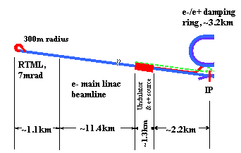

**Figure 3.2:** Positron Source Beamlines Cartoon

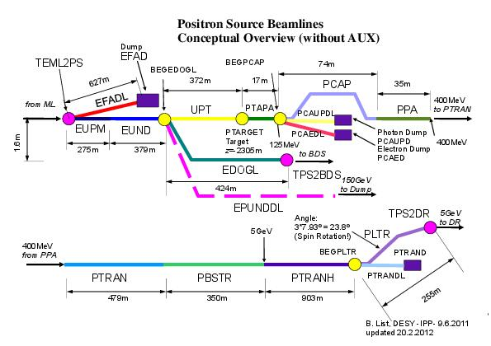

The 400 MeV positron beam is then transported for approximately 479m in beamline PTRAN (400MeV) to a booster linac (PBSTR) where the beams are further accelerated to 5 GeV using SC L-band RF. Before injected to the damping ring, the beam transports for 903 meters in PTRANH and then passes through a beamline section (PLTR) that contains energy compression and spin rotations for maximum injection acceptance. Finally, the beam is injected into the positron damping ring at point TPS2DR.

Showing in Figure 3.3, for the given undulator parameters (K, u), the performance of the positron source (yield and polarizations) are strongly depend on the the main electron beam energy. At higher electron beam energy, the undulator B field is re-optimized to restore the polarization to 30% . The final parameters for 350 and 500 GeV collider are listed in table 3.2 with adjusted undulator parameters.

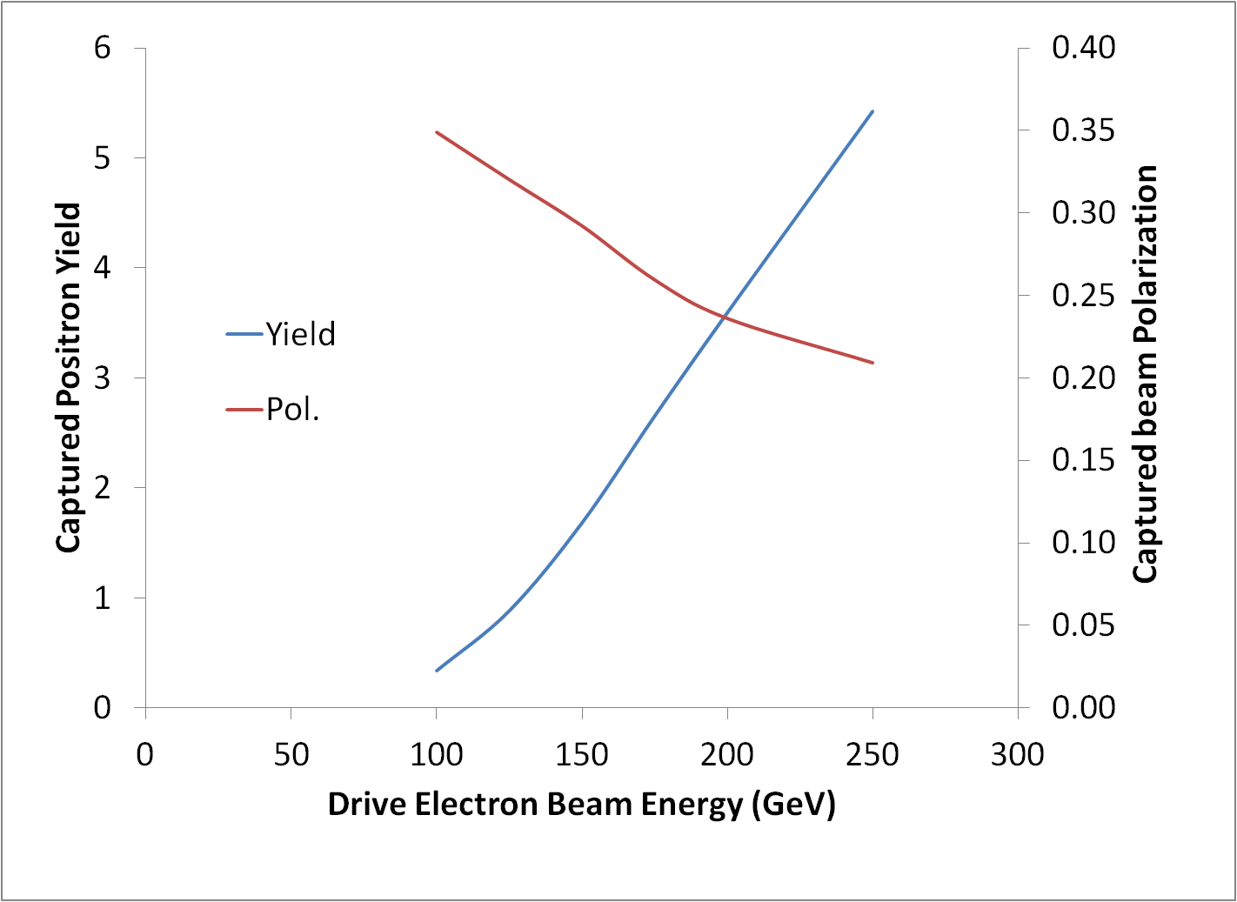

Figure 3.3. Simulation results of positron source yield and polarization as a function of drive beam energy for 147m long undulator with K=0.92 and u=1.15cm using flux concentrator as OMD.

Table 3.2: Parameters for 350GeV CM and 500GeV CM.

|  |  |  |  |
| --- | --- | --- | --- |
| **Parameter** | **units** | **350GeV** | **500GeV** |
| Electron beam energy (e+ prod.) | GeV | 178 | 253 |
| Bunches per pulse | N | 1312 | 1312 |
| Photon energy (first harmonic) | MeV | 16.2 | 42.8 |
| Photon openning angle (=1/) | r | 2.9 | 2.0 |
| Undulator length | m | 147 | 147 |
| Required undulator field | T | 0.698 | 0.42 |
| undulator period length | cm | 1.15 | 1.15 |
| undulator *K* |  | 0.75 | 0.45 |
| Electron energy loss in undulator | GeV | 2.6 | 2.0 |
| Induced energy spread(assume 0% initial) | % | 0.122 | 0.084 |
| Emittance growth | nm | -0.55 | -0.31 |
| Average photon power on target | kW | 54.7 | 41.7 |
| Incident photon energy per bunch | J | 8.1 | 6.0 |
| Energy deposition per bunch (e+ prod.) | J | 0.59 | 0.31 |
| Relative energy deposition in target | % | 7.20% | 5% |
| Photon rms spot size on target | mm | 1.2 | 0.8 |
| Peak energy density in target | J/cm3 | 295.3 | 304.3 |
|  | J/g | 65.6 | 67.5 |
| Pol. of Captured Positron beam | % | 30 | 30 |

One additional part of the positron source system is the Keep Alive Source (KAS), which is not shown in Fig 3.2. The current KAS scheme requires to generate a single bunch low intensity positron beam (1% of nominal beam intensity) with structure single bunch) which allow various beam feedbacks to remain active if the main electron beam producing the undulator based positrons is off. This source uses a S band 500 MeV electron drive beam from a conventional electron accelerator impinging on the same production target to produce positrons which then pass through the capture, acceleration and transport beamlines sections, and then injected into the damping ring .

**3.3.1 Photon Production**

Production of an adequate number of positrons requires both that the photons hitting on the target have sufficient intensity and high enough energies to produce ~ 1 – 100 MeV electron-positron pairs that can escape from the target to be captured. In general this means photon energies of the order of 10 MeV. The total number of positrons produced must allow for losses between the target and the IP.

The ILC source of sufficient energy and intensity photons is a helical undulator described in **Section 3.5.1**. To generate the necessary photon energy requires a beam of very high energy electrons. As shown in **Figure 3.1**, the undulator is installed at the end of the electron main linac. Above 150 GeV, the production electron beam is used as the drive beam and passes through the undulator to generate the required photons. At lower production beam energy, the positron yield is too low and a dedicated 150GeV drive beam is interlaced with the production electron beam.

In general, a helical undulator generates twice the synchrotron radiation power per period than the equivalent (same maximum field) planar undulator, reducing the length required to produce the same number of positrons. Another benefit is that the helical undulator generates circularly polarized photons which in turn generates longitudinally polarized positrons. For the baseline undulator system, with 150 GeV drive beam, the produced photons generate enough captured positrons with ~30% longitudinal polarization. To achieve higher positron polarization, one needs to increase the undulator length , which increases the number of photons produced, that will allow photons with the wrong polarization state to be spatially collimated before hitting the target. Here we consider a case for an upgrade of 60% positron polarization can be achieved with extension undulator length of 73.5 meters.

**3.3.2 Positron Production & Capture**

**Figure 3.3 shows the schematic layout for t**he positron beam production, capture and transport to the damping rings. **.** The photon beam generated from the helical undulator is incident on the rim of a rotating titanium target (**see Section 3.5.2)** with 0.4 radiation lengths thickness. The incident photon beam has transverse size of ~ 1 mm rms and the electron/positron particles emerging from the downstream side of the target are captured in a 0.07 m-rad transverse dynamic aperture. The target is followed by the tapered magnetic device called Optical Matching Device (OMD) (see **Section 3.5.3**) which has a field varying from < 0.5T at the target and then quickly ramped to over 3T in ~ 2 cm, , and then decays from 3-0.5 T over 14 cm. This OMD has wide energy acceptance and is used to match the beam phase space out of the target into the capture L-band RF cavities (TAP). The capture RF cavities are placed directly after the OMD to accelerate the positron beam to 125 MeV. The accelerating RF cavities have an average gradient of 9 MV/m and are located inside 0.5 Tesla solenoids which provide beam focusing. Further details of the RF are given in **Section 3.3.3.**



**Figure 3.3.** Schematic layout of Positron Source

The target and equipment immediately downstream of the target will become highly activated. A remote-handling system is used to replace the target, OMD and 1.3 meter NC RF cavities. The remote handling system is described indetail in TDR1 Section 5.3.9.

**3.3.3 Positron Transport**

After the capture section, the positrons are separated from electrons and photons in the dipole magnet at the entrance of an achromatic chicane which horizontally deflects the positrons by 1.5 m. The chicane includes collimators to remove positrons with large incoming angles and large energy errors.

The pre-accelerator immediately downstream of the chicane accelerates positron beam from 125 MeV to 400 MeV. It consists of normal conducting L-band RF structures immersed in a constant solenoid field of 0.5 T. The accelerating gradient is designed ~8 MV/m and the total length is 34.6 m.

The transport line is 480m long and transfers the 400MeV positron beam to the positron energy booster linac.

**3.3.4 5-GeV SC Booster Linac**

The booster linac accelerates the beam from 400 MeV to 5 GeV using SC L-band RF modules. There are three sections with periodic FODO lattice. The first low energy section up to 1083 MeV contains four cryomodules with six 9-cell cavities and six quadrupoles, instead of the standard ILC cryomodules. The quad’s field strength (∂B/∂x)×L is in the range of 0.8-2.4 T. The second section up to 2507 MeV has six standard ILC-type cryomodules, each containing eight 9-cell cavities and two quadrupoles. The quad strength is in the range of 0.6-1.4 T. The last section up to 5 GeV has twelve standard ILC-type RF cryomodules, each with eight 9-cell cavities and one quadrupole. The quad strength is in the range of 0.8-1.7 T. The total length of the SC booster beamline is 350m

**3.3.5 Linac to Damping Ring Beam Line**

The linac to damping ring (LTR) system from the booster linac to the DR injection line has two main functions: to rotate the polarization into the vertical plane; and to compress the energy spread to meet the DR longitudinal acceptance.

PLTR_FLR.eps

**Fig.3.5** Geometry of LTR beamline. z=0 is at where LTR beamline starts.

The positrons from the target are longitudinally polarized and this polarization is to be preserved through transport and acceleration. The polarization must be rotated into the vertical plane to preserve the polarization in the DR. The spin rotation system consists of bending magnets and solenoids, changing the spin of positrons first from the longitudinal to horizontal plane and then from horizontal to vertical. To produce 90° of spin rotation (n is odd integer) from longitudinal to horizontal plane at 5 GeV, a total bending angle  is required. To rotate the spin 90° from the horizontal to vertical plane at 5 GeV energy requires a solenoid magnetic field integral of  = 26.2 T.m. This is achieved with an 8.3-m-long superconducting solenoid with 3.16 T field.

The energy compression uses a combination of booster linac RF phase, a chicane at the beginning of the LTR and RF voltage. The chicane has a transverse offset of ~1.5m and a nominal R56 of -0.75m. The first arc of the LTR has a bending angle of 7.929°= 23.787° to rotate the spin 90o. After the 1st arc, an RF voltage of 225 MV provided by a 9 cavity RF cryomodule with no quads. This compresses the positron energy to match into the DR. The rest of the LTR system includes: a section with an additional 9.626° horizontal bending; a vertical dogleg to raise the elevation up by 1.65m; another vertical dogleg to lower the elevation back down to its final 0.35m; a FODO lattice to transport the beam and a matching section into the DR injection line. Its geometry is shown in **Figure 3.5.**

**3.4 Optics Parameters**

The optics of the positron source system starting from the capture section to the DR injection is shown in **Figure 3.6.** The lattice is optimized to have maximum transmission and minimum emittance growth.

**Fig. 3.6:** Optics of positron source

**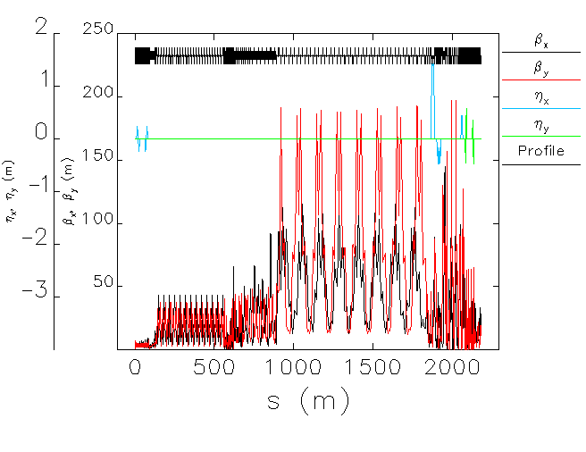**

Multi-particle tracking has been performed from the target to the DR injection Using Elegant [1] to track the large angular divergence and long low-energy tails. Energy compression is required before injection into the DR to accommodate more positron beam within the 6-D acceptance in the DR equal to  m and (±37.5MeV)×(±3.5cm).

**3.5 Accelerator Components**

**3.5.1 Undulator**

The undulator uses superconducting technology to achieve high field with a short period. Two interleaved helical windings of NbTi spaced half a period apart generate the transverse helical field. The undulator length requires that it be built in modular units. Each 4m long cryomodule contains two separate undulators with an active undulator length of ~3.5m.

The present baseline parameters are given in **Table 3.2**

**Table 3.2:** Helical Undulator Parameters

|  |  |
| --- | --- |
| Period (mm) | 11.5 |
| K | 0.92 |
| Field on Axis (T) | 0.86 |
| Beam aperture (mm) | 5.85 |
| First Harmonic Energy (MeV) | 10.1 |
| Nominal Drive Beam Energy(GeV) | 150 |

The undulator vacuum chamber is made of copper and operates at a temperature of 4.2K. Copper is selected for its high conductivity which alleviates resistive wall effects. For the most difficult ILC parameter set (150 m long Gaussian bunch containing 1 x 1010 electrons interacting with a 200m long copper vessel with internal aperture of 5.6mm), estimates are that the resistive wall effect would only increase the RMS energy spread from the nominal value of 0.05% to 0.0505%. Another advantage of using copper is that excellent surface roughness is readily achievable in real copper vessels. A pessimistic wakefield model has suggested that for a measured surface roughness (RA value) of <100 nm, the electron energy spread would only increase from 0.05% to <0.051%. The resistive wall wakefield has the potential of causing emittance growth. But numerical simulations have shown that there is no effect the ILC undulator until the transverse kick strength is increased to >5000 times the nominal value.

The material between the superconducting windings is soft magnetic iron and this serves as an outer yoke to increase the field and to provide additional support. Each cryomodule contains a liquid helium bath and zero liquid boil off is achieved through the use of in-situ cryocoolers.

Since the electron vacuum vessel is at cryogenic temperatures, each module effectively acts as a long cryopump. Roughing pumps are installed in room temperature sections between cryomodules (approximately every 12 m) but achieving UHV conditions relies upon cryopumping. The baseline pressure target of 10-8 mbar is set to avoid fast ion instability problems. Vacuum calculations indicate that the cryopumping is adequate provided that the number of photons with energy > 10eV striking the vessel surface is kept low enough. Extensive calculations of the undulator photon output down to these very low energies have been carried out and these indicate that low power photon absorbers should be spaced approximately every 12 m to provide an adequate shadowing of the cold vessel surfaces. These absorbers are in room temperature sections.

The electron beam transport through the complete undulator system is based upon a simple FODO arrangement with quadrupole spacing of ~12 m (again in the room temperature sections). There are electron beam position monitors at every quadrupole and two small horizontal and vertical corrector magnets per cryomodule. Simple electron beam transport calculations have shown that excellent relative alignment between the quadrupoles and neighboring BPMs is required. In this simple model, quadrupole to BPM misalignment of ~5 m leads to an emittance growth of ~2%. It is important to note however that this is not due to the undulator but to the effect of the quadrupoles and is therefore a general problem for the ILC beam transport. Sophisticated dispersion free steering correction algorithms are needed.

**3.5.2 Target**

The positron production target is a rotating wheel made of titanium alloy (Ti6Al4V). The photon beam is incident on the rim of the spinning wheel. The diameter of the wheel is 1 m and the thickness is 0.4 radiation lengths (1.4 cm). During operation the outer edge of the rim moves at 100 m/s. The combination of wheel size and speed offsets radiation damage, heating and the shock-stress in the wheel from the ~300kW photon beam. A picture of the conceptual target layout is shown in **Figure 3.7**. The current design has a single shaft. The motor is water union on the other end to allow cooling water to be fed into the wheel. The beam power is too high to allow a vacuum window downstream of the target. The target wheels sit in a vacuum enclosure at 10-8 Torr (needed for NC RF operation), which requires vacuum seals for access to the vacuum chamber. The rotating shaft penetrates the enclosure using one vacuum passthroughs, The optical matching device (OMD – sees **Section 3.5.3**), is mounted on the target assemblies, we use rm temp amd developed at LLNL.. The motor driving the target wheel is sized to overcome forces due to eddy currents induced in the wheel by the OMD.

The target wheel assembly is designed for an operational life of two years. In the event that the target fails during a run, the assembly can be replaced by a new assembly in less than a day using a vertical removable remote handling scheme.

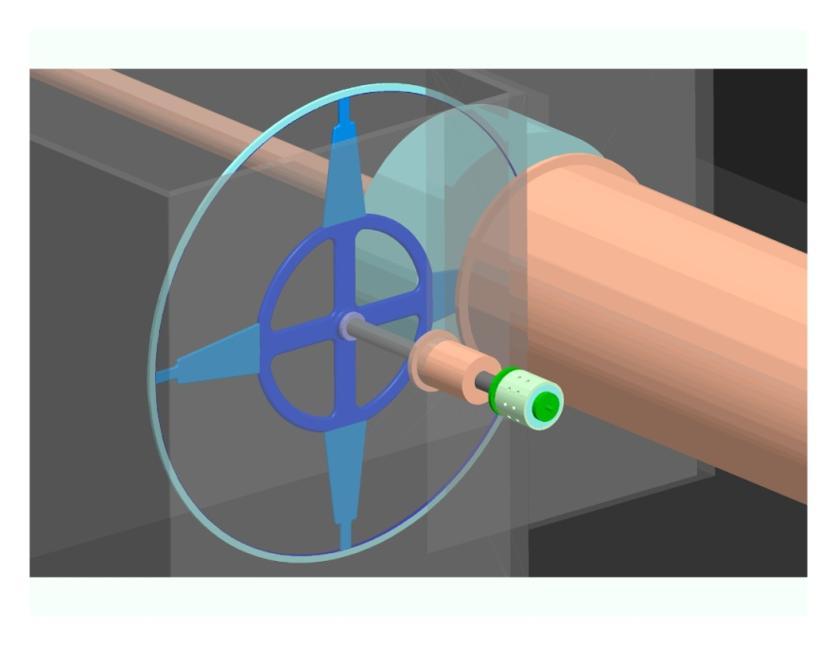

**Figure 3.7.** Overall Target Layout.

A series of sensors provide information on the target behavior. An infrared camera tracks temperatures on the wheel, to allow for quick shutdown in the case of a cooling failure. Flowmeters monitor cooling water flow in and out of the wheel (to watch for leaks), and thermocouples check ingoing and outgoing flow temperature. There is a torque sensor on the shaft, and vibration sensors on the wheel to report mechanical behavior. Finally, the wheel’s rotational speed is monitored.

**3.5.3 Optical Matching Device**

The OMD generates a solenoidal magnetic field which peaks in strength at 3.2 Tesla close to the target and falls off to 0.5 Tesla to match the solenoidal field at the entrance of the capture section. The OMD increases the capture efficiency by a factor of 2. The OMD is a normal conducting pulsed flux concentrator designed and prototyped by LLNL.

The magnetic field of the OMD interacts with the spinning metal of the target to create eddy currents. The target design must take into account this drag force which produces an increased average heat load, requires a stronger drive motor and possibly causes 5Hz resonance effects.

**3.5.4 Normal Conducting RF Accelerator System**

Due to the extremely high energy deposition from positrons, electrons, photons and neutrons behind the positron target, the 1.3 GHz pre-accelerator uses normal conducting structures up to an energy of 400 MeV. Major challenges are achieving adequate cooling with the high RF and particle loss heating, and sustaining high accelerator gradients during millisecond-long pulses in a strong magnetic field. The current design contains both standing-wave (SW) and traveling-wave (TW) L-band accelerator structures. The capture region has two 1.27 m SW accelerator sections at 15 MV/m and three 4.3 m TW accelerator sections at 8.5 MV/m accelerating gradient. The electrons are then accelerated from 125 MeV to 400 MeV in the pre-accelerator region, which contains eight 4.3 m TW sections at 8.5 MV/m accelerating gradient. All accelerator sections are surrounded with 0.5 T solenoids. **Figure 3.8** shows the schematic layout.

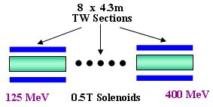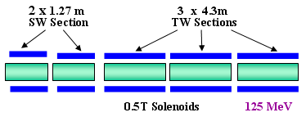

**Figure 3.8.** Layout of the Capture Region (left) and Pre-Accelerator Region (right).

*3.5.4.1 SW Accelerator Structure for Positron Capture*

The high gradient (15 MV/m) positron capture sections are simple π mode 11 cell SW accelerator structures. The advantages are a more effective cooling system, higher shunt impedance with larger aperture (60 mm), lower RF pulse heating, apparent simplicity and cost savings. The mode and amplitude stability under various cooling conditions have been theoretically verified for this type of structure. **Figure 3.7** shows a cutoff view of the SW structure and **Table 3.3** gives the important RF parameters.

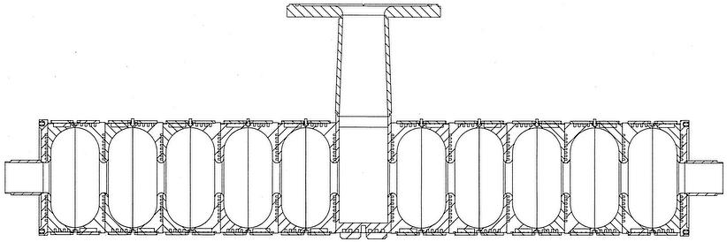 **Table 3.3.** Parameters of SW Structure.

|  |  |
| --- | --- |
| Structure Type | Simple π Mode |
| Cell Number | 11 |
| Aperture 2a | 60 mm |
| Q | 29700 |
| Shunt impedance r | 34.3 MΩ/m |
| E0 (8.6 MW input) | 15.2 MV/m |

.

**Figure 3.9**. 11–cell SW Structure.

*3.5.4.2 TW Accelerator Structure for Pre-Accelerator Region*

All TW sections are 4.3 m long, 3π/4 mode constant gradient accelerator structures. The “phase advance per cell” was chosen to optimize the RF efficiency for this large aperture structure. The advantages are lower pulse heating, easy installation for long solenoids, no need to use circulators for RF reflection protection, apparent simplicity and cost saving. Details of the TW sections are given in TDR1 **Section 5.3.6.2** and **Table 3.4** gives the important RF parameters.

**Table 3.4**. Parameters of TW Structure.

|  |  |
| --- | --- |
| Structure Type | TW 3π/4 Mode |
| Cell Number | 50 |
| Aperture 2a | 46 mm |
| Attenuation τ | 0.98 |
| Q | 24842 - 21676 |
| Group velocity Vg/c | 0.62% – 0.14% |
| Shunt impedance r | 48.60 – 39.45 MΩ/m |
| Filling time Tf | 5.3 μs |
| Power Dissipation | 8.2 kW/m |
| E0 (10 MW input) | 8.5 MV/m |

*3.5.4.3 RF System*

Each accelerator section has an individual RF station powered by a 1300 MHz, peak power 10 MW pulsed klystron. The RF station is composed of modulator, RF windows, phase shifters, RF loads, directional couplers and low-level RF system. For the SW structures, RF circulators are needed for reflection protection of the power klystrons.

**3.5.5 Magnets**

The Positron magnet system has 157 dipoles, 509 quadrupoles and 253 corrector magnets. The large magnet count is a result of the long beamlines connecting the various segments of the source. The magnet designs themselves are quite straightforward. In addition the source uses large aperture DC solenoids, surrounding the L-band capture RF, for focusing the positrons at low energies. These magnets are normal conducting to withstand the beam loss in the target hall. In addition there are two SC solenoids for spin rotation in the PLTR. The three types of solenoids and their parameters are shown in **Table 3.5.**

**Table 3.5:** Solenoid Parameters

|  |  |  |  |  |  |
| --- | --- | --- | --- | --- | --- |
| **Item** | **Length** | **ID** | **Field Range** | **Field, nominal** | **N** |
|  | m | cm | kG | kG | # |
| **Short Solenoid** | 1.3 | 36 | 4-8 | 5 | 4 |
| **Long Solenoid** | 4.3 | 31 | 4-8 | 5 | 23 |
| **SC Solenoid** | 2.5 | 6 | 52.4 | 52.4 | 2 |

**3.5.6 Diagnostics**

The Positron source has the normal complement of beamline instrumentation to measure orbit, emittance, charge and energy spread. Specialized diagnostics are designed into the unique positron systems, e.g. target. The major cost is in the BPM system because of the large channel count coming from the long beamlines. The number of readout channels is halved by processing only one transverse plane of the BPM x,y pair at each quadrupole. Performance specifications for the diagnostics are in most cases equal to or less than the Main Linac or RTML.

**3.5.7 Electron & Photon Beam Dumps**

There are 9 beam dumps, 16 variable aperture collimators, 1 fixed aperture collimator and 5 stoppers with burn through monitors planned for the positron source system. Three of the beam dumps must absorb sufficiently large beam power that they require designs with water in the path of the beam. The plumbing required to cool and treat the resulting radioactive water dominates the cost of the dump and collimator technical system in this area of the ILC.

There is a tune-up dump in front of the undulator at the 150 GeV point of the electron linac. It is assumed that this dump is only used with a shortened bunch train (100 bunches) at nominal beam parameters and 5 Hz. With these parameters the tune-up dump must absorb 240kW. This dump, roughly in line with the linac, also serves as the abort dump for up to a full train of electrons (1.35 MJ) to protect the undulator. The dump consists of a roughly 40cm diameter by 250cm long stainless vessel filled with 10mm diameter aluminum balls through which flows approximately 30 gallons per minute of water; it is backed by a short length of peripherally cooled solid copper. The dump needs to be shielded from the access passageway by 10cm of steel and 40cm of concrete. A service cavern is required to house a heat exchanger, pumps and a system to treat the water for hydrogen and tritium.

A second dump, technically identical (225kW at nominal beam parameters), is required to tune the 5 GeV positrons before injection into the damping ring.

The most challenging dump in the positron production system is the one that absorbs non-interacting undulator photons from the positron production target. This dump must absorb 300kW continuously (2 x 1017 photons/sec of 10 MeV average energy produced with a 3 microradian angular spread.) The primary absorber in this case must be water, contained in a vessel with a thin window. Preliminary calculations have shown that, at the nominal mid-undulator to positron target distance of 500m and the nominal target to dump separation of 150m, the power density on a 1mm Ti window is 0.5 kW/cm2 and the resultant temperature rise after the passage of one bunch train of 425 degrees Celsius; in the core of the beam the rise in the water temperature would be 190 degrees Celsius. The dump is a compact (10cm diameter by 100cm long) pressurized (12 bar) water vessel and Ti window, with a radioactive water processing system. It may be possible that lengthening the target to dump distance to 500m will result in a less technically challenging and inexpensive system.

The remaining dumps and collimators in the positron system all are based on peripherally cooled solid metal construction, with the cooling water supplied directly from the accelerator low conductivity water (LCW) system and do not present a technical or cost challenge