Expression of Interest for participation in the follow-up project of AIDA
to be submitted to the 1st Call for Integrating Activities under Horizon 2020

Type of activity | Joint Research Activity
Title of the proposed project | “Evaluation of vibrational characteristics of low mass support structures for position sensitive silicon detectors”. This EIO is associated with the more generic EOI titled: “Integrated support structures and novel cooling concepts for position sensitive silicon detectors” submitted by Marcel Vos (IFIC, Valencia).
Short description of the project | The mechanical support structures for tracking systems in future experiments are required to be stiffer and lighter than ever before in order to maximise the benefits of the sensor technologies being considered. These requirements motivate the use of ultra-light weight, high-stiffness structures and gaseous or evaporative cooling systems. Historically a major aspect of the development of such structures has been the determination of long-term deformation and vibrational characteristics of prototypes, backed up with detailed computational models which are used to optimise the final design. Examples of where such studies are required for future application are the assessment of possible vibrational deformations introduced by power-pulsing at 50 Hz, as proposed for the ILC, or by high flow gas or bi-phase cooling at much higher frequencies.  During the last year the Liverpool Particle Physics group has acquired a digital image correlation (DIC) system from Dantec Dynamics. This equipment employs two high resolution cameras and complex computer algorithms to determine the movement of surfaces away from a baseline position. This equipment allows us to measure slowly acting deformations. However, through colleagues in the Mechanical Engineering department, we now have access to experimental equipment which allows for investigations of vibrational performance into the kHz range.  The images below show a photograph of a prototype ‘stavelet’ for ATLAS mounted on a shaker system and a screen-dump from the DIC analysis software showing the mode-shapes corresponding to an out-of-plane vibrational stimulus at 417Hz.  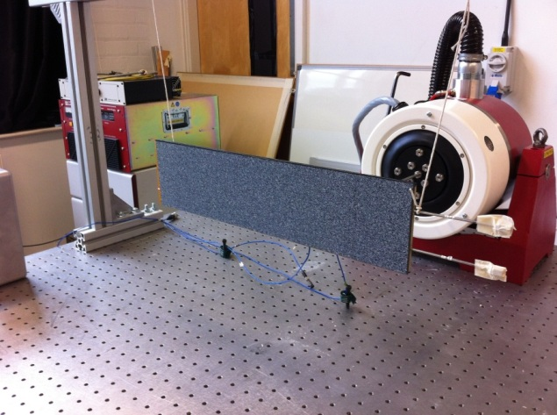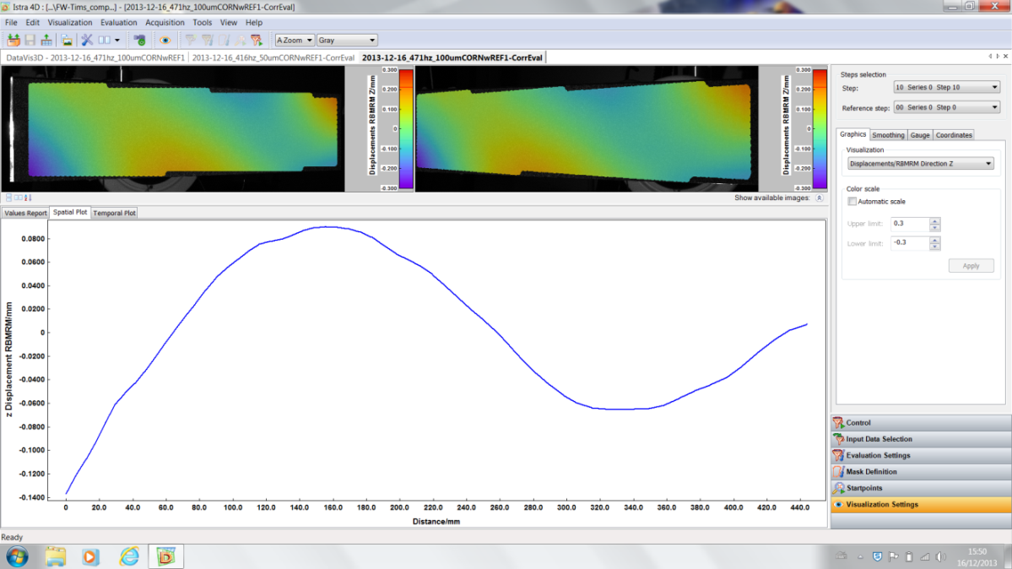  We are asking for support to initiate a programme targeted at investigating the vibrational stability of candidate low-mass support structures subject to the anticipated vibrational stimuli coming from pulsed power delivery and the different cooling mechanisms being considered. We would test proposed detector support structures with integrated electrical services and cooling and in parallel develop and validate FEA simulations of the vibrational characteristics of these test structures.
Main partners | Joost Vossebeld, Tim Jones, Gianluigi Case, Liverpool, Dept. of Physics (ATLAS, LHCb, LC)  Eann Patterson, Liverpool, Dept. of Mechanical Engineering  Further partners to be confirmed. (This proposal is closely integrated with that of the wider proposal on “Integrated support structures and novel cooling concepts for position sensitive silicon detectors”. We’d expect a close collaboration with a number of the partner institutes on the latter proposal.)
Estimated man-power needed | Liverpool could contribute to the proposed work with a total of 12 months of researcher effort. The proposed work would require an additional 6 months of effort from a engineer to do design and FEA work as well 6 months of technician effort to built necessary test equipment.
Estimated direct costs | Direct cost would be very small compared to the requested effort. An estimate could be made once a more detailed proposal is being formulated
Contacts | vossebeld@hep.ph.liv.ac.uk

