DEVELOPMENT OF A LOW-LATENCY, HIGH-PRECISION, INTRA-TRAIN BEAM FEEDBACK SYSTEM
BASED ON CAVITY BEAM POSITION MONITORS
N. Blaskovic Kraljevic, D. R. Bett, P. N. Burrows, G. B. Christian, M. R. Davis, Y. I. Kim, C. Perry John Adams Institute, Oxford, UK

Abstract
A low-latency, intra-train, beam feedback system utilising a cavity beam position monitor (BPM) has been developed and tested at the final focus of the Accelerator Test Facility (ATF2) at KEK. A low-Q cavity BPM was utilised with custom signal processing electronics, designed for low latency and optimal position resolution, to provide an input beam position signal to the feedback system. A custom stripline kicker and power amplifier, and an FPGA-based digital feedback board, were used to provide beam correction and feedback control, respectively. The system was deployed in single-pass, multi-bunch mode with the aim of demonstrating intra-train beam stabilisation on electron bunches of charge ~1 nC separated in time by c. 280 ns. The system has been used to demonstrate beam stabilisation to below the 100 nm level. Results of the latest beam tests, aimed at even higher performance, will be presented.

Introduction
A number of fast beam-based feedback systems are required at future single-pass beamlines such as the International Linear Collider (ILC) [ILC?]. For example, at the interaction point (IP) a system operating on nanosecond timescales within each bunch train is required to compensate for residual vibration-induced jitter on the final-focus magnets by steering the electron and positron beams into collision. The deflection of the outgoing beam is measured by a beam position monitor (BPM) and a correcting kick applied to the incoming other beam (Fig. 1). In addition, a pulse-to-pulse feedback system is envisaged for optimising the luminosity on timescales corresponding to 5 Hz.

Figure 1: Schematic of IP intra-train feedback system with a crossing angle.

Slower feedbacks, operating in the 0.1 − 1 Hz range, will control the beam orbit through the Linacs and Beam Delivery System. The key components of each system are BPMs for measuring the beam orbit; fast signal processors to translate the raw BPM pickoff signals into a position output; feedback circuits, for applying gain and taking account of system latency; amplifiers to provide the required output drive signals; and kickers for applying the correction to the beam.
The Feedback on Nanosecond Timescales (FONT) project has developed ILC prototype systems, incorporating digital feedback processors based on Field Programmable Gate Arrays (FPGAs), to provide feedback correction systems for sub-micron-level beam stabilisation at the KEK Accelerator Test Facility (ATF2). Previous results [RA?], [DB?] have demonstrated an upstream closed-loop feedback system that meets the ILC jitter correction and latency requirements. Furthermore, results demonstrating the propagation of the correction obtained using the upstream stripline BPM feedback system at ATF2 are reported in [PB?].
The ultimate aim is to attempt beam stabilisation at the nanometre-level at the ATF2 IP [ATF?]. We report here the latest development and beam testing results from the FONT project using cavity BPMs to drive local feedback correction at the ATF2 IP.

FONT5 DESIGN
An overview of the extraction and final focus beamlines at the ATF, showing the positions of the FONT5 system components in the IP region, is given in Fig. 2.
The IP feedback system comprises a C-band cavity BPM (IPB) and a stripline kicker (IPK). The final focus magnets (QF1FF, QD0FF) can be used to steer the beam by introducing a position offset or to move the x and y beam waists longitudinally along the beamline. The offset of the QF7FF magnet can be used to change the pitch of the beam trajectory through the IP region.
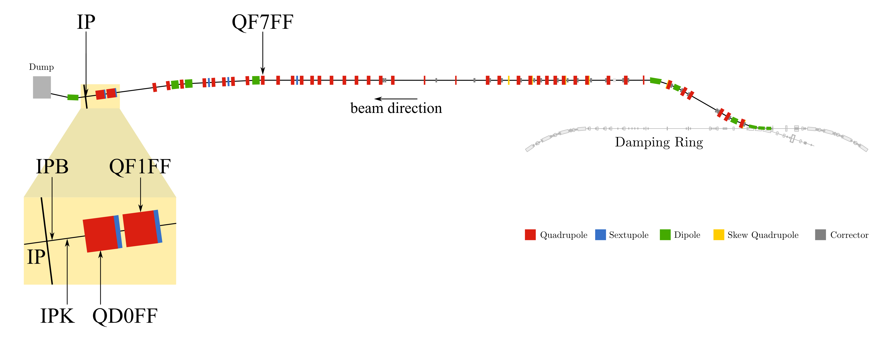
A schematic of the IP feedback system is given in Fig. 3. Determining the position of the beam at IPB requires both the dipole mode signal of IPB and the monopole mode signal of a reference cavity (Ref). The cavities were designed such that the y-port frequency of both signals is 6.426 GHz [YI?]. The signals are downmixed to baseband using a two-stage downmixer [Honda?], as follows. The first stage downmixer (M1) takes the 6.426 GHz reference and IPB signals and mixes each with an external, common 5.712 GHz local oscillator (LO) to produce downmixed signals at 714 MHz. The second stage downmixer (M2) mixes the IPB 714 MHz signal using the reference 714 MHz as LO, giving two baseband signals: I (IPB and reference mixed in phase) and Q (IPB and reference mixed in quadrature). The I and Q signals are subsequently charge normalised (in the FONT5 digital board) by the amplitude of the reference cavity signal. The charge-normalised I and Q signals are calibrated against known beam position offsets (by moving the beam using QD0FF), allowing the IPB vertical beam position to be known in terms of a linear combination of charge-normalised I and Q.
Figure 2: Layout of the ATF extraction and final focus beamline [PRL?] with the IP region zoomed in.

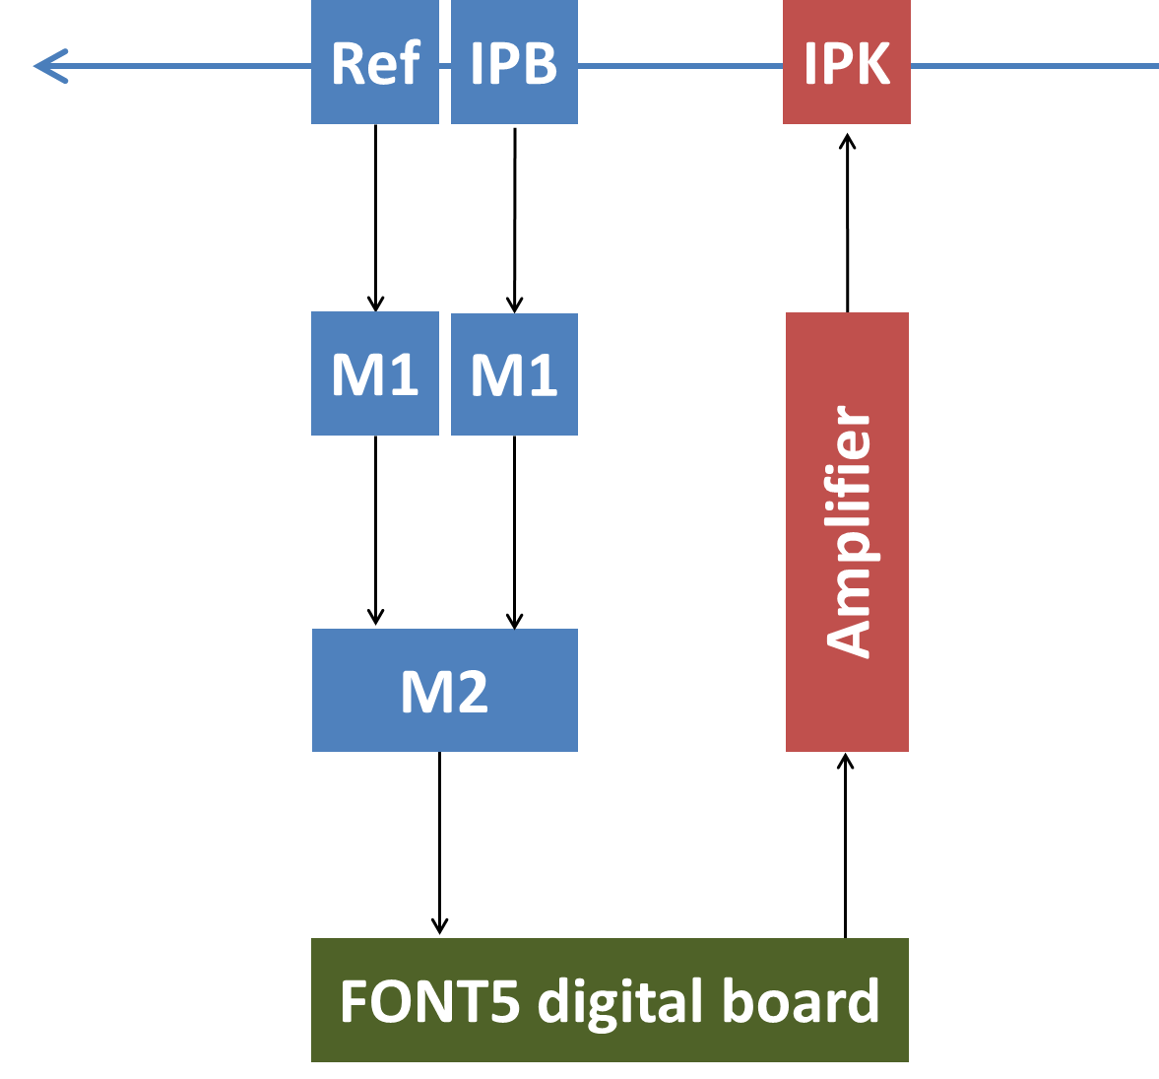

Figure 3: Schematic of IP feedback system showing the cavity BPM (IPB), reference cavity (Ref), first and second downmixer stages (M1 and M2), FONT5 digital board, amplifier and kicker (IPK). The beam travels from right to left.

The I, Q and reference cavity amplitude are digitised by the FONT5 digital board (Fig. 4): a custom digital feedback processor board. The board has nine analogue signal input channels digitised using ADCs with a maximum conversion rate of 400 MS/s, and two analogue output channels formed using DACs, which can be clocked at up to 210 MHz. The digital signal processing is based on a Xilinx Virtex5 FPGA [Xilinx?]. The FPGA is clocked with a 357 MHz source derived from the ATF master oscillator and hence locked to the beam. The ADCs are clocked at 357 MHz. The analogue I, Q and reference cavity amplitude signals are sampled to provide the input signals to the digital processor. The gain stage is implemented via a lookup table stored in FPGA RAM. The digital output is converted back to analogue and used as input to the kicker amplifier. A pre-beam trigger signal is used to enable the amplifier drive output from the digital board.

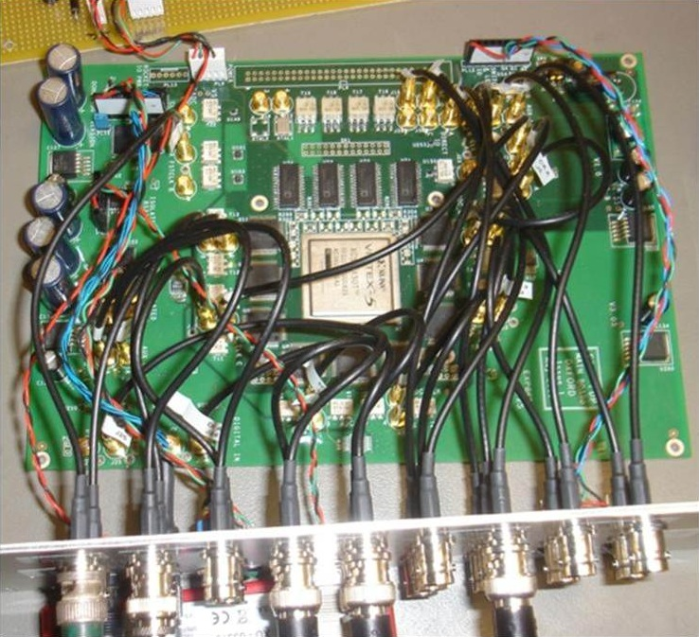

Figure 4: FONT5 digital feedback board.

The driver amplifier was manufactured by TMD Technologies [TMD?] and provides ±30 A of drive current into the kicker (IPK). The rise-time is 35 ns from the time of the input signal to reach 90% of peak output. The output pulse length was specified to be up to 10 μs.

Beam test results
We report the results of beam tests of the FONT5 system in the 2013 running period; earlier tests were reported in [MD_IPAC?].

Accelerator Setup
The ATF facility was set up to provide two bunches per pulse of beam extracted from the damping ring, with a bunch separation of 274.4 ns. This separation was found typically to provide a high degree of measured vertical spatial correlation between the two bunches. The feedback tests therefore involve measuring the vertical position of bunch one and correcting the vertical position of bunch two. The system was typically operated in an ‘interleaved’ mode, whereby the feedback correction was toggled on and off on alternate machine pulses; the feedback ‘off’ pulses thereby provide a continual ‘pedestal’ measure of the uncorrected beam position. For the purpose of recording data with BPM IPB the longitudinal location of the beam waist in the IP region was adjusted by varying the strengths of the two final focus magnets QF1FF and QD0FF. For the results reported here the beam waist was typically set near the position of IPB.

IP Feedback
The IPK kicker was exercised at a range of input voltages and its effect on beam position at IPB was measured, allowing the required gain for the IP feedback system to be determined.
The response of the feedback system was measured using IPB. Fig. 5 shows the vertical position of bunch two recorded in IPB. The IP feedback reduced the vertical beam jitter from 168 ± 7 nm to 98 ± 5 nm. It also improved the average vertical position from 1.68 ± 0.01 μm to 0.81 ± 0.01 μm. The performance is consistent with a BPM resolution of somewhat better than 100 nm [MD_DPhil?].

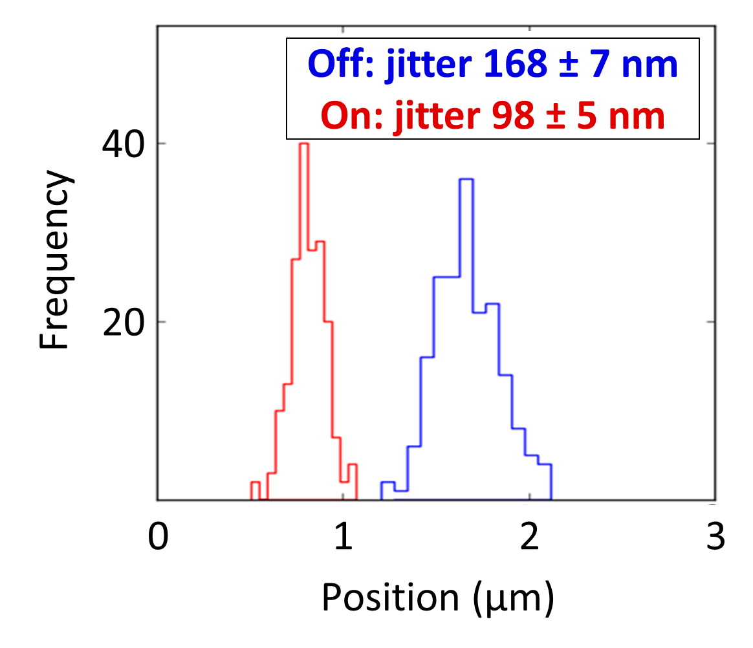
Figure 5: Distribution of the vertical position of bunch two in IPB with (red) and without (blue) application of the IP feedback correction.

For best feedback performance, a high incoming bunch-to-bunch position correlation is required, which was measured to be 81 % with feedback off. Fig. 6 shows the bunch-to-bunch position correlation. The feedback acts to remove the correlated bunch-to-bunch position component, reducing the correlation to -16 %.

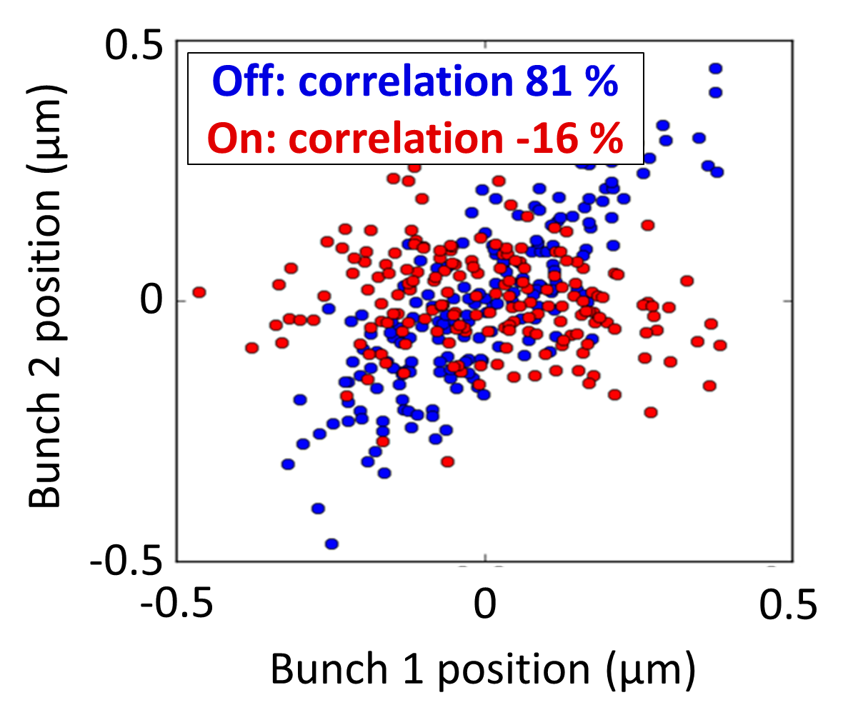
Figure 6: Bunch-to-bunch vertical position correlation with (red) and without (blue) application of the IP feedback correction.

The IP feedback system latency was measured and found to be 134 ns; however this could be reduced if, for example, a greater effort was made to optimise cable lengths.

CONCLUSIONS
Beam stabilisation using cavity BPMs at the IP has been demonstrated successfully at ATF2. Vertical beam position stabilisation was achieved at the level of 100 nm using a local IP feedback system. The system has a demonstrated latency of 134 ns. Work is ongoing to improve the resolution of the cavity BPMs at the IP in order to obtain improved feedback results.

References
[ILC?] T. Behnke at al., The International Linear Collider Technical Design Report.
[RA?] R. Apsimon et al, Proceedings IPAC11, MOPO17.
[DB?] D. Bett et al., Proceedings IPAC12, WEPP068.
[PB?] P. Burrows et al., these Proceedings, TUPME009.
[ATF?] B. Grishanov et al., ATF2 proposal, vol. 2.
[PRL?] G. White et al., “Experimental Validation of a Novel Compact Focusing Scheme for Future Energy-Frontier Linear Lepton Collider”, Phys. Rev. Lett., vol. 112, p. 034802, Jan 2014.
[YI?] Y. I. Kim, PhD thesis, Kyungpook National University, 2012.
[Honda?] Y. Inoue et al., “Development of a high-resolution cavity-beam position monitor”, Phys. Rev. ST Accel. Beams, vol. 11, p. 062801, Jun 2008.
[Xilinx?] http://www.xilinx.com/products/virtex5/index.htm
[TMD?] www.tmdtechnologies.co.uk
[MD_IPAC?] M. R. Davis et al., Proceedings IPAC13, WEPME053.
[MD_DPhil?] M. R. Davis, DPhil thesis, Oxford University, 2014.

