|  |  |
| --- | --- |
| ILC-CRP-0012: Change REVIEW PANEL REPORT on CHANGE REQUEST ILC-CR-0012: REDUCTION OF THE WIDTH OF THE LINAC SHIELD WALL AND TUNNEL CROSS-SECTION | EDMS No:  **D*1138995** |
|

**Change Review Panel Members: C. Adolphsen, J. Osborne, M. Harrison**

# Summary of the CRP Review

Change Request ILC-CR-0012 “Reduction of the Width of the Linac Shield Wall and Tunnel Cross-Section” (EDMS ID [D*01127835](https://ilc-edmsdirect.desy.de/ilc-edmsdirect/file.jsp?edmsid=D00000001127835)) was presented by E. Patterson at LCWS15 and the 12th CMB meeting. It was submitted to the CMB on 15.12.2015. After some discussion with the CRP the request was updated on 23.02.2016

**Introduction**

The principle goal of this Change Request (CR) is cost reduction. Significant cost reduction is achieved by minimizing the shield wall thickness in addition to the overall tunnel size itself. The TDR baseline shield wall was designed to allow personnel access to replace or repair the klystron/modulator equipment with the beam on - otherwise it was estimated that there would be an unacceptable downtime (or too many installed spares) to reliably maintain full energy operation (i.e., uptime > 90%). This CR is predicated on a design which allows RF-power-on access but not beam-on access. Being able to run the RF stations while personnel are present will allow faster and more thorough debugging of the components than would be possible if the systems could not be powered.

Since the TDR design, > 1 km of ‘free’ space has been added to the linacs, which allows for additional RF stations if needed, and more experience has been gained in the operation of ILC-like RF systems at DESY for the European XFEL. Thus, a re-evaluation of the linac energy overhead and RF system reliability seems warranted, in particular, as it may open up the possibility of significant cost savings as the proponents argue.

The CR panel focused on three main aspects of the CR. Was the proposed tunnel cross-section suitable for the generic main linac tunnel ? Was the proposed shield wall thickness sufficient to allow RF-power-on access ? And, was the reliability of the HLRF acceptable from an operational standpoint without beam-on access ?

**The Tunnel Cross-section**

The typical tunnel cross included in the TDR has a width of 11m, with a 3.5m thick concrete shield wall separating the beam tunnel and the RF Service tunnel. The TDR cross section is shown below in Fig 12.1

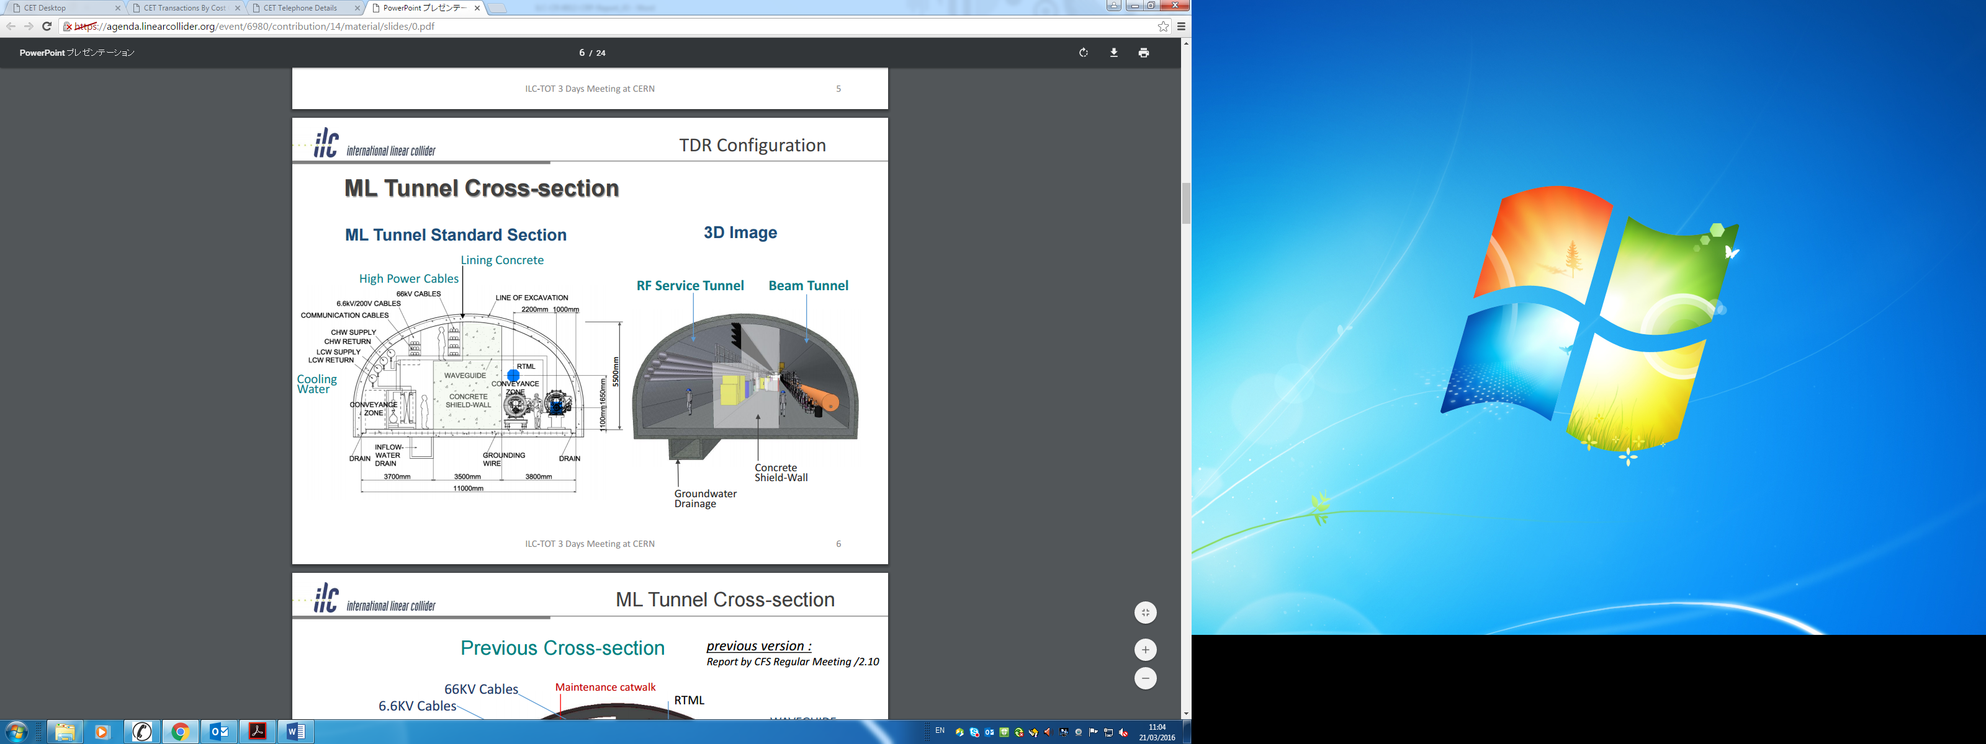

Fig 12.1: TDR Tunnel Cross-section

CR-012 proposes to reduce the thickness of the concrete shield wall by 2 m, from the TDR thickness of 3.5 m to 1.5 m. However, due to further detailed integration studies since the TDR, it has been concluded that it is not possible to reduce the overall width of the tunnel accordingly, i.e. by 2 m, instead it is proposed to reduce the tunnel width from 11 m to 9.5 m. The new proposed 9.5 m wide cross section is shown below in Fig 12.2.

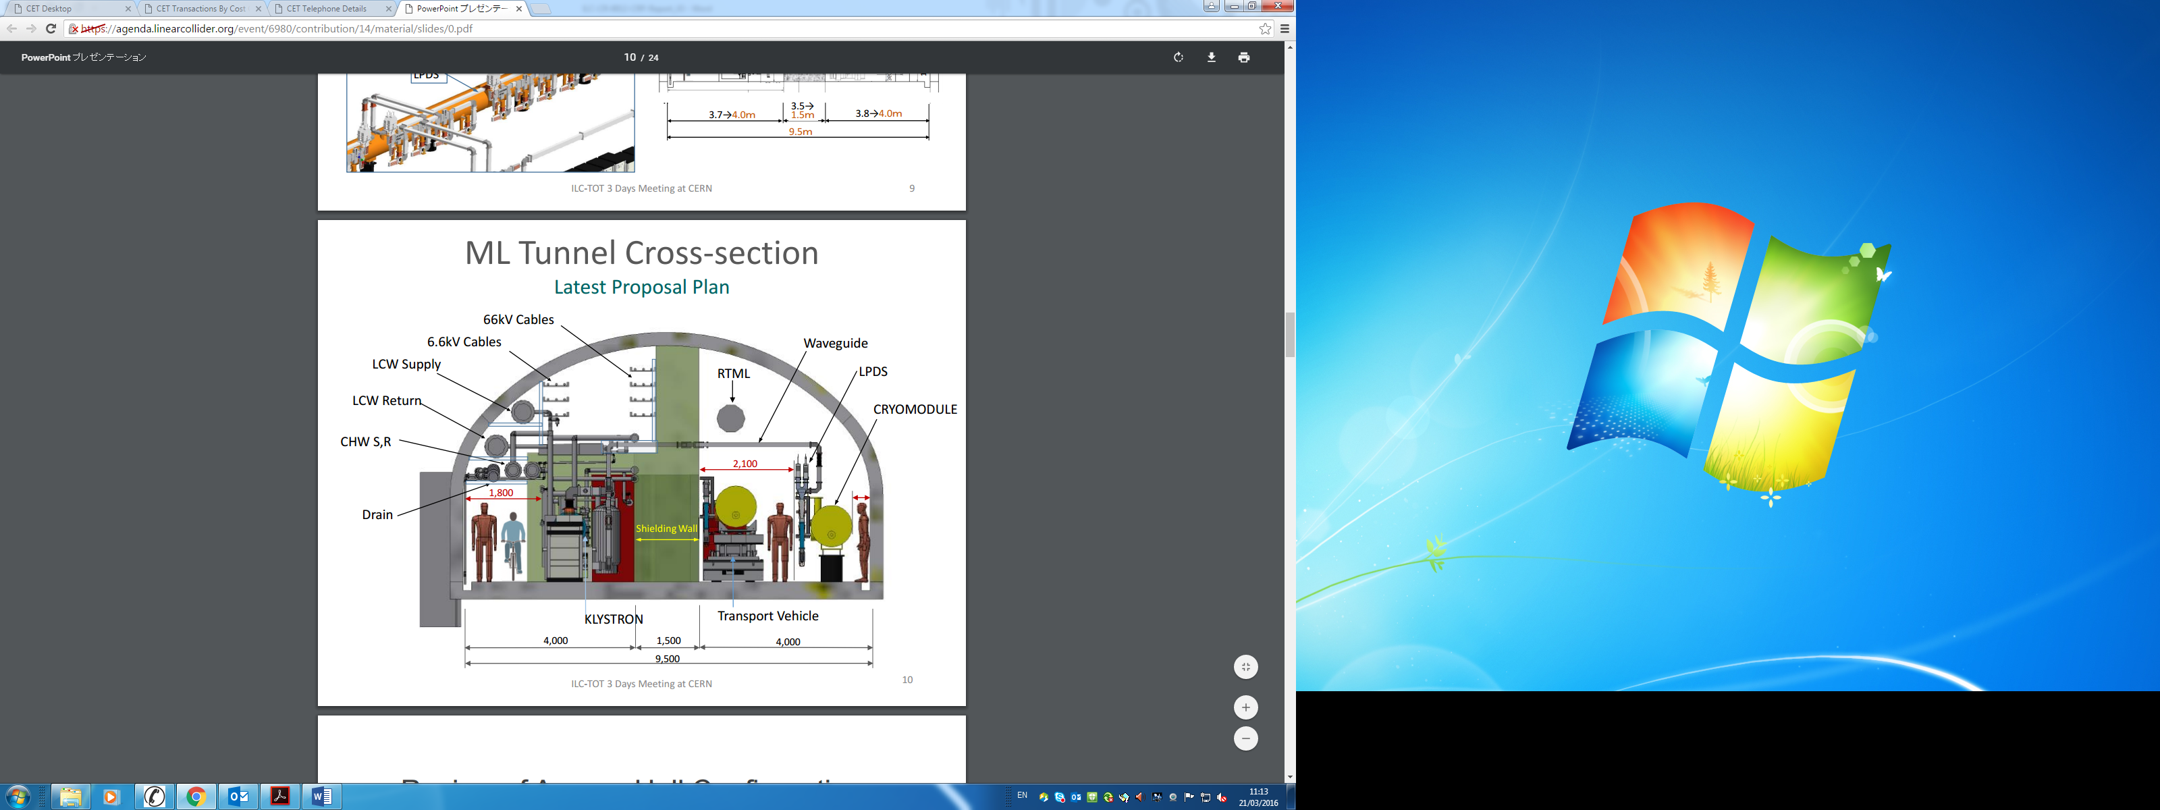

Fig 12.2: Proposed cross-section

**Shield Wall Design**

The defining issue in determining the tunnel wall thickness is field-emission induced radiation from the cavities (dark current) when the RF power is on since it is proposed that personnel access will be permitted during these times. This situation was simulated by the Solyak group at Fermilab. Starting with a uniform distribution of field emitters in the cavity surface, information on the particle losses were calculated (co-ordinates, phase, momentum etc..). Particles which survived were propagated to the next cryomodule, both upstream and downstream. Each cavity was assumed to produce 50nA of captured dark current (the ILC design limit). Simulation of the tunnel radiation dose arising from these particles was performed using the MARS software package. MARS has been well validated over the years and the results of this simulation was cross-checked against FLUKA at SLAC as part of the LCLS-II safety analysis as well as several earlier studies during the GDE era. Both simulations produced consistent results.

Most of the particles are swept out of the cryomodule string by the magnetic fields in the quadrupoles (one every three cryomodules) and were lost in or around the location of these magnets. Loss distributions for different magnetic field settings were investigated. In all cases the loss patterns achieved an equilibrium value within a few cryomodules. The distributions were more peaked in the magnets for the highest settings corresponding to a linac energy of 125 GeV or greater. The ambient tunnel radiation in the personnel access region for these conditions and with a 1.5m shield wall, was estimated to be ~5Sv/h immediately adjacent to the quadrupole location and negligible elsewhere. The Japanese regulatory requirements set a limit of 25 Sv/hr for permanent occupancy. Hence a 1.5m shield wall was deemed sufficient for a uniform 50 nA current per cavity.

The CR panel noted that these calculations were done using the baseline machine settings. This raised the question of whether a worst case scenario involving a pathology of operating parameters (HLRF on, magnets off, etc.) could result in higher doses than the normal parameters. Based on additional simulation results, the worst case scenario involves the quadrupoles turned off so that the dark current electrons are not swept out of the beamline by the quadrupole magnets. The steering dipoles however remain on at their nominal values. This allows a fraction of the electrons to be transported a significant distance and thus gain significant energy (> 15 GeV) before being lost. This in turn increases the tunnel radiation level per lost particle significantly. The resultant tunnel radiation level is shown in fig 12.3 for a uniform 50 nA per cavity current. The worst-case scenario is the green curve, the nominal dark current condition is the red one. The difference is a factor of ~20 and exceeds the Japanese regulatory level of 25  Sv/hr. The tunnel radiation contour plot shows the maximum value in Region A, the cable tray area. The personnel zone, region B, remains significantly below the regulatory limit.

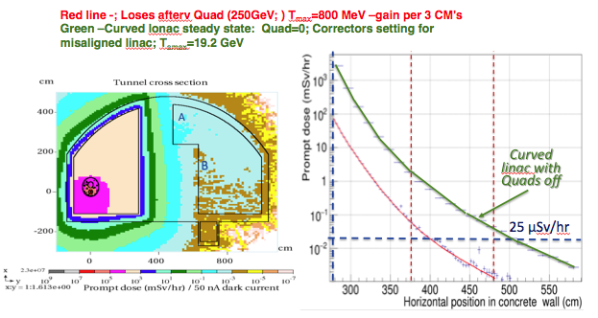

Fig 12.3 Dark current tunnel radiation level nominal (red) and worst case (green)

This result prompted further scrutiny of the worst case scenario or more accurately the adoption of a 50nA value for the cryomodule dark current. The most recent survey in this regard is shown in fig 12.4 and was used for the dark current analysis of the LCLS-II project. From this, it is not clear that 50 nA is a reasonable limit at 31.5 MV/m given that the radiation increases rapidly with gradient and most measurements have been made at lower gradients. Also, it would difficult to guarantee that a cavity would quench before exceeding any predetermined emission value. Indeed under certain pathologies, the linac can sustain very large dark currents (~ mA), but this requires thousands of space-charge limited field emission sites. With such levels of uncertainty the panel believes that purely passive protection is not practical from a regulatory standpoint and that some form of administrative and/or active protection would be necessary. There are many ways to implement such systems which could involve cryomodule mis-phasing, interlocks to ensure the quadrupoles are on and various magnet and cryomodule powering schemes. In addition, direct monitoring of the dark current radiation in the linac enclosure would be done at minimum and personnel radiation monitors would likely be part of the interlock system.

Other requirements of the shield wall in regard to life safety (fire and ODH), emergency egress, and the shielding of electronics are all satisfied with < 1 m of concrete.



Fig 12.4: Dark Current measurements for ILC style cryomodules

**Reliability**

With no access allowed in the tunnels during beam operation, it is assumed all repairs would be done on maintenance days, which would nominally be two weeks apart. Considering only failures in the RF system components (LLRF, DC PSs, Modulators and Klystrons) that would disable RF station operation, there are two factors that determine the probably that the linacs can each maintain 250 GeV operation during these two week periods: (1) the reliability of the RF systems (based on the mean-time-to-failure, or MTBF, for each component) and (2) the linac energy overhead available to offset the energy loss from failed stations. The mean-time-to-repair (MTTR) is not a factor as the proponents assume all repairs can be completed within 24 hours when the access to the tunnel is allowed (which may require an increase in the size of the maintenance crew relative to that assumed in the TDR).

The proponents argue that further to the experience gained since the TDR from RF system operation and tests at DESY, it is reasonable to increase the expected MTBFs of Modulators and Klystrons from 50 khr to 100 khr, although no supporting data is provided. With the 1.5% energy overhead (3 RF stations) assumed in TDR for RF station failures, these MTBF increases alone would not achieve the desired 90% probability that both linacs would operate at 250 GeV during a two week period. Thus the proponents also propose an increase in the energy overhead, to 2.5% (5 RF stations), to achieve 90% probability (in practice, the repair day would be scheduled earlier if the energy overhead was depleted). With operation at lower energy, the probability of maintaining the beam energies approaches 100% (e.g., over 95% with 245 GeV beams).

A table summarizing all of the changes being proposed is given at the end of CR0012 Addendum 1.

**Cost and Schedule considerations**

The estimated cost saving for a 2 m reduction in the concrete shield wall and 1.5 m in the tunnel width is approximately 13 B yen* for a 500 GeV CoM energy. The number of installed spare modules could affect the bottom line cost savings at the several percent level.

It is also estimated that the construction time would be reduced by 5 months*.

**Other Impacts**

Beam-on personnel access to the tunnel will not be permitted. RF-power-on access to the equipment gallery will be allowed under controlled conditions. The effective tunnel size for equipment is increased by 0.5m. The tunnel cost is reduced and the construction schedule is shortened.

**Recommendations**

The panel believes that it is difficult to envisage a purely passive shield wall radiation protection system that would be capable of validation under a worst-case scenario associated with dark currents. An active protection system involving administrative controls and direct radiation interlocks will be necessary. If this is deemed acceptable, the panel recommends approval of the proposal to reduce the shield wall thickness from 3.5 m to 1.5 m as described in CR-012. The installed energy overhead will need to be re-evaluated during cryomodule production when more complete gradient data becomes available.

**Version History**

|  |  |  |  |
| --- | --- | --- | --- |
| Ver: | Date | modified: | by: |
| 1.0 | 5/25/16 | Final version 1 | MH |
| 1.1 | 5/26/16 | Formatting for EDMS | BL |
|  |  |  |  |