ILC Final Focus

Overview:
The ILC final focus (FF) uses independently adjustable compact superconducting magnets for the incoming and extraction beam lines. The adjustability is needed to accommodate beam-energy changes and the separate beam line allows optics suitable for post-IP beam diagnostics. The BNL Direct-Wind technology is used to produce closely spaced coil layers of superconducting multi-strand cable. The design is extremely compact and the coils are almost touching inside shared cold-mass volumes. Cooling is provided by superfluid helium at 2 K in order to avoid exciting magnet vibration.
To facilitate “push-pull” at a shared IP, the superconducting final-focus magnets are arranged
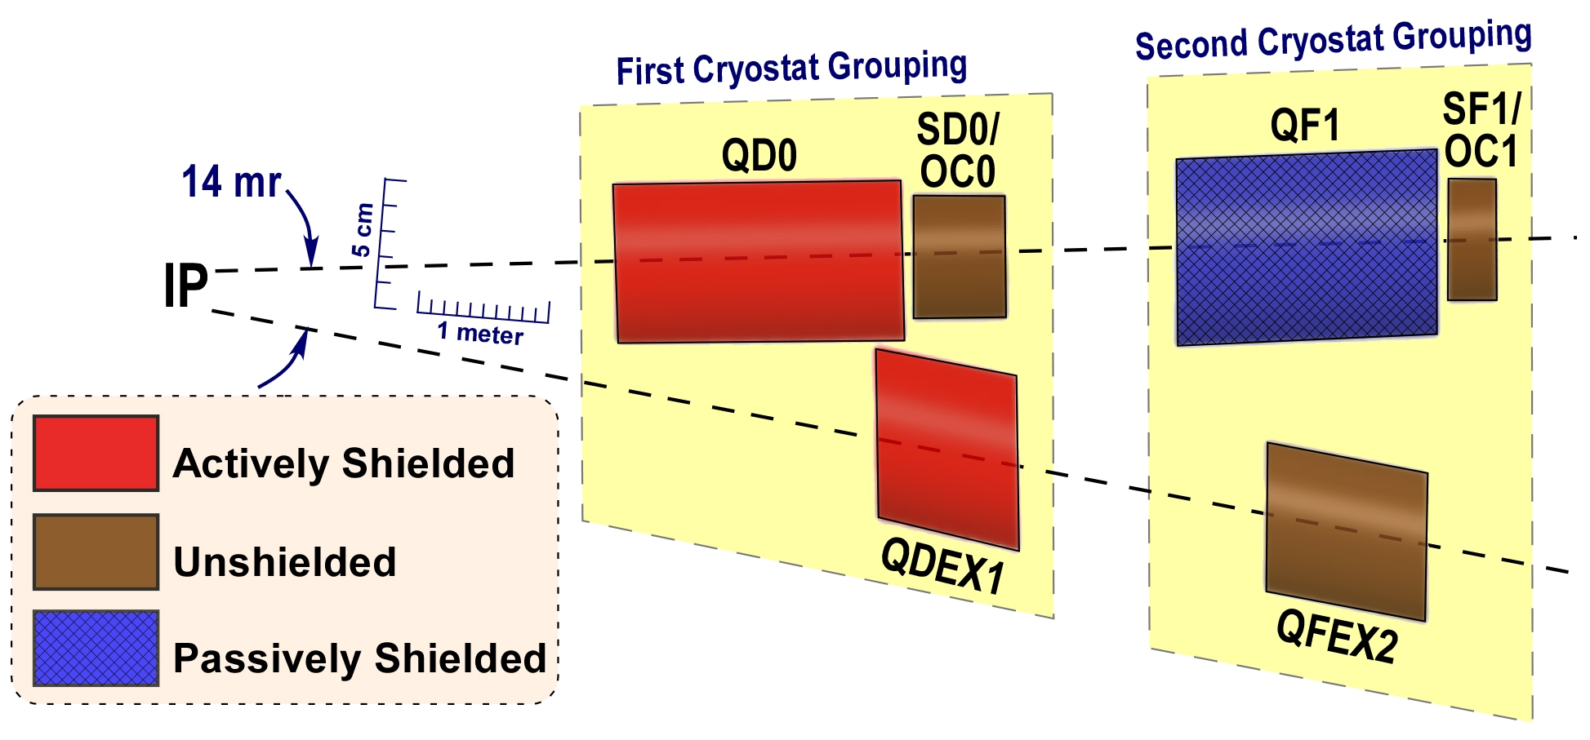
Figure FF1: Schematic IR Magnet Layout
into two groups so that they can be housed in two separate cryostats as shown in Fig. FF1, separated by only warm components and vacuum valves. The first cryostat grouping in Fig. FF1 moves with the detector during switchover, while the second remains fixed on the beam line. Fig. FF2 shows the engineering model of the magnets that are in the detector-mounted cryostat; the QD0 quadrupole; the sextupole package; and the extraction line quadrupole. In this design, the QD0 magnet is split into two coils. This allows for higher flexibility in running at lower energies. The quadrupoles closest to the IP are actually inside the detector solenoidal and therefore cannot have magnetic-flux-return yokes; at the closest coil spacing, magnetic cross talk between the two beam lines is controlled via actively shielded coil configurations and by use of local correction coils, dipole, skew dipole and skew quadrupole or skew sextupole, as appropriate. An anti-solenoid (not shown) that overlaps QD0 is required compensate the effects of the detector’s solenoidal field interacting with the accelerator IR magnets. The first task, FF1, is to reevaluate the FF design using new coil winding patterns and recently developed coil topologies.
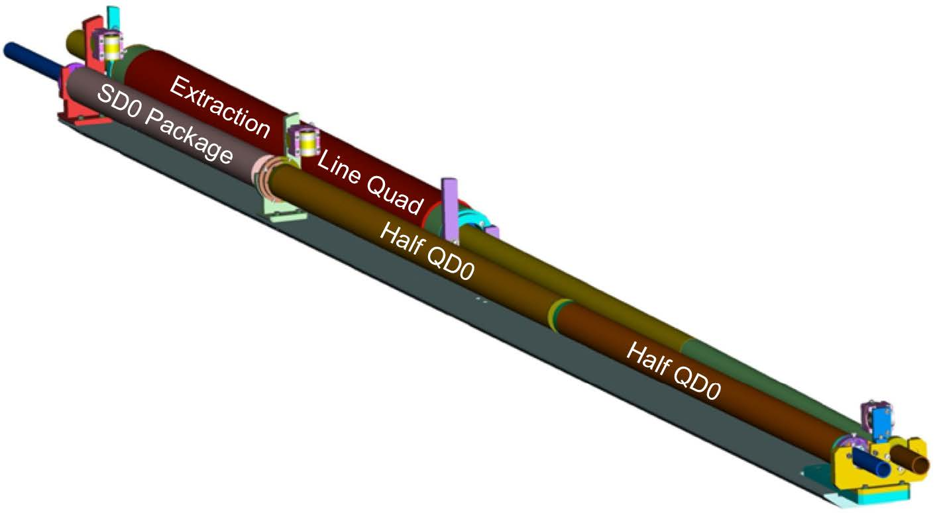
Figure FF2: Engineering prototype model of detector-mounted FF magnets. Note the QD0 coil is split in two units to allow for energy flexibility.
The vertical position of the center of the incoming-beam-line quadrupole field must be stable to order of 50 nm, in order to stay within the capture range of the intra-train-collision feedback. This requirement is well beyond experience at existing accelerators and was partially addressed in an R&D program; the second task, FF2, is to complete this vibration stability measurement R&D using the QD0 prototype and taking advantage of experience gained during later SuperKEKB vibration work.
FF1 | FF Design Optimization | Re-optimization of TDR FF design taking into account new technologies
FF2 | FF QD0 Prototype Test | QD0 prototype assembly, cooldown and vibration stability measurement
Technical Preparation：FF Design Optimization
Outline：

Goals of the technical preparation:
.
Parameters | Symbol | Unit | Design

Expected costs and human resources:
Tasks | Cost | Human Resources
(not including corresponding cost of human resources)
Candidate participating labs:
BNL and KEK
Status and prospects:

Technical Preparation：FF QD0 Prototype Test
Outline：

Goals of the technical preparation:
.
Parameters | Unit | Design

Expected costs and human resources:
Tasks | Cost | Human Resources
(not including corresponding cost of human resources)
Candidate participating labs:
BNL, SLAC and KEK
Status and prospects:

.

